User Manual

*Boardwalk Universal Template Version 3.1*

**Contents**

**1. Organization of the Manual…………………………………………………………………………………...4**

**2. Introduction………………………………………………………………………………………………………….5**

2.1. Overview………………………………………………………………………………………………………..5

2.2. Purpose………………………………………………………………………………………………………….5

**3. System Summary…………………………………………………………………………………………………..6**

3.1. System Configuration……………………………………………………………………………………...6

3.2. Users……………………………………………………………………………………………………………...6

3.3. Pre-Requisite …………………………………………………………………………………………………6

3.4. Assumptions…………………………………………………………………………………………………..6

**4. Getting Started………………………………………………………………………………………………………7**

4.1. Initial Setup……………………………………………………………………………………………………7

4.2. Template Mode………………………………………………………………………………………………7

4.3. Universal Template Tab Menu…………………………………………………………………………8

4.3.1. Boardwalk Application Engine…………………………………………………………….8

4.3.2. Boardwalk Server Actions……………………………………………………………………9

4.3.3. Configure Sheet…………………………………………………………………………………..9

4.3.4. Configure Data Validation……………………………………………………………………9

4.3.5. Configure Data Merge………………………………………………………………………..10

4.3.6. Workbook Settings……………………………………………………………………………10

4.3.7. Utilities……………………………………………………………………………………………..10

4.4. Boardwalk Tab Menu……………………………………………………………………………………11

4.4.1. Updates…………………………………………………………………………………………….11

4.4.2. Review Changes………………………………………………………………………………..11

**5. Design Mode – ‘Create New Application Using UT’……………………………………………….12**

5.1. Initial Settings – Set Mode & System Properties……………………………………………..12

5.2. Version Check……………………………………………………………………………………………….14

5.3. Link Export or Create Cuboid………………………………………………………………………...14

5.4. Link Import or Download Cuboid…………………………………………………………………..16

5.5. Apply Formatting………………………………………………………………………………………….18

5.5.1. Single Row Format……………………………………………………………………………18

5.5.2. Measure Format………………………………………………………………………………..19

5.5.3. Column Format…………………………………………………………………………………20

5.5.4. Assign Format…………………………………………………………………………………...21

5.5.5. Test Format………………………………………………………………………………………22

5.5.6. View/Edit Available Formats……………………………………………………………..22

5.5.7. View/Edit Assigned Formats……………………………………………………………..22

5.5.8. Clear Format……………………………………………………………………………………..23

5.6. Applying Right Click Menus…………………………………………………………………………..23

5.6.1. Apply Standard Right Click ‘Boardwalk Menu’……………………………………23

5.6.2. Add New Custom Right Click Menu Option…………………………………………25

5.6.3. View/Edit Right Click Menu……………………………………………………………….26

5.6.4. Deactivating and deleting Right Click Menu………………………………………..26

5.6.4.1. Deactivate Right Click Menu Items using ‘View/Edit Items’……..26

5.6.4.2. Deactivate using ‘View Metadata’…………………………………………...27

5.7. Including the Event Macro or Custom Macro………………………………………………….28

5.7.1. Attach Event Macros and Remove Event Macros………………………………...28

5.7.2. Adding Custom Macro……………………………………………………………………….29

5.7.2.1. Adding Macro at Template Level…………………………………………….29

5.7.2.2. Adding Macro at Worksheet Level………………………………………….30

5.8. Setting User Access……………………………………………………………………………………….32

5.8.1. User Row Access……………………………………………………………………………….32

5.8.2. User Column Access…………………………………………………………………………..35

5.9. Setting Row Behaviour or Measure Behaviour……………………………………………….36

5.9.1. Insert Row or Measure Behaviour……………………………………………………...36

5.9.1.1. Insert Blank Row or Measure…………………………………………………37

5.9.1.2. Insert Row or Measure with Defaults……………………………………...38

5.9.1.3. Insert Row or Measure with Only Formulas……………………………40

5.9.1.4. Insert Row or Measure with Defaults and Formulas………………..41

5.9.1.5. Macros Before or After Insert Row Behaviour…………………………42

5.9.1.6. Insert Row or Measure Defaults……………………………………………..44

5.9.1.7. Insert Row or Measure Format………………………………………………45

5.9.2. Copy Row or Measure Behaviour……………………………………………………….46

5.9.2.1. Copy Only Formulas or Measure Formulas……………………………..46

5.9.2.2. Copy Only Values or Measure Values………………………………………48

5.9.2.3. Copy Values and Formulas or Measure Values and Formulas…..49

5.9.2.4. Copy Selected Columns or Measure Columns………………………….50

5.9.2.5. Copy Row or Measure Defaults………………………………………………52

5.9.2.6. Copy Row or Measure Format………………………………………………..54

5.9.2.7. Before/After Copy Macro or Measure Macros…………………………55

5.9.3. Delete Row or Measure Behaviour……………………………………………………..57

5.9.4. Verifying and Setting Default Settings………………………………………………...59

5.9.4.1. General Settings…………………………………………………………………….60

5.9.4.2. Default Cuboid Settings………………………………………………………….61

5.9.4.3. Auto-Save Behaviour……………………………………………………………..64

5.9.4.4. Import-Export Metadata Settings…………………………………………...64

5.9.4.5. Template Settings………………………………………………………………….65

5.9.4.6. Macro Settings……………………………………………………………………....65

5.10. Addition of Column……………………………………………………………………………………….65

5.11. Set Cuboid As………………………………………………………………………………………………..67

5.11.1. Submit All – Adding or Removing Cuboids………………………………………….67

5.11.2. Refresh All – Adding or Removing Cuboids…………………………………………69

5.11.3. Bulk Refresh All – Adding or Removing Cuboids…………………………………70

5.12. Attachment Settings……………………………………………………………………………………...72

5.12.1. Attachment Form Settings…………………………………………………………………75

5.12.2. Setting Attachment Rule using Attachment Settings Form…………………..77

5.12.3. Buttons to work with Attachment Rule………………………………………………81

5.13. Setting Column Level Rules…………………………………………………………………………...82

5.13.1. Pre-Defined Text Columns…………………………………………………………………83

5.13.2. Date Column for History……………………………………………………………………83

5.13.3. Locale Dependent Columns………………………………………………………………..84

5.13.4. Data Validation Rules………………………………………………………………………...85

5.13.5. Conditional Format Rules…………………………………………………………………..88

5.14. Business Rules……………………………………………………………………………………………...92

5.14.1. Defining a Business Rule……………………………………………………………………94

5.14.2. Run Business Rules While Submitting………………………………………………..98

5.14.3. View/Edit or Delete Business Rules…………………………………………………...99

5.15. Setting Cuboid Links…………………………………………………………………………………...100

5.15.1. One Source to Multiple Target………………………………………………………….106

5.16. Unlink Cuboid……………………………………………………………………………………………..107

5.16.1. Unlink with Keep Dependencies………………………………………………………107

5.16.2. Unlink with Remove Dependencies………………………………………………….108

5.17. Setting Template Manifest…………………………………………………………………………..109

5.18. Adding Worksheet as Default Tab………………………………………………………………..112

5.19. Utilities………………………………………………………………………………………………………114

5.20. Navigation Section………………………………………………………………………………………117

5.20.1. Go to Application Sheet……………………………………………………………………118

5.20.2. View Metadata………………………………………………………………………………...118

5.20.3. Range Settings………………………………………………………………………………...119

5.20.4. Global Settings………………………………………………………………………………...119

5.20.5. Standard Sheet Layouts…………………………………………………………………...119

**6. User Mode Functions…………………………………………………………………………………………121**

6.1. Data Download…………………………………………………………………………………………...121

6.2. Submit………………………………………………………………………………………………………..123

6.3. Refresh………………………………………………………………………………………………………124

6.4. Download Sheet………………………………………………………………………………………….125

6.5. Submit All…………………………………………………………………………………………………..126

6.6. Refresh All………………………………………………………………………………………………….126

6.7. Download All……………………………………………………………………………………………...126

6.8. Cell History…………………………………………………………………………………………………127

6.9. Row History………………………………………………………………………………………………..128

6.10. Table History……………………………………………………………………………………………...129

6.11. Sort…………………………………………………………………………………………………………….130

6.12. Hide/Unhide………………………………………………………………………………………………130

6.13. Attachment…………………………………………………………………………………………………131

6.14. Clear Template……………………………………………………………………………………………134

6.15. Logout………………………………………………………………………………………………………..134

6.16. Upgrade Template……………………………………………………………………………………....134

1. **Organization of the Manual**

The user’s manual consists of four sections:

* Introduction
* System Summary
* Getting Started
* Design Mode Functionalities
* User Mode Functionalities

The Introduction section explains in general terms the system and the purpose for which it is intended.

The System Summary section provides a general overview of the system. The summary outlines the uses of the system’s hardware and software requirements, system’s configuration, user access levels and system’s behavior in case of any contingencies.

Getting Started section presents briefly about ‘Universal Template’ Menu.

Using The System section provides a detailed description of the functions provided by this tool.

1. **Introduction**

This section provides a brief introduction of Universal Template and the purpose for which it is intended.

* 1. **Overview**

Universal template is a tool to build the Boardwalk Template inclusive of all standard Boardwalk features, provision to include custom features, faster. This tool provides built in Customized Ribbon to carry out various configurations i.e. add Cuboid, assign formatting, add custom macro etc.

* 1. **Purpose**

The Universal Template is developed with the standard coding framework which is extensible too.

Why we need to go for standardization?

**Eliminate Duplication of Code**

Several versions of the same code and testing the same features are time consuming.

**Forget to remove unnecessary code**

Due to the usage of old template from previous application, the unwanted code is not removed and resides in new templates too. In UT when we go for new project the basic code remains the same and the customize code is cleared from the template, so it will be ready for new one.

**Installer Issues**

In earlier stages, we used light installer for installation of BCP client which would get installed successfully; however, it would sometimes give an error if there were any environmental issues. The environmental issues can be like ‘Missing some .dll file’, ‘Missing MSCOMCTL’ etc.With UT, there is no need to install BCP Client anymore. Moreover, there will be a ‘System check’ before every download checking the compatibility of user’s system, and generates the test report. This test report helps to take further actions.

To Summarize, UT Provides the below advantages:

* Easy to use
* No dependency on MSCOMCTL
* Ribbon based Design Interface which is very easy to operate

1. **System Summary**

The System Summary section provides a general overview of the system. The summary outlines the uses of the system’s hardware and software requirements, system’s configuration, user access levels and system’s behavior in case of any contingencies.

* 1. **System Configuration**

This tool is compatible with Excel 2007, 2010, 2013 and 2016 versions, as it requires ‘Excel Ribbon’ which is not present in Excel 2003. It requires connection to Internet in order to save data to database, when Link Export, Link Import, Submit and Refresh.

* 1. **Users**

There are 2 user groups for this tool:

* User; who uses this tool in ‘User Mode’ to use the application.
* Designer; who uses this tool in ‘Design Mode’ to create application.
* Here, Designer or User Role can be played by a Developer, Analyst, Manager, Tester and End User.
  1. **Pre-Requisite**
* A designer should have knowledge of Microsoft Excel.
* Knowledge of BCP (Boardwalk Collaboration Platform) knowledge.
* Knowledge of Boardwalk Concepts like Link Export, Link Import, Submit and Refresh etc.
  1. **Assumptions**
* A BAE server with Version 4.2 is setup.
* Designers have sufficient access / rights to create BCP objects.

1. **Getting Started**

The Getting Started section presents brief options under ‘Universal Template’ Menu.

* 1. **Initial Setup**

This section provides the details on how to setup the server URL, Process Name, Workbook Name, Template Version etc.

To set the above settings go to Universal Template > Workbook Settings > Range Settings > System Properties.

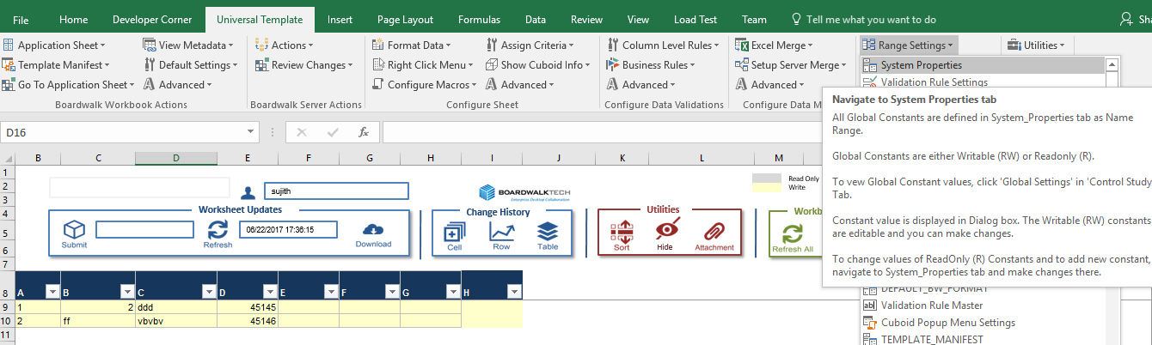

This will open worksheet ‘System_Properties’.

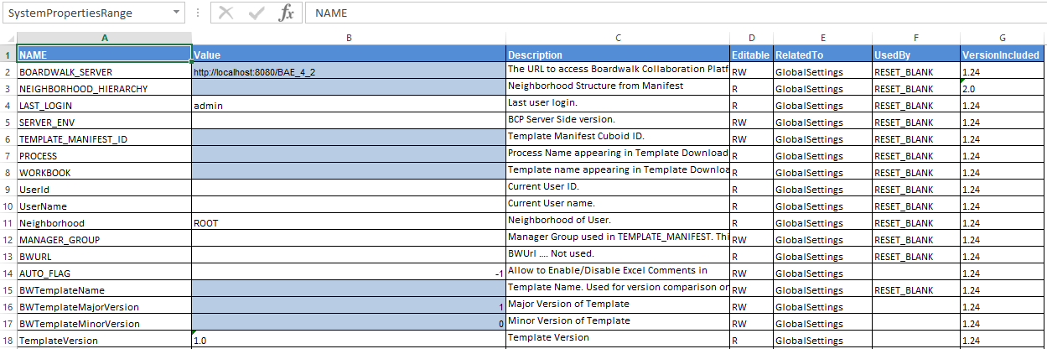

* 1. **Template Mode**

Universal Template works in two modes as below

* **Design Mode**

To create the Boardwalk template, use this tool in ‘Design Mode’.

‘Universal Template’ Menu is enabled, when this mode is ON.

Template cannot be downloaded, when Deign Mode is ON.

* **User Mode**

To operate the Final Boardwalk Template, use this tool in ‘User Mode’.

‘Boardwalk’ Menu is enabled, when this mode is ON.

No design level changes/enhancements can be made in ‘User Mode‘.

Template can be downloaded in ‘User Mode’.

* 1. **Universal Template Tab Menu**

Universal Template menu is enabled when ‘Design Mode’ is made ON. The functionalities of each group is mentioned below.

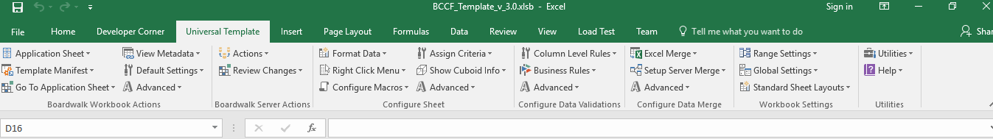

#### Boardwalk Application Engine

|  |  |  |
| --- | --- | --- |
| **S No** | **Name of Feature** | **Functionality Description** |
| 1 | Application Sheet | Adds new tab in the template, using which user can-   * Link Export new Cuboid. * Submit changes in link imported Cuboid. * Refresh Cuboid. * Audit Trails (Cell, Row & Table History) can be launched. |
| 2 | Template Manifest | New Tab with Cuboid entries can be added to Link Export the Template Manifest. |
| 3 | Go to Application Sheet | This is the navigation option where developer can navigate from one Cuboid to another Cuboid. |
| 4 | View Metadata | Displays all relative information of the Cuboid like column names, active format, validation, Cuboid Id etc. |
| 5 | Default Settings | This will set the default behavior of new Cuboid for Insert, Copy and Delete Row operations. |
| 6 | Advanced | It helps to allow set the links between Cuboids & to configure basic macros at Template level. |

#### Boardwalk Server Actions

|  |  |  |
| --- | --- | --- |
| **S No** | **Name of Feature** | **Functionality Description** |
| 1 | Actions | All Server Level Action Like   * Link Export * Link Import * Submit * Refresh |
| 2 | Review Changes | Cell, Row and Cuboid History actions can be called. |

#### Configure Sheet

|  |  |  |
| --- | --- | --- |
| **S No** | **Name of Feature** | **Functionality Description** |
| 1 | Format Data | Using this we can generate, apply and assign Cuboid format. |
| 2 | Right Click Menu | Using this we can apply right click menus at cell or/and row level. |
| 3 | Configure Macros | Apart from the built-in macros some custom macros based on business rules are defined which will be displayed in this tab. This option enables designer to manage the custom macro and events. |
| 4 | Assign Criteria | Using this we can define Criteria at Row & Column Level. |
| 5 | Show Cuboid Info | This will display all the Cuboid related information. |
| 6 | Advanced | Advanced options like Row/Measure behaviors, Attachments, New Columns are accessible here. |

#### Configure Data Validation

|  |  |  |
| --- | --- | --- |
| **S No** | **Name of Feature** | **Functionality Description** |
| 1 | Column Level Rules | All the column specific rules can be accessed here. |
| 2 | Business Rules | This will provide all the Business Validation Rules of the Cuboid. |
| 3 | Advanced | Advanced options like viewing, editing and deleting the rules are accessible here. |

#### Configure Data Merge

|  |  |  |
| --- | --- | --- |
| **S No** | **Name of Feature** | **Functionality Description** |
| 1 | Excel Merge | All the options related to Excel Merge can be accessible here.  *Note: Separate Document for Excel Merge.* |
| 2 | Setup Server Merge | This will provide the option to add new Cuboids for Supermerge functionality.  *Note: There is a separate User Manual for Excel Merge.* |
| 3 | Advanced | Advanced options like viewing, editing Excel Merge Rules are accessible here. |

#### Workbook Settings

|  |  |  |
| --- | --- | --- |
| **S No** | **Name of Feature** | **Functionality Description** |
| 1 | Range Settings | All the template ranges can be accessible here. |
| 2 | Global Settings | All the global settings of the template can be accessible here. |
| 3 | Standard Sheet Layouts | All the base sheets of different Cuboids can be viewed here. |

#### Utilities

|  |  |  |
| --- | --- | --- |
| **S No** | **Name of Feature** | **Functionality Description** |
| 1 | Utilities | This gives the list of utilities for eg. Reset template, reset last update, reset ribbon. |
| 2 | Help | Provides a list of all features (topics). Further, provides details information on the selected topic. |

* 1. **Boardwalk Tab Menu**

Boardwalk Tab is enabled when ‘User Mode’ is made ON.

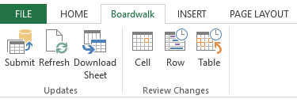

#### Updates

|  |  |  |
| --- | --- | --- |
| **S No** | **Name of Feature** | **Functionality Description** |
| 1 | Submit | To Submit changes in the selected Cuboid. |
| 2 | Refresh | To Refresh changes to the selected Cuboid. |
| 3 | Download Sheet | To Bulk Refresh changes to the selected Cuboid. |

#### Review Changes

|  |  |  |
| --- | --- | --- |
| **S No** | **Name of Feature** | **Functionality Description** |
| 1 | Cell | To check the Cell History of the selected Cuboid cell. |
| 2 | Row | To check the Row History of the selected Cuboid row. |
| 3 | Table | To check the History of the selected Cuboid. |

1. **Design Mode – ‘Create New Application Using UT’**

This Section provides a detailed step by step procedure to build an application using UT.

* 1. **Initial Settings – Set Mode & System Properties**

To work with UT, we first need to set the template mode to Design mode.

Template mode can be set to Design by VB Editor by opening the VB editor using Key ALT + F11.

Select ‘View’ from the menu bar and click on ‘Immediate Window’ as

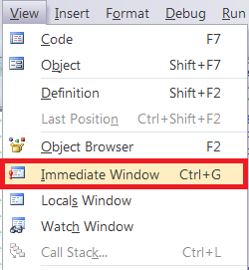

This opens window named as ‘Immediate’.

Type ‘settemplatemodedesign’ in text area of ‘Immediate Window’

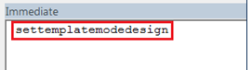

This opens Login form if user is not logged in

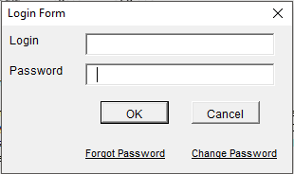

Put appropriate credentials. On successful authentication, design mode gets activated in template.

User must be member of Level 0 or Level 1 Neighborhood (first two levels) to get access of design mode.

Navigate to ‘System_Properties’ sheet using ‘Universal Template > Workbook Settings > Range Settings as shown below.

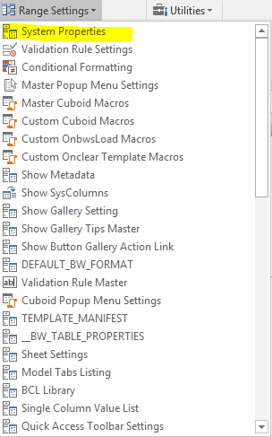

In System_Properties Sheet, configure the following parameters related to the new application under design, so in next step we can start creating data for our new application. (Description of these fields are present in template ‘Description’ column on worksheet ‘System Properties’)

* BOARDWALK_SERVER
* NEIGHBORHOOD_HIERARCHY
* TEMPLATE_MANIFEST_ID
* PROCESS
* WORKBOOK
* BWTemplateName
* BWTemplateMajorVersion
* BWTemplateMinorVersion

Below is an example of the settings for a sample application.

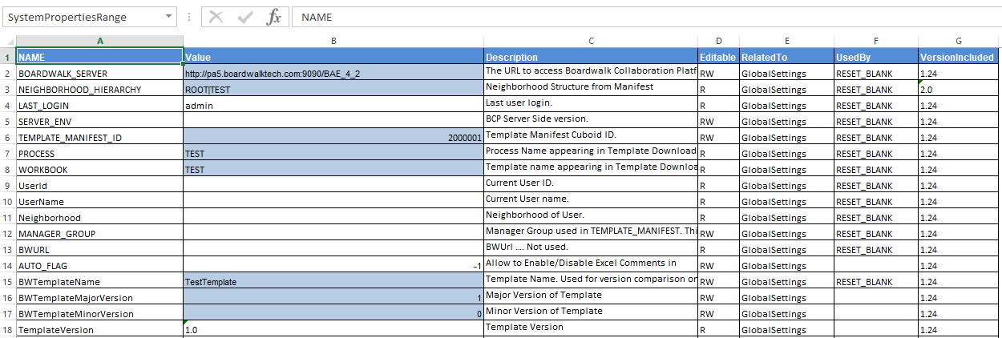

* 1. **Version Check**

Versioning is used in Universal Template to release the new versions of the template once released. So the versioning is updated according to the new changes. There are two flags used for versioning in ‘System_Properties’.

Field ‘CHECK_VERSION’ is set to ‘TRUE’ to verify Template Version with version specified in SQL table ‘BW_TEMPLATE_VERSION’. If this flag is ‘FALSE’ then version checking is not done.

This SQL table has major version and minor version columns which will be compared with ‘BWTemplateMajorVersion’ and ‘BWTemplateMinorVersion’ in ‘System_Properties’.

In case if version mismatch, appropriate message is popped up to user with information about new version availability.

Field ‘SUPPORTED_VERSIONS_CHECK’ is set to ‘TRUE’ to verify supported version specified in SQL table ‘BW_TEMPLATE_SUPPORT_VERSIONS’. This is basically used to complete ‘Submit’ and ‘Refresh’ functionalities in case of version mismatch. If this flag is ‘False’ then version checking is not done.

* 1. **Link Export or Create Cuboid**

We can create a new Data Cuboid by adding New Tab.

Go to Universal Template > Boardwalk Workbook Actions > Add New

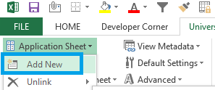

A new sheet with name ‘Standard Cuboid’ is added

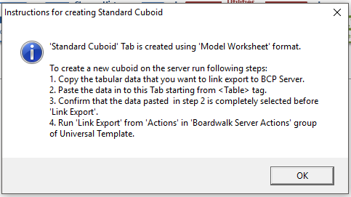

Copy Paste the Data starting from the cell which has the value as ‘Table’.

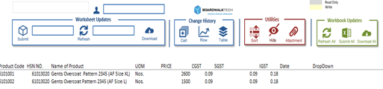

Select the Range and Click on “Link Export” from ‘Universal Template > Boardwalk Server Actions > Actions’.

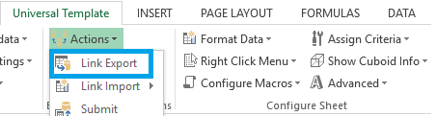

A pop-up like below will be displayed to select the location of the Cuboid. In drop down list it will show the entire Neighborhood structure present in the server. When we select the Neighborhood structure, Collaborations under that particular neighborhood will appear in the drop down. Select the required White Board under that to give the required Cuboid Name.

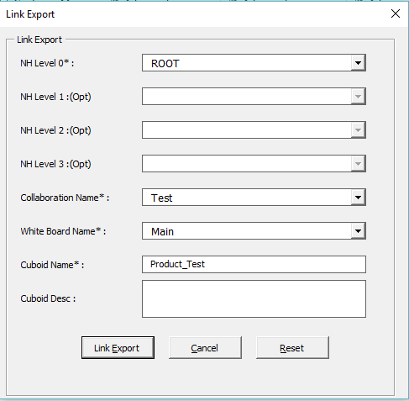

Click Link Export and the below pop-ups will be displayed.

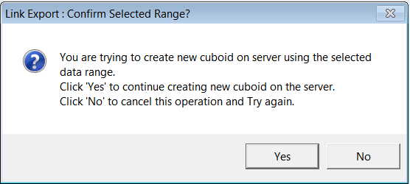

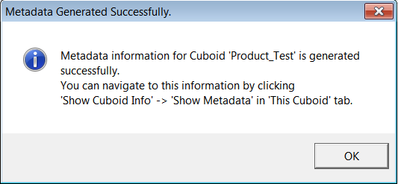

Cuboid is created and Linked Exported. The Cuboid Name is now assigned to the Sheet Name.

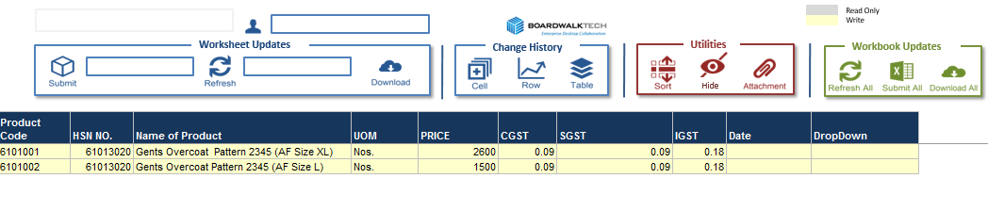

* 1. **Link Import or Download Cuboid**

We can download a Cuboid by using Link Import.

Go to Universal Template > Boardwalk Server Actions > Link Import > Standard Cuboid.

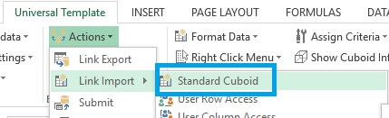

A confirmation pop-up will be opened and we need to click ‘Yes’.

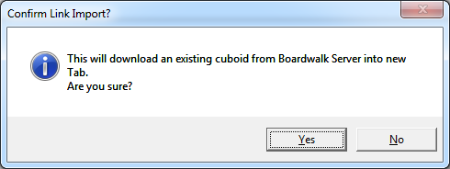

A pop-up like below will be displayed to select the location of the Cuboid. In drop down list it will show the entire Neighborhood structure present in the server. When we select the Neighborhood structure, Collaborations under that particular neighborhood will appear in the drop down. Select the required White Board under that and select Cuboid Name which needs to be Link Imported.

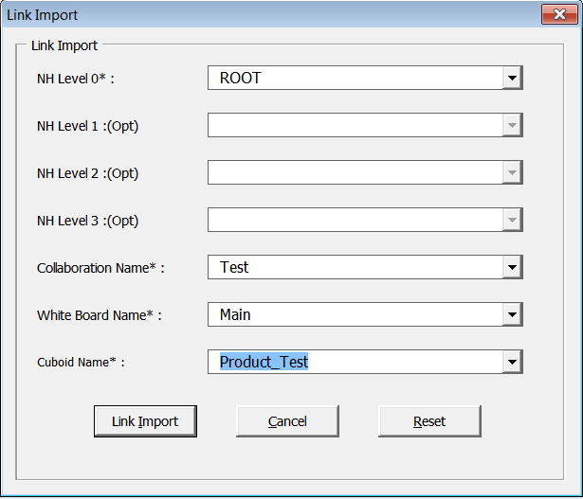

Once clicking on Link Import button, the selected Cuboid data will be Link Imported into the template like below.



* 1. **Apply Formatting**

By using ‘Format Data’ group, below aspects of formatting can be saved in the template

* Format Cells
* Column Width
* Cell Protection
* Column Alignments
* Hide, Unhide Columns

To apply formatting to a Cuboid, we can use ‘Apply Default’ to apply Default Format or we can generate one of the following formats, depending on the form of the data.

* **Single Row Format:** Generate and assign this format, when all rows of the Cuboid need same formatting.
* **Measure Format:** Generate and assign this format, when formatting of a group of rows is Uniform and the same needs to be applied across the Cuboid.
* **Column Format:** Generate and assign this format, when a specific column of the Cuboid needs different formatting.

#### Single Row Format

Apply desired formatting to the Header and 1st row of the Cuboid.

Select the Header data and the data in the 1st Row.

Go to Universal Template > Configure Sheet > Format Data > Generate Format > Single Row.

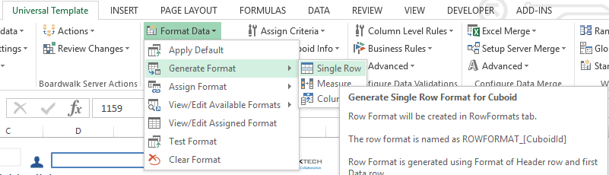

Single Row Format will be generated with a Name Range and the below pop-up.

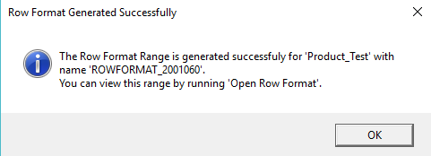

The ROWFORMAT is generated successfully, however, it is not assigned yet to the cuboid.

We can check the generated format in ‘Available Format’ ribbon as shown below

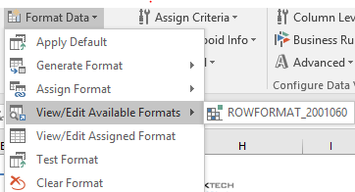

#### Measure Format

Apply desired formatting to the Header and First set of rows below the Header.

The set of rows grouped based on Product# (1st set of measures) and Header row is selected for Measure formatting.

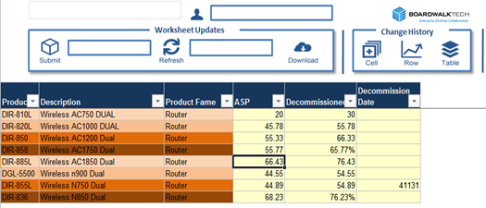

Go to Universal Template > Configuring Sheet > Format Data > Generate Format > Measure.

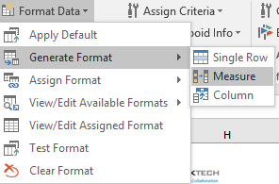

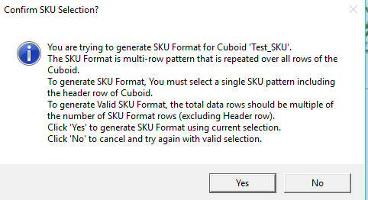

Measure (SKU) Format will be generated with a Name Range and the below pop-up.

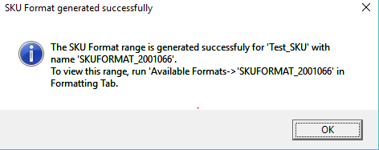

The SKUFORMAT is generated successfully; however it is not assigned yet to the Cuboid.

#### Column Format

This is the traditional formatting where the column formatting is defined using column indexes. Go to the required Cuboid (Test_UT1) in which you desire to apply Column Format.

Go to Universal Template > Configure Sheet > Generate Format > Column.

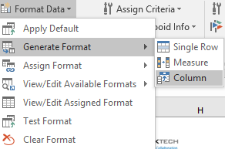

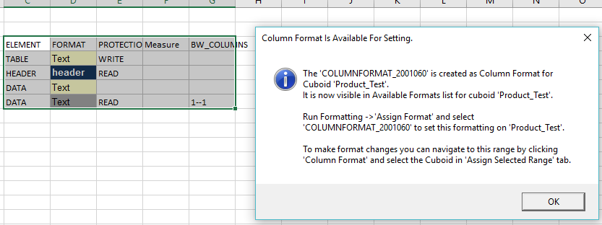

Update COLUMNFORMAT Range as per the required formatting.

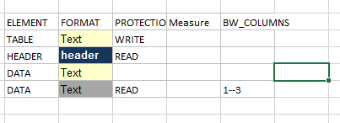

The COLUMNFORMAT is generated successfully; however it is not assigned yet to the Cuboid.

#### Assign Format

Once the format is generated successfully, we need to assign the generated format by navigating to Universal Template > Configure Sheet > Format Data> Assign Format.

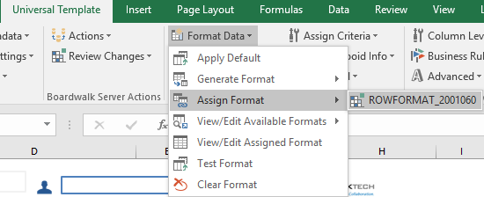

Select appropriate Row/Column/Measure format and the same will be assigned to the Cuboid once clicked.

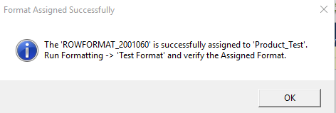

The assigned format will be applied to the Cuboid only when you ‘Test Format’ or in ‘User Mode’.

#### Test Format

Once the generated format is assigned to the Cuboid, we can test the format by navigating to Universal Template > Configure Sheet > Format Data> Test Format.

The assigned format will be applied to entire Cuboid, hence tested.

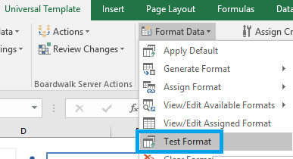

#### View/Edit Available Formats

All the available formats generated on a selected Cuboid sheet will be available by navigating to Universal Template > Configure Sheet > Format Data > View/Edit Available Formats.

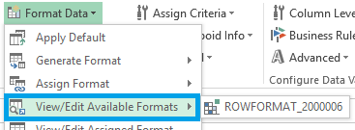

#### View/Edit Assigned Formats

Among all the available formats generated on a selected Cuboid, only one format can be applied once. The assigned format can be viewed or edited by navigating to Universal Template > Configure Sheet > Format Data > View/Edit Available Formats.

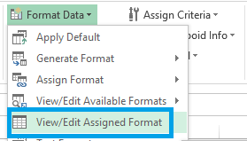

#### Clear Format

To remove the format assigned to Cuboid, Select ‘Clear Format’ by navigating to Universal Template > Configure Sheet > Format Data > Clear Format.

With this the default format gets applied to the Cuboid. On Clearing, the format is removed from the Cuboid but still exists in the template and present in the ‘View/Edit Available Formats’ so that we can assign it anytime in future.

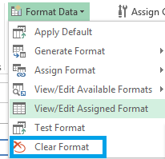

* 1. **Applying Right Click Menus**

This section helps you to add a standard Right Click ‘Boardwalk’ Menu or Custom menu to a Cuboid.

#### Apply Standard Right Click ‘Boardwalk Menu’

Open Cuboid where you need to apply the Right Click Menus and go to Universal Template > Configure Sheet > Right Click Menu > Create Default.

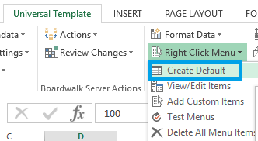

Default Boardwalk Right Click Menu will be created along with below pop-up.

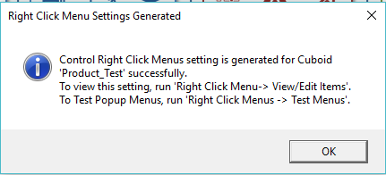

Now the standard popup menus are assigned to the cuboid. However, the Right Click Menu will appear when you click ‘Test the Popup Menus’.

To test the menu, Go to Universal Template > Configure Sheet > Right Click Menu > Test Menus.

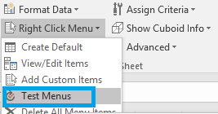

Right Click on any cell and check the standard Right Click Menu that we just assigned.

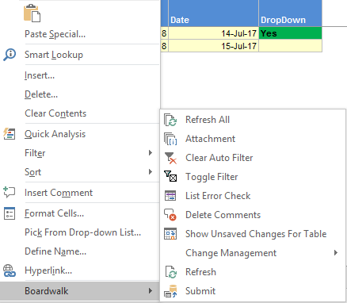

*Note: This standard right click menu is also available at Row Level. To test this, Right Click on any row in the Cuboid on which the Right Click Menu is created.*

#### Add New Custom Right Click Menu Option

Apart from the standard Boardwalk Right Click Menu, we can add custom options also in the Right Click Menu.

To add, go to Universal Template > Configure Sheet > Right Click Menu > Add Custom Items.

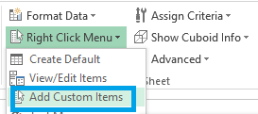

A new row will be added to ‘MouseClickActions’ sheet with the following pop-up.

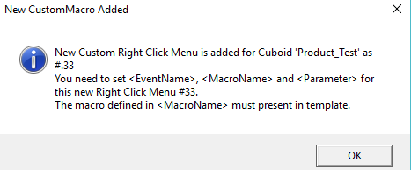

Once clicking on OK button, ‘MouseClickActions’ sheet will be opened where we need to enter the option name and Macro name.

To see new option, go to the Cuboid and Universal Template > Configure Sheet > Right Click Menu > Test Menus.

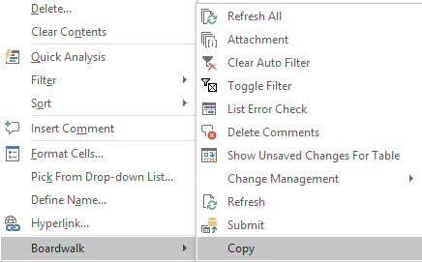

#### View/Edit Right Click Menu

The Right Click Menu list is defined and maintained under ‘MouseClickActions’ sheet. These items can be edited using the option ‘View/Edit Items’.

Go to Universal Template > Configure Sheet > Right Click Menu > View/Edit Items.

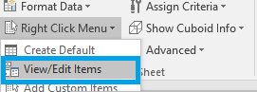

Once clicked, the below pop-up screen will be opened where we can Check/Uncheck the options listed for that particular cuboid.

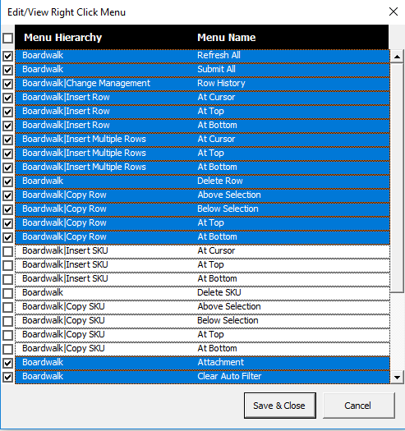

*Note: There will be some items selected by default. Items of Row and Measure(SKU) cannot be selected together.*

#### Deactivating and deleting Right Click Menu

Sometime we create certain menus but in future we want to remove such menus or deactivate menus.

If we need to deactivate the complete Right Click Menu, go to Universal Template > Configure Sheet > Right Click Menu > Delete All Menu Items.

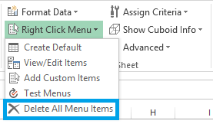

But if we need to deactivate a specific item from the Right Click Menu, we can either use ‘View/Edit Items’ or ‘View Metadata’.

#### Deactivate Right Click Menu Items using ‘View/Edit Items’

Select the Cuboid and go to Universal Template > Configure Sheet > Right Click Menu > View/Edit Items.

‘MouseClickActions’ sheet will be activated with the list of items as shown below.

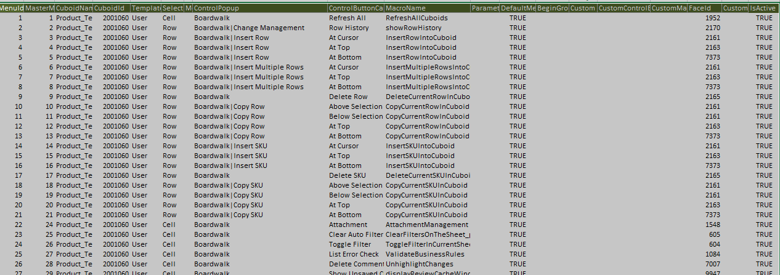

To deactivate a particular item, set value ‘False’ in Is Active column in the sheet as shown below.

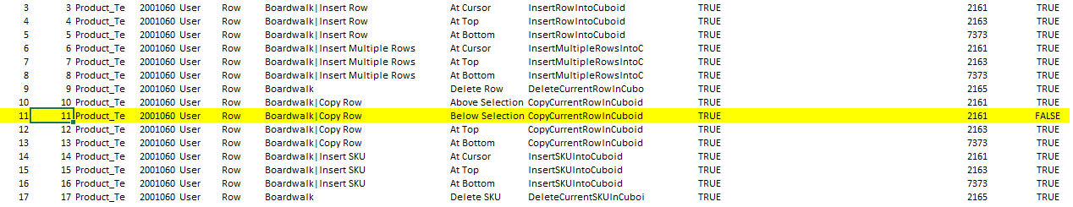

Test the Right Click Menu by navigating to the Cuboid sheet.

#### Deactivate using ‘View Metadata’

Go to Universal Template > Boardwalk Workbook Actions > View Metadata > Cubiod Name > ControlPopupMenu > mouseClickCubiodMenu > Cell/Row > Deactivate the desired optioned as shown below.

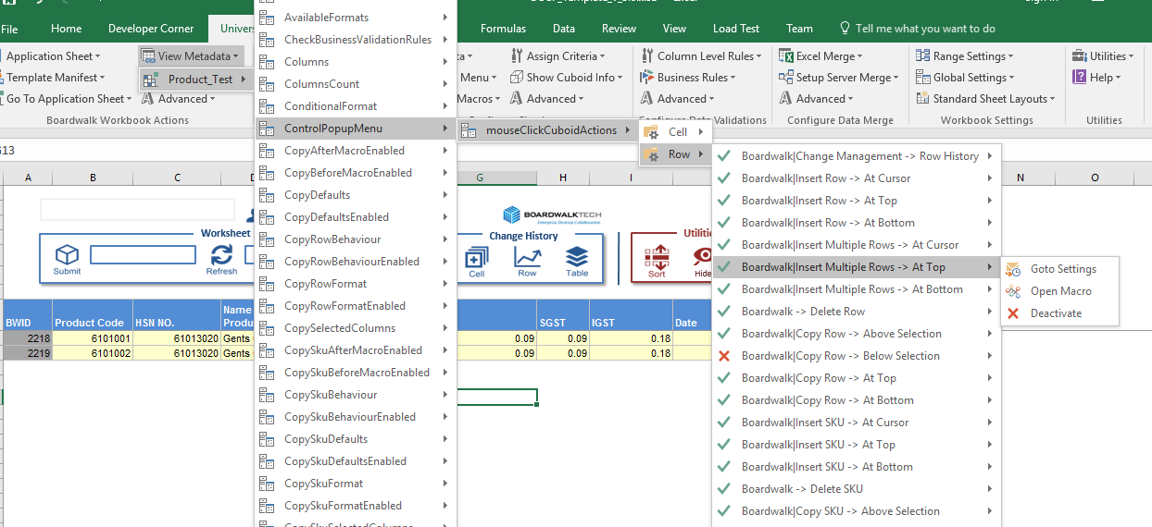

Once menu is deactivated it will be shown with cross marked. Using this process, we can deactivate single menu at a time. We can also activate any item in a similar way just by selecting “Activate” for deactivated menu.

* 1. **Including the Event Macro or Custom Macro**

This section explains how to include the event macros or custom macro as per need of the application.

#### Attach Event Macros and Remove Event Macros

Event macros will provide the info to the user about the time of last Submit or Refresh on a selected sheet. To attach the Event Macro,

To attach, Go to Universal Template > Configure Sheet > Configure Macros > Attach Event Macros.

Below pop-up will be displayed once the Event Macros are attached successfully.

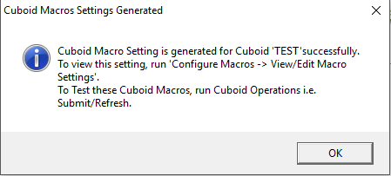

Once the Event macros are attached, last Submit/Refresh info will be displayed in the Cuboid sheet like below.

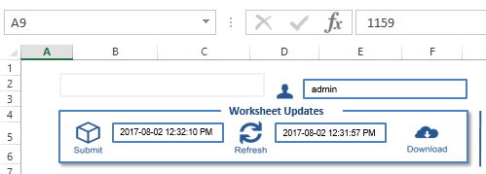

To remove the custom Event Macros, Go to Universal Template > Configure Sheet > Configure Macros > Remove Event Macros.

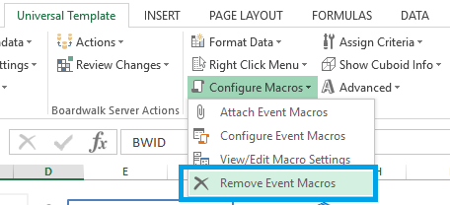

#### Adding Custom Macro

Custom Macros can be added at 2 levels i.e.

* At Template Level
* At Worksheet level

#### Adding Macro at Template Level

This is used when custom macro need to be run at the time of downloading or clearing the template data. To configure this functionality,

Go to Universal Template > Boardwalk Workbook Actions > Configure Macros > At Download Data/At Clear Data.

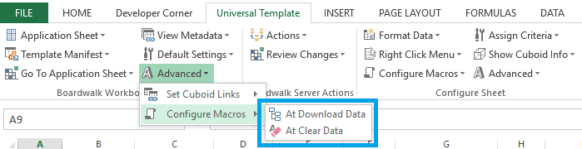

Clicking this will open ‘CustomCuboidMacros’ worksheet along with a new row in ‘CustomOnbwsLoadMacros’ or ‘CustomOnClearTemplateMacros’ ranges as shown below. We need to give the values respectively.

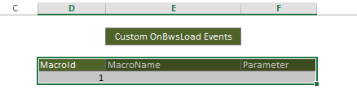

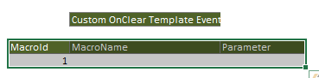

#### Adding Macro at Worksheet Level

This is used when custom macro need to be run at the time of Pre Submit/Refresh or Post Submit/Refresh. To configure this functionality,

Go to Universal Template > Configure Sheet > Configure Macros > Configure Event Macros.

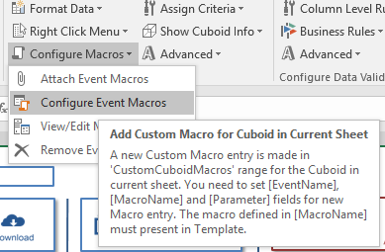

It will open ‘CustomCuboidMacros’ sheet which contains master macros and table for adding customize macros with instruction about the addition of macro as shown below.

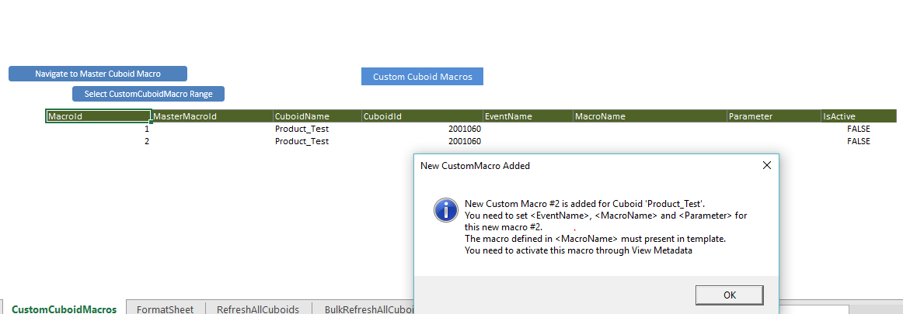

Update this table with the following details

* **Macro name**
* **Event name** which decides the execution flow of new macro
* **MasterMacroId** is the Id from Master macro table after or before new macro is going to execute.
* **Parameter** if passing the parameters
* **IsActive** flag should be made **True**

Let’s consider an example – To include a custom macro, which we need to call before ‘Refresh’.

1. Set Macro name as ‘TEST_CUSTOM_MACRO’, Event name as ‘PreRefresh’, MasterMacroid is ‘7’, Parameter as <blank> and IsActive flag as ‘True’.

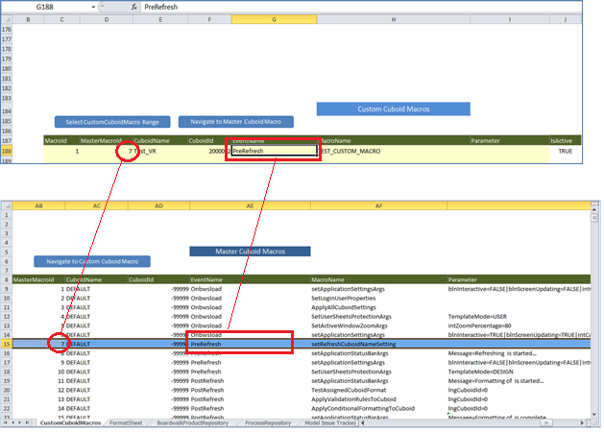

Note: To navigate to master macro sheet, click on ‘Navigate to Master Cuboid macro’. To navigate to custom macro range, click ‘Navigate to Custom Macro’.

1. Include the Custom Macro and Save the template.

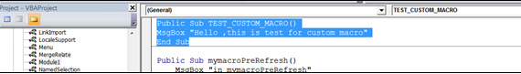

1. Test the Custom Code by clicking on ‘Refresh’.

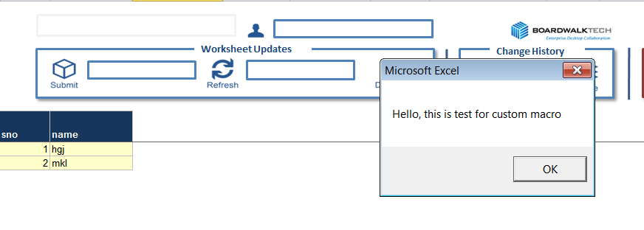

1. We can also navigate to custom macro settings by Universal Template > Configure Sheet > Configure Macros > View/Edit Macro Settings.

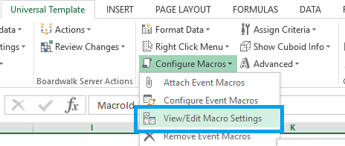

1. We can update the IsActive flag to FALSE to deactivate the custom macro.
   1. **Setting User Access**

There are 2 types of access can be applied on a Cuboid as follows

* User Row Access
* User Column Access

#### User Row Access

User Row Access is set to display specific group of rows to a particular user as per business needs. The basic idea behind User Row Access is setting row criteria to particular user using criteria table.

To set User Row Access in Universal Template, add “User row Access” Cuboid by going to Universal Template > Configure Sheet > Assign Criteria > Row > Create.

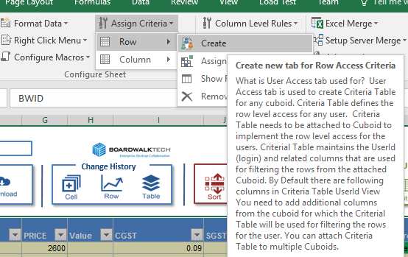

This will add a new sheet named as “User Row Access” with message containing instructions as shown below.

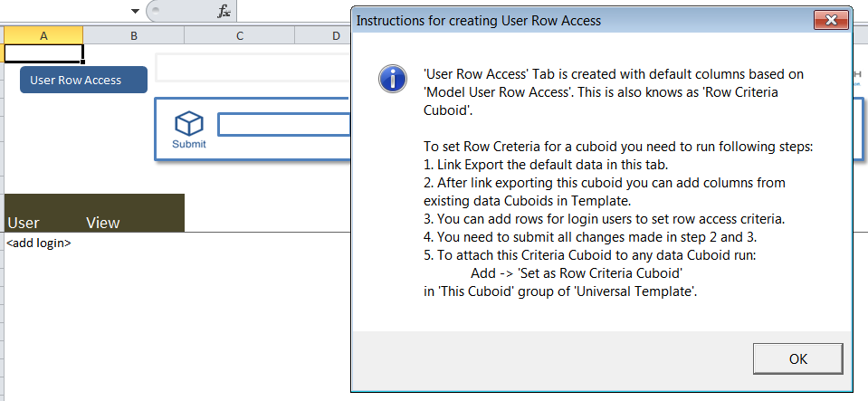

Link Export the default table with User and View columns present in the sheet.

Go to the Cuboid to which you want to assign Access Criteria.

To assign, Go to Universal Template > Configure Sheet > Assign Criteria > Row > Assign Row Criteria and click on the Cuboid Name which was Link Exported above.

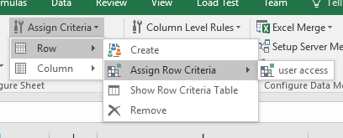

This will set the criteria for the respective cuboid and popup message given below and once clicked on Yes, the User Access is set on the Cuboid.

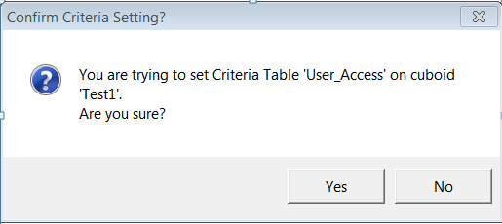

Once User Access is set, we need to decide and choose a Column as a filter to apply criteria. For example, column ‘HSCODE’ can be used for setting criteria. And the values from this column can be used assigned to users as their row criteria.

Go to Universal Template > Boardwalk Workbook Actions > View Metadata > Select Appropriate Cuboid > Columns > Column Name on which criteria to be set🡪Add as Row Criteria Column.

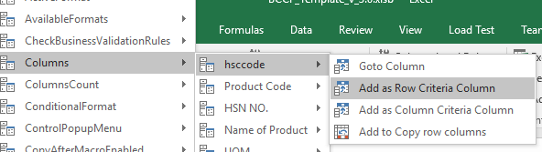

This gives the messages as below confirming the addition of criteria column and successful addition message.

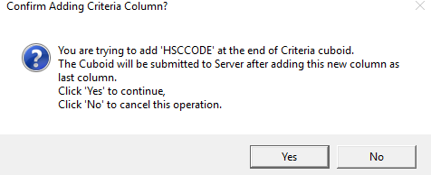

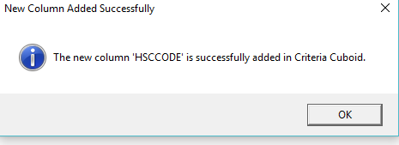

Add the user name and value which should be accessible by that user in the Cuboid and submit the User Access Cuboid. Here, by assigning “1” to user “test”, we will ensure that user “test” would see and have access to rows where HSCODE has “1” as value.

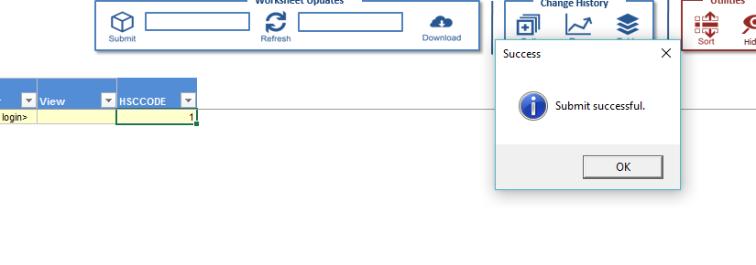Go to the Cuboid and click on refresh to check the access application. (For example the rows with value “1” only will be accessible by user and all other rows won’t be visible to user.)

#### User Column Access

This Functionality is used to set Column Access Criteria for a Cuboid. Criteria Table defines the column level access for any user. We can provide Read/Write/None access using this

To set the User Column Access, Go to Universal Template > Configure Sheet > Assign Criteria > Column > Create.

A new sheet with name ‘User Column Access’ will be created as shown below.

By Default, Group and Default Access columns will be there in this new sheet.

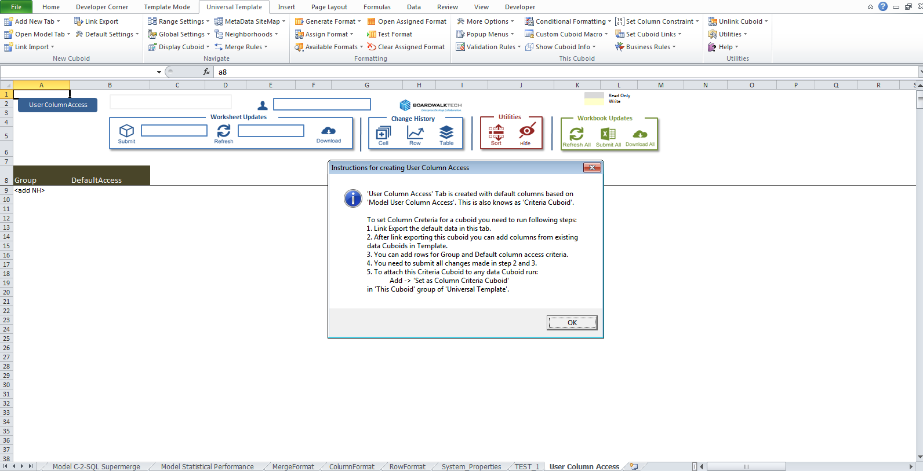

Click on “OK” Button, and add the column form the main Cuboid for which we need the Column Access Criteria and provide the access such as for:

* + Read Access, provide “1”
  + Write Access, provide “2”
  + None, provide “0”

Link Export the Cuboid to the server after providing the complete access for the entire column.

After successfully Link Export, open the main Cuboid and go to Universal Template > Configure Sheet > Assign Criteria > Column > Assign Column Criteria and select the newly created Column Access Cuboid.

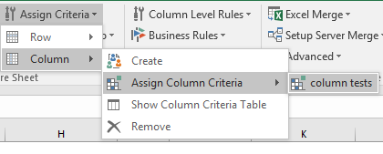

Column Access Criteria will be set on the main Cuboid and change the appropriate NEIGHBORHOOD_HIERARCHY value of the System_Properties sheet to test the assigned Column Access.

* 1. **Setting Row Behaviour or Measure Behaviour**

We can control the behaviour of a Row or a Set of Rows (Measures) by using Universal Template

This can be set at 3 different levels as mentioned below

* Insert
* Copy
* Delete

To set the settings at Workbook level i.e. for all the Cuboids which will be Link Exported or Link Imported in the template, we need to use ‘Universal Template > Boardwalk Workbook Actions > Default Settings’.

To modify these settings for a specific Cuboid, we need to use ‘Edit Row Behaviour’ and ‘Edit Measure Behaviour’ from ‘Universal Template > Configure Sheet > Advanced’.

#### Insert Row or Measure Behaviour

These settings are applicable at the time of inserting Row or Measure. Using Insert row behaviour we can

* Insert blank Row or Measure
* Insert Row or Measure with Defaults
* Insert row or Measure with only formulas
* Insert row or Measure with Defaults and formulas

The above mention behavior need to be enabled or disabled as per the need which can be possible by

* Enable Insert row or Measure behavior
* Disable Insert row or Measure behavior

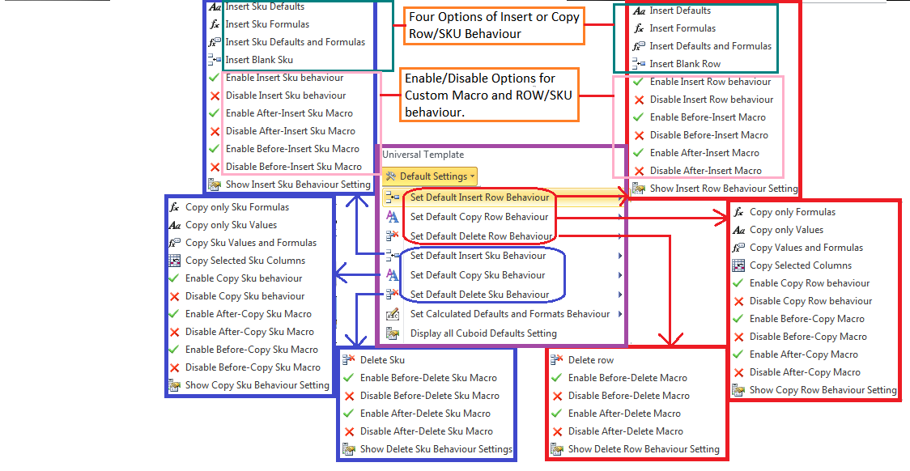

Above we have seen how to create generalized default setting for all Cuboids now below are the steps to modify such settings for specific Cuboid using ‘Universal Template > Configure Sheet > Advanced > Edit ROW/SKU Behaviour’.

#### Insert Blank Row or Measure

This behavior will add blank row or Measure into the cuboid. Neither constants nor formulae are inserted from defined ROW Format or Measure Format into the Cuboid.

*Note: In ‘Insert Measure Behavior’ it will insert Measure always with Measure column values and all other cells are blank.*

To apply in general go to Universal Template > Boardwalk Workbook Action > Default_Settings > Set Default Insert Row Behavior’ or ‘Set Default Insert SKU Behavior’ > ‘Insert Blank Row’ or ‘Insert Blank SKU’

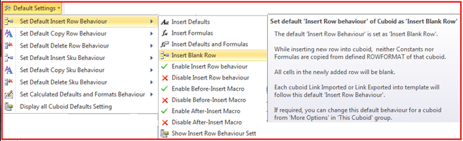

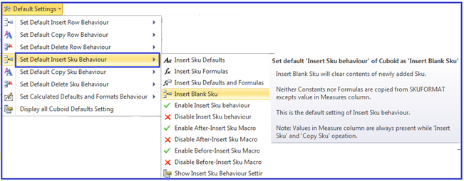

To modify these settings go to Universal Template > Congigure Sheet > Advanced > ‘Edit Row Behaviour’ or ‘Edit Measure Behaviour’ > ‘Insert ROW Behavior’ or ‘Insert Measure Behavior’🡪 ‘Enable Insert Row Behavior’ or ‘Enable Insert SKU Behavior’.

Go to Universal Template > Congigure Sheet > Advanced > ‘Edit Row Behaviour’ or ‘Edit Measure Behaviour’ > ‘Insert Row Behavior’ or ‘Insert Measure Behavior’🡪 ‘Insert Blank ROW’ or ‘Insert Blank SKU’.

Use Right Click Menu ‘Boardwalk **>** Insert Row/SKU’ option to confirm successful application of settings.

*Note: The above process is same for inserting Measure only select appropriate option for Measure settings.*

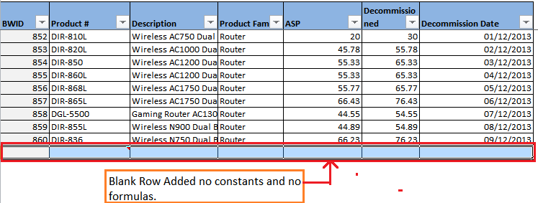

#### Insert Row or Measure with Defaults

Constant values from the defined Row Format or Measure Format are inserted in this type.

To apply in general go to Universal Template > Boardwalk Workbook Action > Default_Settings > ’Set Default Insert Row Behavior’ or ‘Set Default Insert SKU Behavior’ > ‘Insert Defaults’ or ‘Insert SKU Defaults’

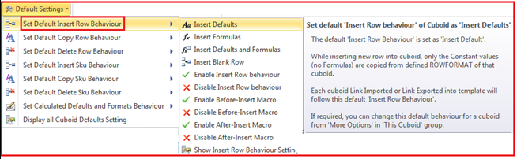

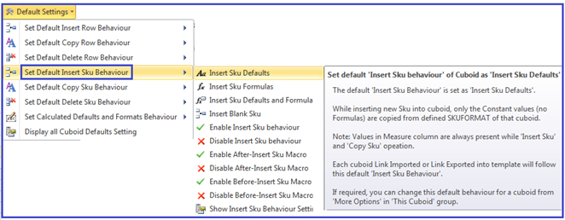

To modify these settings go to Universal Template > Configure Sheet > Advanced > ‘Edit Row Behaviour’ or ‘Edit Measure Behaviour’ > ‘Insert Row Behavior’ or ‘Insert Measure Behaviour’🡪 ‘Enable Insert Row Behaviour’ or ‘Enable Insert SKU Behaviour’.

Go to Universal Template > Configure Sheet > Advanced > ‘Edit Row Behaviour’ or ‘Edit Measure Behaviour’ > ‘Insert Row Behavior’ or ‘Insert Measure Behaviour’🡪 ‘Insert Defaults’ or ‘Insert SKU Defaults’.

Use Right Click Menu ‘Boardwalk **>** Insert Row/Measure’ option to confirm successful application of settings.

*Note: The above process is same for inserting Measure only select appropriate option for Measure settings.*

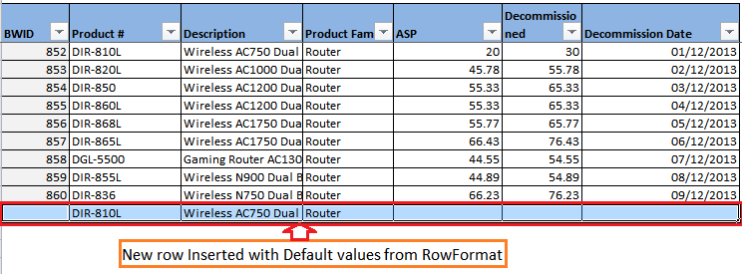

#### Insert Row or Measure with Only Formulas

This will insert Row or Measure with formula values defined in Row Format or Measure Format.

To apply in general go to Universal Template > Boardwalk Workbook Actions > Default Settings > ’Set Default Insert Row Behaviour’ or ‘Set Default Insert SKU Behaviour’ > ‘Insert Formulas’ or ‘Insert SKU Formulas’

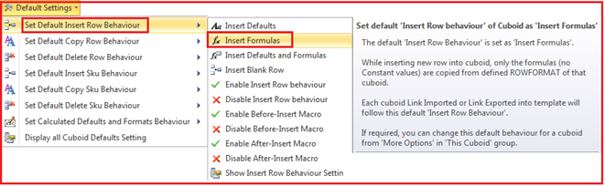

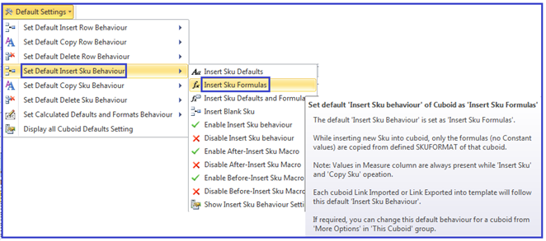

To modify these settings go to Universal Template > Configure Sheet > Advanced > ‘Edit Row Behaviour’ or ‘Edit Measure Behaviour’ > ‘Insert Row Behaviour’ or ‘Insert Measure Behaviour’ > ‘Enable Insert Row Behaviour’ or ‘Enable Insert SKU Behaviour’.

Go to Universal Template > Configure Sheet > Advanced > ‘Edit Row Behaviour’ or ‘Edit Measure Behaviour’ > ‘Insert Row Behaviour’ or ‘Insert Measure Behaviour’ > ‘Insert Formulas’ or ‘Insert SKU Formulas’.

Use Right Click Menu ‘Boardwalk > Insert Row/Measure’ option to confirm successful application of settings.

*Note: The above process is same for inserting Measure only select appropriate option for SKU settings.*

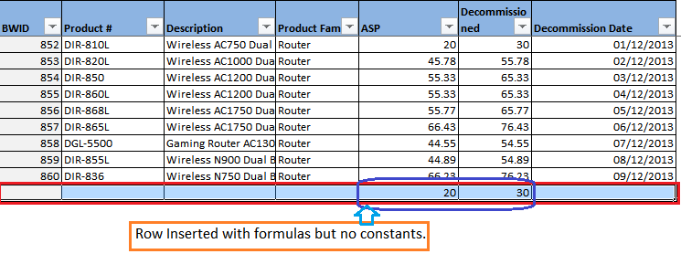

#### Insert Row or Measure with Defaults and Formulas

This will insert Row or Measure with default values as well as formulas defined in Row Format or Measure Format.

To apply in general go to Universal Template > Boardwalk Workbook Action > Default Settings > ’Set Default Insert Row Behaviour’ or ‘Set Default Insert SKU Behaviour’ > ‘Insert Defaults and Formulas’ or ‘Insert SKU Defaults and Formulas’.

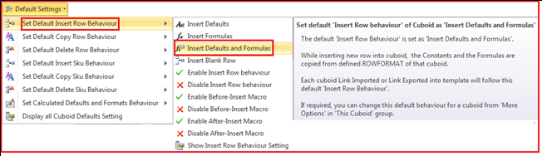

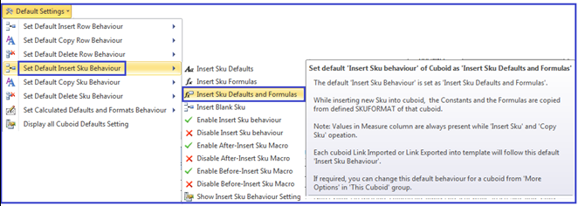

To modify these settings go to Universal Template > Configure Sheet > Advanced > ‘Edit Row Behaviour’ or ‘Edit Measure Behaviour’ > ‘Insert Row Behaviour’ or ‘Insert Measure Behaviour’ > ‘Enable Insert Row Behaviour’ or ‘Enable Insert SKU Behaviour’.

Go to Universal Template > Configure Sheet > Advanced > ‘Edit Row Behaviour’ or ‘Edit Measure Behaviour’ > ‘Insert Row Behaviour’ or ‘Insert Measure Behaviour’🡪 ‘Insert Defaults and Formulas’ or ‘Insert SKU Defaults and Formulas’.

Use Boardwalk Right Click Menu ‘Boardwalk > Insert Row/Measure’ option to confirm successful application of settings.

*Note: The above process is same for inserting Measure. Only select appropriate option for Measure settings.*

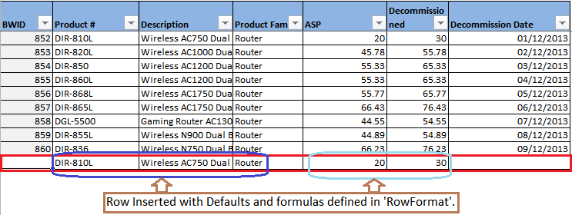

#### Macros Before or After Insert Row Behaviour

Macros named as ‘BeforeInsertRowCustomMacro’ and ‘AfterInsertRowCustomMacro’ are executed before and after inserting row respectively. These macros returns Boolean variable and facilitate to write custom code inside in it which is effective on inserting row action.

To enable or disable the Before or After Insert Macro Settings for all Cuboids in template, go to Universal Template > Boardwalk Workbook Actions > Default Settings > ’Set Default Insert Row Behaviour’ or ‘Set Default Insert SKU Behaviour’ > ‘Enable Before Insert Macro’ or ‘Enable Before-Insert SKU macro’.

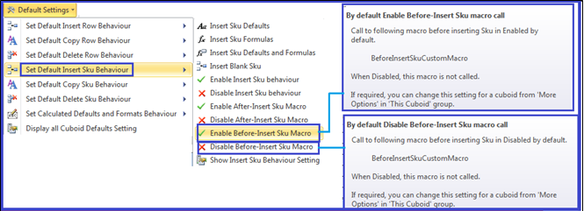

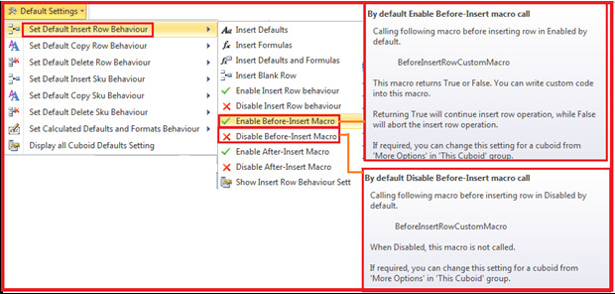

Before Insert Macro will execute ‘BeforeInsertRowCustomMacro’ and After Insert Macro will give a call for ‘AfterInsertRowCustomMacro’.

These macros has facility to write custom code inside it so that it will be effective on respective call.

To open the macro go to Universal Template > Configure Sheet > Advanced > ‘Edit Row Behaviour’ or ‘Edit Measure Behaviour’ > ‘Open Before-Insert Macros’ or ‘Open Before-Insert SKU Macros’.

This will open the Visual basic editor with the respective macro as

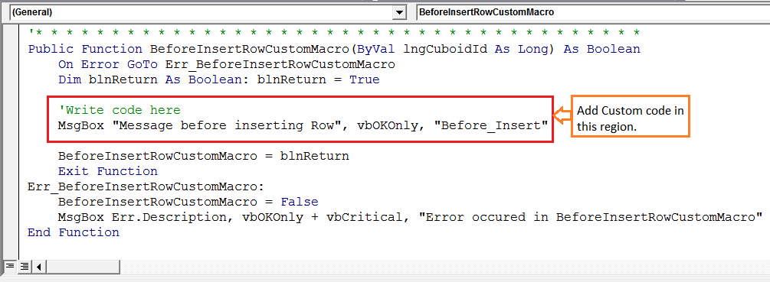

Add the code required to execute Before or After Insert Row Operation which will be executed on Insert Row Operation as shown below.

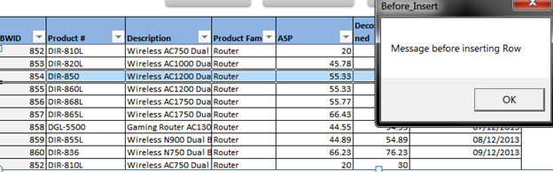

*Note: To disable macro use ‘Disable before-Insert macro’ or ‘Disable before-Insert SKU macro’*

*Procedure remains same for enabling or disabling ‘After Insert Macro’ or ‘After Insert-SKU Macro’ select appropriate option for the same.*

#### Insert Row or Measure Defaults

The defaults values can be set for new rows or SKUs using this functionality.

To set the default values for new row go to Universal Template > Configure Sheet > Advanced > ‘Edit Row Behaviour’ or ‘Edit Measure Behaviour’ > ‘Insert Row Defaults’ or ‘Insert Measure Defaults’🡪 ‘Set Default Insert values’ or ‘Set default Insert SKU values’.

Clicking on ‘Set Default Insert Values’ or ‘Set Default Insert SKU values’ will prompt message box to enter ‘Column Name = Default Value’ which will need to be present in the new row.

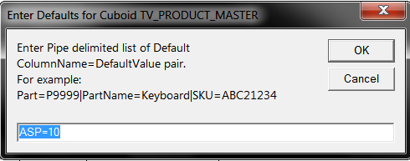

To enable Insert row or SKU defaults go to, Universal Template > Configure Sheet > Advanced > ‘Edit Row Behaviour’ or ‘Edit Measure Behaviour’ 🡪 ‘Insert Row Defaults’ or ‘Insert Measure Defaults’🡪 ‘Enable Insert Row defaults’ or ‘Enable Insert SKU defaults’.

Use Boardwalk Right Click Menu ‘Boardwalk > Insert Row/Measure’ option to confirm successful application of settings.

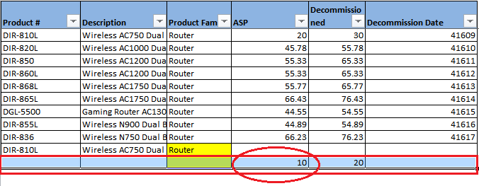

New row added with column ‘ASP=10’ by default.

*Note: Similarly we can add default settings for Measure.*

#### Insert Row or Measure Format

New format can be applied to the newly added row and format can be different than the existing row or SKU format. In such cases ‘Insert Row or SKU format’ functionality can be used.

To check the current status of format settings go to Universal Template > Configure Sheet > Advanced > ‘Edit Row Behaviour’ or ‘Edit Measure Behaviour’ > ‘Insert Row Format’ or ‘Insert Measure Format’ > ‘Show Insert Row Format Settings’ or ‘Show Insert SKU Format Settings’.

This will show the current status of format.

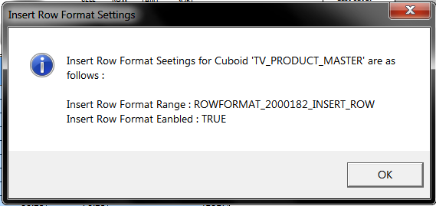

To apply these settings enable format first as, Universal Template > Configure Sheet > Advanced > ‘Edit Row Behaviour’ or ‘Edit Measure Behaviour’ > ‘Insert Row Format’ or ‘Insert Measure Format’🡪 ‘Enable Insert Row Format’ or ‘Enable Insert SKU Format’.

*Note: ‘Disable Insert Row Format’ or ‘Disable Insert SKU Format’ are used to disable format settings.*

Open the format setting and make the changes in format which we want to apply to the new row.

To open the format go to Universal Template > Configure Sheet > Advanced > ‘Edit Row Behaviour’ or ‘Edit Measure Behaviour’ > ‘Insert Row Format’ or ‘Insert Measure Format’ > ‘Open Insert Row Format’ or ‘Open Insert SKU Format’

This will open the format setting worksheet as shown below.

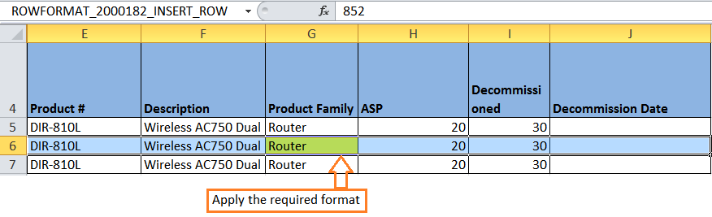

Insert new row using Boardwalk Right Click Menu. New format gets applied to newly added row.

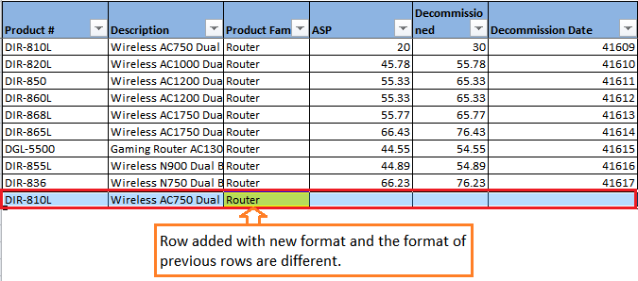

*Note: All the steps will remain same for Measure formatting by selecting path for Measure.*

#### Copy Row or Measure Behaviour

Row or Measure can be copied using these settings. It provides following options.

* Copy only Formulas or Measure Formulas
* Copy only Values or Measure Values
* Copy Values and Formulas or Measure Values and Formulas
* Copy selected columns or selected Measure Columns

#### Copy Only Formulas or Measure Formulas

This will copy only formulas from the source row to copied row.

To apply this setting first enable Copy Row or Measure Behavior and follow the steps given below.

To apply in general to all cuboids by default go to Universal Template > Boardwalk Workbook Actions > Default Settings > ‘Set Default Copy Row Behaviour’ or ‘Set Default Copy Measure Behaviour’ > ‘Copy Only Formulas’ or ‘Copy Only SKU Formulas’.

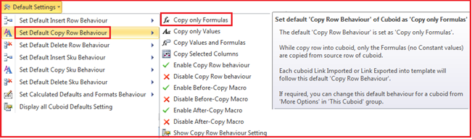

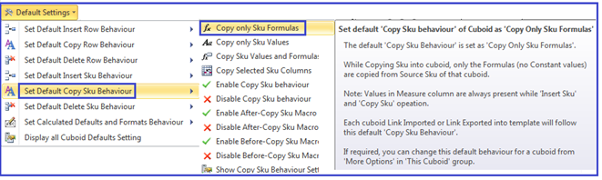

To update the setting for Cuboid**,** go to Universal Template > Configure Sheet > Advanced > ‘Edit Row Behaviour’ or ‘Edit Measure Behaviour’ > ‘Copy Row Behavior’ or ‘Copy Measure Behaviour’ > ‘Enable Copy Row Behaviour’ or ‘Enable Copy SKU Behaviour’.

Go to Universal Template > Configure Sheet > Advanced > ‘Edit Row Behaviour’ or ‘Edit Measure Behaviour’ > ‘Copy Row Behavior’ or ‘Copy Measure Behaviour’🡪 ‘Copy Only Formulas’ or ‘Copy Only SKU Formulas’.

Use Boardwalk Right Click Menu ‘Boardwalk **>** Copy Row/Measure’ option to confirm successful application of settings.

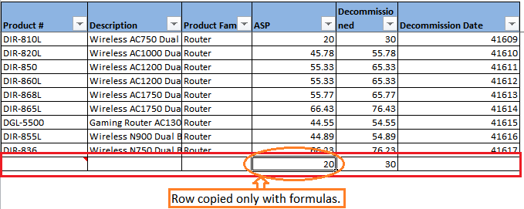

*Note: Same steps can be followed for Measure copy operation by selecting Measure path.*

#### Copy Only Values or Measure Values

Only Values from the row are copied from the source to copied row.

To apply in general to all cuboids by default, go to Universal Template > Boardwalk Workbook Actions > Default Settings > ‘Set Default Copy Row Behaviour’ or ‘Set Default Copy Measure Behaviour’🡪 ‘Copy Only Values’ or ‘Copy Only SKU Values’.

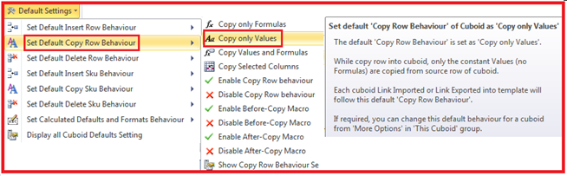

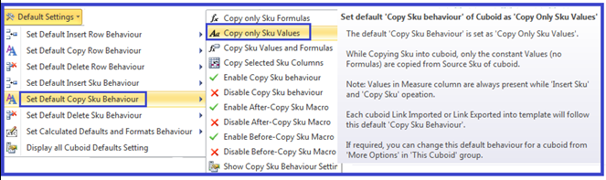

To update the setting for Cuboid**,** go to Universal Template > Configure Sheet > Advanced > ‘Edit Row Behaviour’ or ‘Edit Measure Behaviour’ > ‘Copy Row Behavior’ or ‘Copy Measure Behaviour’ > ‘Enable Copy Row Behaviour’ or ‘Enable Copy SKU Behaviour’.

Go to Universal Template > Configure Sheet > Advanced > ‘Edit Row Behaviour’ or ‘Edit Measure Behaviour’ > ‘Copy Row Behavior’ or ‘Copy Measure Behaviour’ > ‘Copy only Values’ or ‘Copy Only SKU Values’.

Use Boardwalk Right Click Menu ‘Boardwalk > Copy Row/Measure’ option to confirm successful application of settings.

*Note: Same steps can be followed for Measure copy operation by selecting Measure path.*

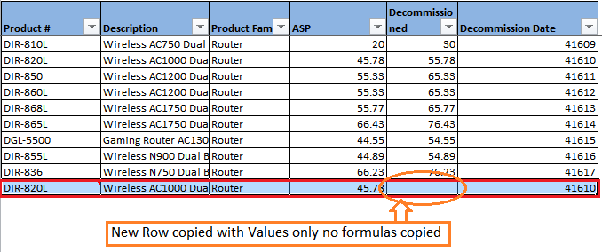

#### Copy Values and Formulas or Measure Values and Formulas

Values and Formulas from the row are copied from the source to copied row.

To apply in general to all cuboids by default go to

Universal Template🡪Boardwalk Workbook Actions🡪Default Settings🡪 ‘Set Default Copy Row Behaviour’ or ‘Set Default Copy SKU Behaviour’🡪 ‘Copy Values and Formulas’ or ‘Copy SKU Values and Formulas’.

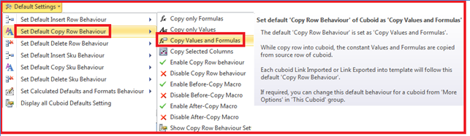

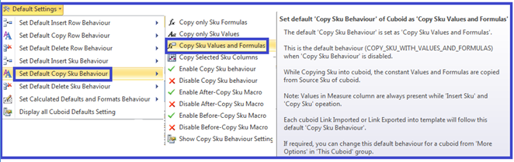

To update the setting for Cuboid, go to Universal Template > Configure Sheet > Advanced > ‘Edit Row Behaviour’ or ‘Edit Measure Behaviour’ > ‘Copy Row Behavior’ or ‘Copy Measure Behaviour’ > ‘Enable Copy Row Behaviour’ or ‘Enable Copy SKU Behaviour’.

Go to Universal Template > Configure Sheet > Advanced > ‘Edit Row Behaviour’ or ‘Edit Measure Behaviour’ > ‘Copy Row Behavior’ or ‘Copy Measure Behaviour’ > ‘Copy Values and Formulas’ or ‘Copy SKU Values and Formulas’.

Use Boardwalk Right Click Menu ‘Boardwalk > Copy Row/Measure’ option to confirm successful application of settings.

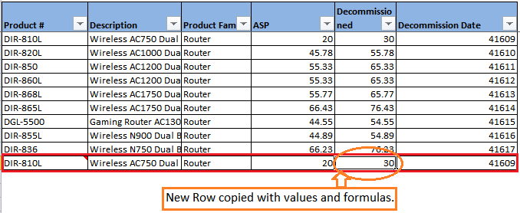

*Note: Same steps can be followed for Measure copy operation by selecting Measure path.*

#### Copy Selected Columns or Measure Columns

Copy values from specific columns can be copied from source row or SKU to the copied row or SKU. The column name from which values need to copy must be selected first.

To apply in general to all cuboids by default, go to Universal Template > Boardwalk Workbook Actions > Default Settings > ‘Set Default Copy Row Behavior’ or ‘Set Default Copy Measure Behavior’🡪 ‘Copy Selected Columns’ or ‘Copy Selected SKU Columns’.

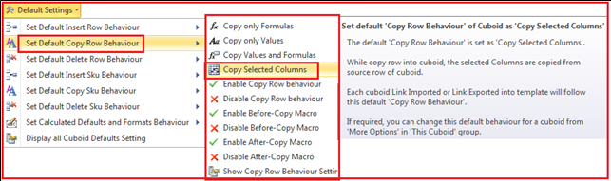

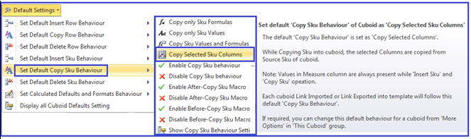

To update the setting for Cuboid, go to Universal Template > Configure Sheet > Advanced >‘Edit Row Behaviour’ or ‘Edit Measure Behaviour’ > ‘Copy Row Behaviour’ or ‘Copy Measure Behaviour’ > ‘Enable Copy Row Behavior’ or ‘Enable Copy SKU Behavior’.

This will enable behavior settings.

To check the copy row or SKU settings go to Universal Template > Configure Sheet > Advanced >‘Edit Row Behaviour’ or ‘Edit Measure Behaviour’ > ‘Copy Row Behaviour’ or ‘Copy Measure Behaviour’ > ‘Show Copy Row Behavior Settings’ or ‘Show Copy SKU Behavior Settings’

Select the column from which values required to copy. Keep the cursor on respective column header and then go to Universal Template > Configure Sheet > Advanced > ‘Edit Row Behaviour’ or ‘Edit Measure Behaviour’ > ‘Copy Row Behaviour’ or ‘Copy Measure Behaviour’ > ‘Set Selected Columns For Copy’ or ‘Set Selected SKU Columns For Copy’.

On selecting column it will give message as

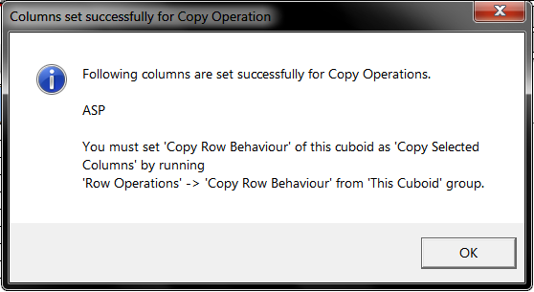

To check the column set for copying go to Universal Template > Configure Sheet > Advanced > ‘Edit Row Behaviour’ or ‘Edit Measure Behaviour’ > ‘Copy Row Behaviour’ or ‘Copy Measure Behaviour’ > ‘Show Selected Columns for Copy’ or ‘Show Selected SKU Columns for Copy’.

Go to Universal Template > Configure Sheet > Advanced > ‘Edit Row Behaviour’ or ‘Edit Measure Behaviour’ > ‘Copy Row Behaviour’ or ‘Copy Measure Behaviour’ > ‘Copy Selected Columns’ or ‘Copy Selected SKU Columns’.

Use Boardwalk Right Click Menu ‘Boardwalk > Copy Row/Measure’ option to confirm successful application of settings.

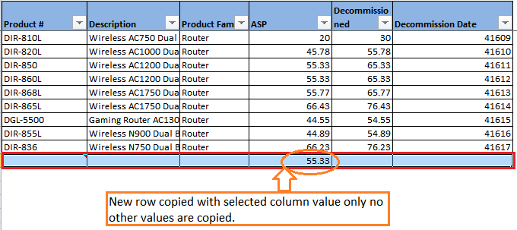

*Note: Same steps can be followed for Measure copy operation by selecting Measure path.*

#### Copy Row or Measure Defaults

Default values can be set for copying Row or Measure using this functionality. The default value needs to be set for specific column which will be copied into the copied Row or Measure.

To set the default value go to Universal Template > Configure Sheet > Advanced > ‘Edit Row Behaviour’ or ‘Edit Measure Behaviour’ > ‘Copy Row Defaults’ or ‘Copy Measure Defaults’🡪 ‘Set Default Copy Values’ or ‘Set Default Copy SKU Values’.

This will pop up the box for setting the default value as

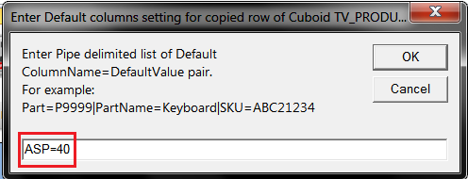

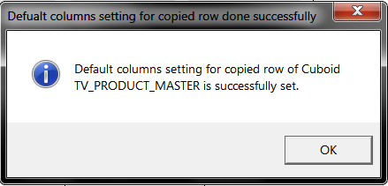

To Check the set value go to Universal Template > Configure Sheet > Advanced > ‘Edit Row Behaviour’ or ‘Edit Measure Behaviour’ > ‘Copy Row Defaults’ or ‘Copy Measure Defaults’🡪 ‘Show Default Copy Values’ or ‘Show Default Copy SKU Values’.

To enable the copy default settings go to Universal Template > Configure Sheet > Advanced > ‘Edit Row Behaviour’ or ‘Edit Measure Behaviour’ > ‘Copy Row Defaults’ or ‘Copy Measure Defaults’ > ‘Enable Copy Row Defaults’ or ‘Enable Copy SKU Defaults’.

This will give message as

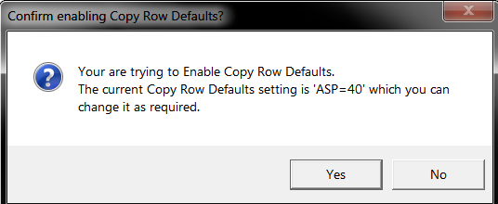

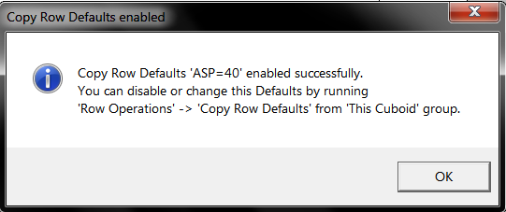

To Check the status of this setting go to Universal Template > Configure Sheet > Advanced > ‘Edit Row Behaviour’ or ‘Edit Measure Behaviour’ > ‘Copy Row Defaults’ or ‘Copy Measure Defaults’🡪 ‘Show Copy Row Default Status’ or ‘Show Copy SKU Default Status’.

To Disable this setting go to Universal Template > Configure Sheet > Advanced > ‘Edit Row Behaviour’ or ‘Edit Measure Behaviour’ > ‘Copy Row Defaults’ or ‘Copy Measure Defaults’🡪 ‘Disable Copy Row Defaults’ or ‘Disable Copy SKU Defaults’

Use Boardwalk Right Click Menu ‘Boardwalk > Copy Row/Measure’ option to confirm successful application of settings.

*Note: Same steps can be followed for Measure copy operation by selecting Measure path.*

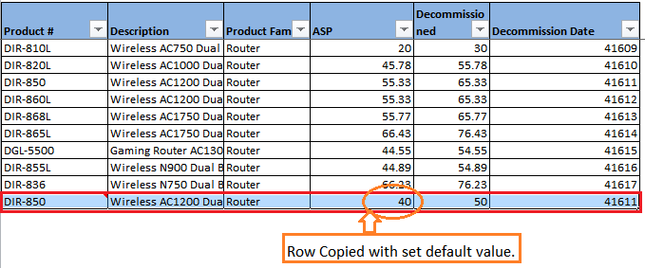

#### Copy Row or Measure Format

New format can be applied to the copied row with this functionality. The format can be different than the existing Rows or Measures.

To enable the format settings go to Universal Template > Configure Sheet > Advanced > ‘Edit Row Behaviour’ or ‘Edit Measure Behaviour’ > ‘Copy Row Format’ or ‘Copy Measure Format’🡪 ‘Enable Copy Row Format’ or ‘Enable Copy SKU Format’.

This will give message as

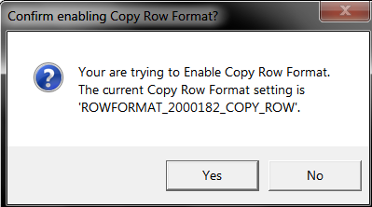

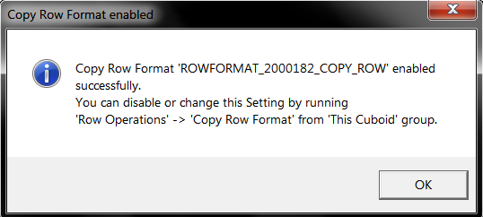

To Check the status of this setting go to Universal Template > Configure Sheet > Advanced > ‘Edit Row Behaviour’ or ‘Edit Measure Behaviour’ > ‘Copy Row Format’ or ‘Copy Measure Format’ > ‘Show Copy Row Format Setting’ or ‘Show Copy SKU Format Setting’.

To Disable the format settings go to Universal Template > Configure Sheet > Advanced > ‘Edit Row Behaviour’ or ‘Edit Measure Behaviour’ > ‘Copy Row Format’ or ‘Copy Measure Format’ > ‘Disable Copy Row Format’ or ‘Disable Copy SKU Format’.

To open the format and make changes as per requirement in the format go to Universal Template > Configure Sheet > Advanced > ‘Edit Row Behaviour’ or ‘Edit Measure Behaviour’ > ‘Copy Row Format’ or ‘Copy Measure Format’🡪 ‘Open Copy Row Format’ or ‘Open Copy SKU Format’.

This will open worksheet with available format. Make the necessary changes in the format which will be applicable to the copied row.

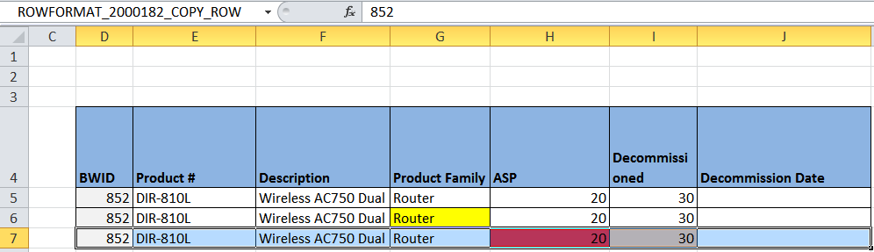

Step 1 and Step 2 are shown below.

Use Boardwalk Right Click Menu ‘Boardwalk > Copy Row/Measure’ option to confirm successful application of settings.

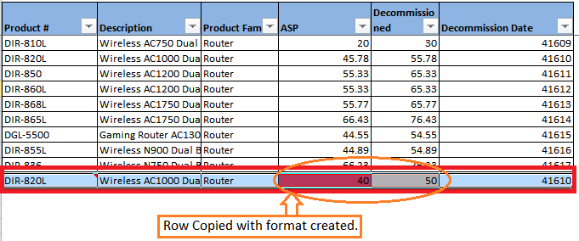

#### Before/After Copy Macro or Measure Macros

Custom code can be executed using macros named as ‘BeforeCopyRowCustomMacro’ or ‘AfterCopyRowCustomMacro’ which are executed before Copy Row/Measure or after copy Row/Measure process.

In general this setting can be set with Universal Template > Boardwalk Workbook Actions > Default Settings > ‘Set Default Copy Row Behavior’ or ‘Set Default Copy Measure Behavior’ > ‘Enable Before-Copy Macro’ or ‘Enable Before-Copy SKU Macro’.

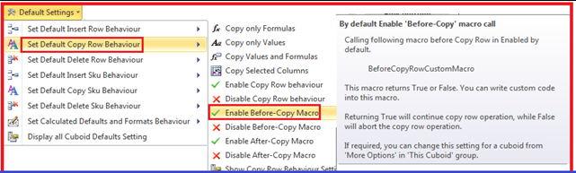

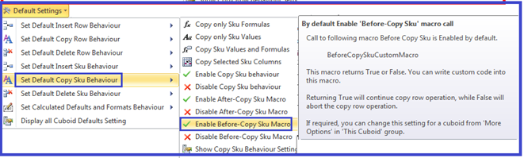

To enable before/after copy macro functionality go to Universal Template > Configure Sheet > Advanced > ‘Edit Row Behaviour’ or ‘Edit Measure Behaviour’ > ‘Before Copy Macros’ or ‘Before Copy Measure Macros’🡪 ‘Enable Before-Copy Macro’ or ‘Enable Before-Copy SKU Macro’.

This will pop-up message

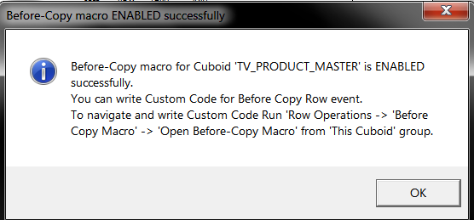

To disable before/after copy macro functionality go to Universal Template > Configure Sheet > Advanced > ‘Edit Row Behaviour’ or ‘Edit Measure Behaviour’ > ‘Before Copy Macros’ or ‘Before Copy Measure Macros’🡪 ‘Disable Before-Copy Macro’ or ‘Disable Before-Copy SKU Macro’.

To Check the status of before/after copy macro functionality go to Universal Template > Configure Sheet > Advanced > ‘Edit Row Behaviour’ or ‘Edit Measure Behaviour’ > ‘Before Copy Macros’ or ‘Before Copy Measure Macros’🡪 ‘Show Before-Copy Macro Status’ or ‘Show Before-Copy SKU Macro Status’.

Open the macro with Universal Template > Configure Sheet > Advanced > ‘Edit Row Behaviour’ or ‘Edit Measure Behaviour’ > ‘Before Copy Macros’ or ‘Before Copy Measure Macros’🡪 ‘Open Before-Copy Macro’ or ‘Open Before-Copy SKU Macro’.

This will open the macro ‘BeforeCopyRowCustomMacro’ or ‘AfterCopyRowCustomMacro’.

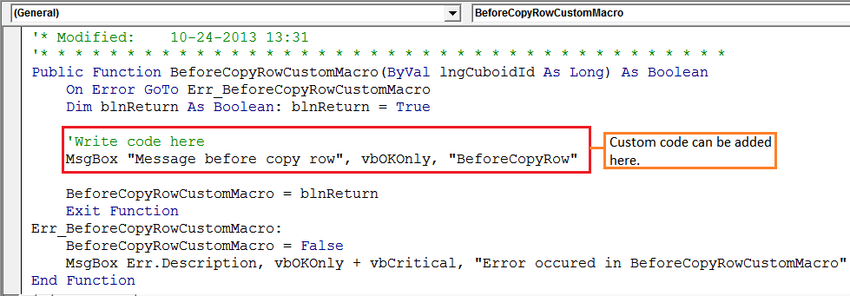

Use Boardwalk Right Click Menu ‘Boardwalk > Copy Row/Measure’ option to confirm successful application of settings.

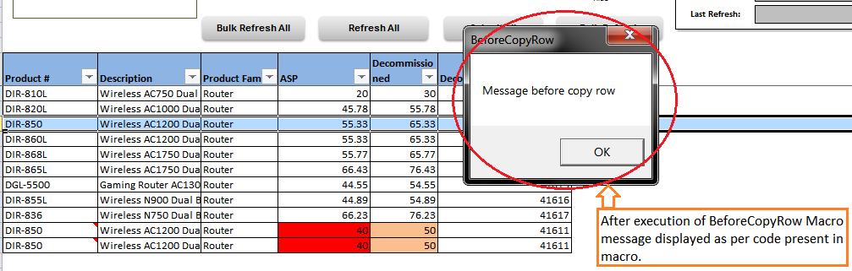

*Note: To execute macro after copy Row or Measure follow the same steps with option as ‘After Copy Macro’ or ‘After Copy Measure Macro’.*

#### Delete Row or Measure Behaviour

Delete row will enable us to execute any macro before or after deleting row.

In general to enable delete row functionality Universal Template> Boardwalk Workbook Actions > Default Settings > ‘Set Default Delete Row Behaviour’ or ‘Set Default Delete Measure Behaviour’🡪 ‘Enable Before-Delete Macro’ or ‘Enable Before-Delete SKU Macro’.

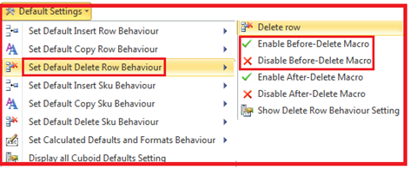

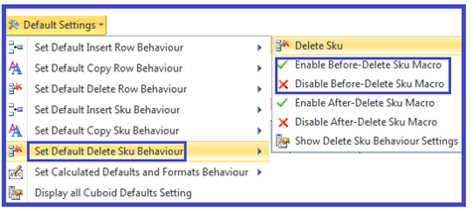

To enable before/after Delete macro functionality go to Universal Template > Configure Sheet > Advanced > ‘Edit Row Behaviour’ or ‘Edit Measure Behaviour’ > ‘Before Delete Macros’ or ‘Before Delete Measure Macros’ > ‘Enable Before-Delete Macro’ or ‘Enable Before-Delete SKU Macro’.

This will pop up message

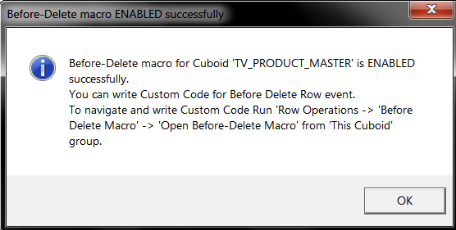

To disable before/after delete macro functionality go to Universal Template > Configure Sheet > Advanced > ‘Edit Row Behaviour’ or ‘Edit Measure Behaviour’ > ‘Before Delete Macros’ or ‘Before Delete Measure Macros’🡪 ‘Disable Before-Delete Macro’ or ‘Disable Before-Delete SKU Macro’.

To Check the status of before/after delete macro functionality go to Universal Template > Configure Sheet > Advanced > ‘Edit Row Behaviour’ or ‘Edit Measure Behaviour’ > ‘Before Delete Macros’ or ‘Before Delete Measure Macros’🡪 ‘Show Before-Delete Macro Status’ or ‘Show Before-Delete SKU Macro Status’.

Open the macro with Universal Template > Configure Sheet > Advanced > ‘Edit Row Behaviour’ or ‘Edit Measure Behaviour’ > ‘Before Delete Macros’ or ‘Before Delete Measure Macros’🡪 ‘Open Before-Delete Macro’ or ‘Open Before-Delete SKU Macro’

This will open the macro

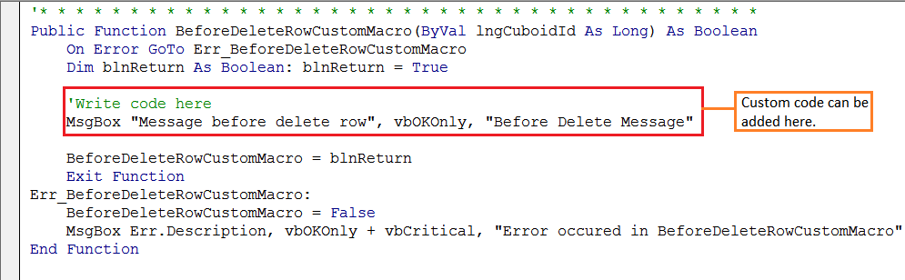

This will open the macro ‘BeforeDeleteRowCustomMacro’.

Use Boardwalk Right Click Menu ‘Boardwalk > Copy Row/Measure’ option to confirm successful application of settings.

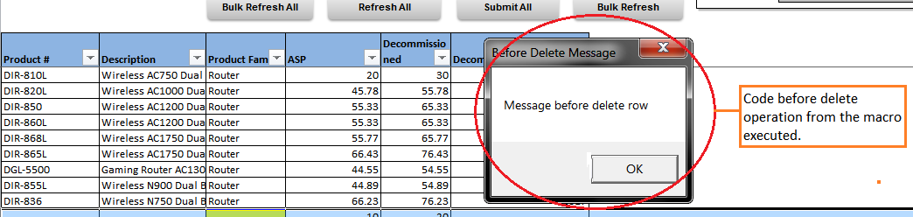

*Note: To execute macro after delete Row or Measure follow the same steps with option as ‘After Delete Macro’ or ‘After Delete Measure Macro’.*

#### Verifying and Setting Default Settings

Default settings can be verified using Universal Template > Boardwalk Workbook Actions > Default Settings > Display Defaults Setting Dialog.

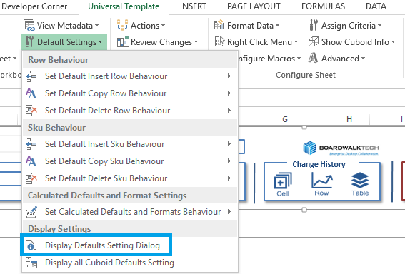

#### **General Settings**

**General Settings:**

Settings related to server URL, User last login name, user ID etc. can be verified and set.

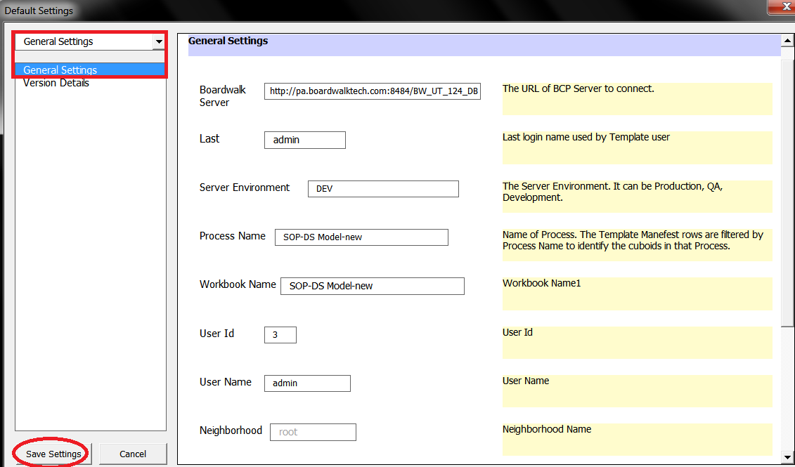

**Version Settings:**

These settings can be checked with ‘Version Details’. It shows template version, XLA version and UT template version in it.

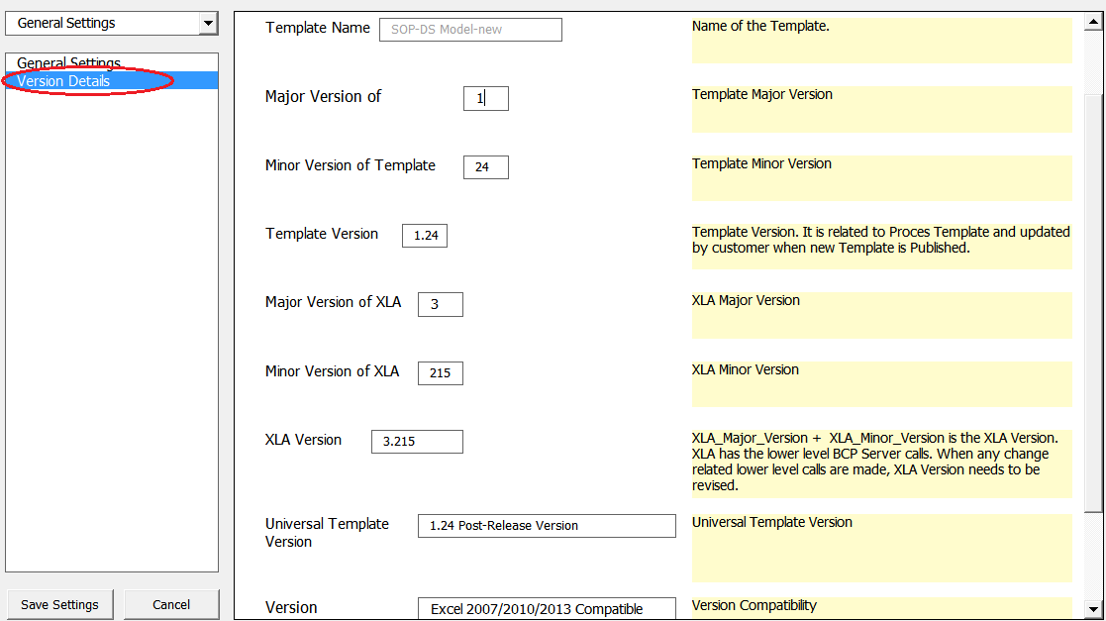

#### **Default Cuboid Settings**

It shows Cuboid related settings. It allows user to work with following settings

* Insert SKU Behavior
* Copy SKU Behavior
* Delete SKU Behavior
* Insert Row Behavior
* Copy Row Behavior
* Delete Row Behavior
* Calculated Defaults
* Formatting Cuboid

To set the properties Check boxes need to be checked and select proper behavior with appropriate type i.e. for SKU or ROW.

**Insert ROW Behavior or Insert SKU Behavior:**

Properties of behavior i.e. SKU or Row can be set also enabling after insert SKU macro or before Insert SKU macro can be done.

As shown in image specific Insert SKU behavior can be selected from drop down list. The same thing is present for Insert Row behavior and properties can be set for the same by selecting ‘Insert Row Behavior’.

After setting the properties save the settings using ‘Save Settings’ and to discard changes ‘Cancel’.

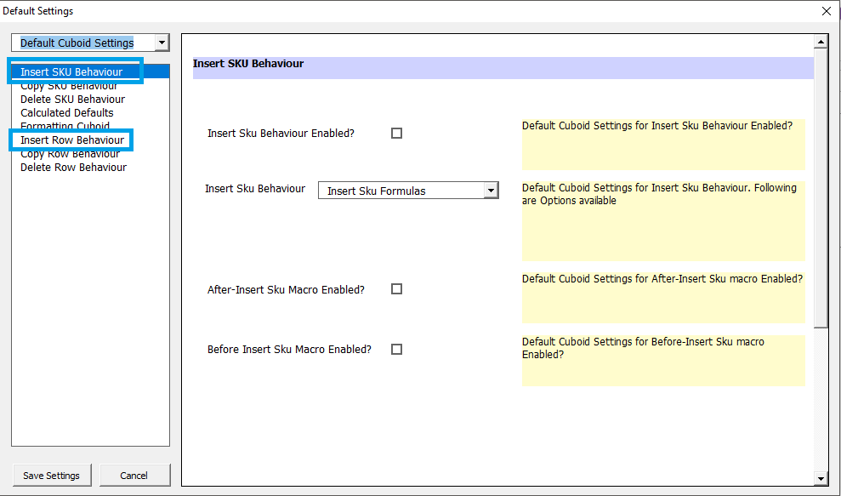

**Copy Row Behavior or Copy SKU Behavior:**

To set the Copy SKU or Row behavior these options are selected.

Using this proper SKU or ROW behavior along with specific option can be set i.e. SKU with formulas or Row with default values etc.

To set row behavior select ‘Copy Row Behavior’ option from the list. After setting the properties save the settings using ‘Save Settings’ and to discard changes ‘Cancel’.

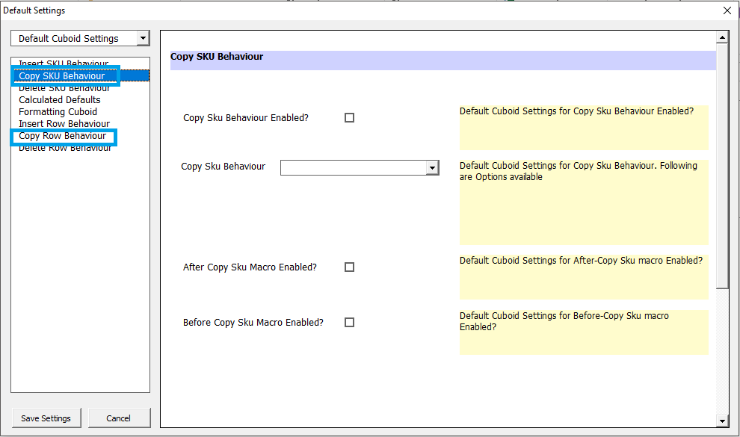

**Delete Row Behavior or Delete SKU Behavior:**

This will be useful to set properties for enabling before or after SKU delete macro. Checking the check box will set particular property.

To set macro enables for before or after Row macro executions select ‘Delete Row Behavior’.

After setting the properties save the settings using ‘Save Settings’ and to discard changes ‘Cancel’.

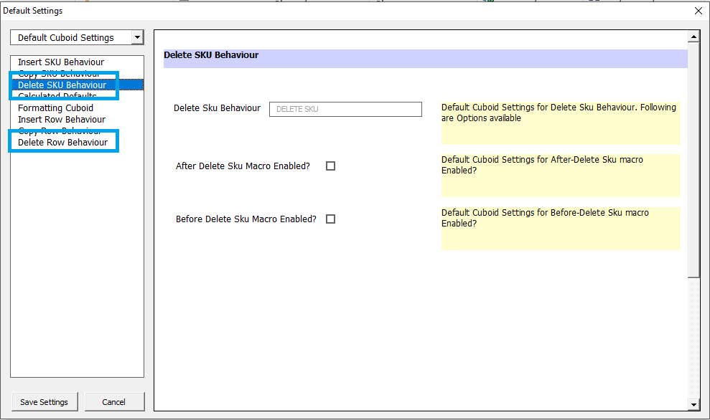

**Calculated Defaults:**

Insert or Copy SKU or Row calculated defaults are set using this.

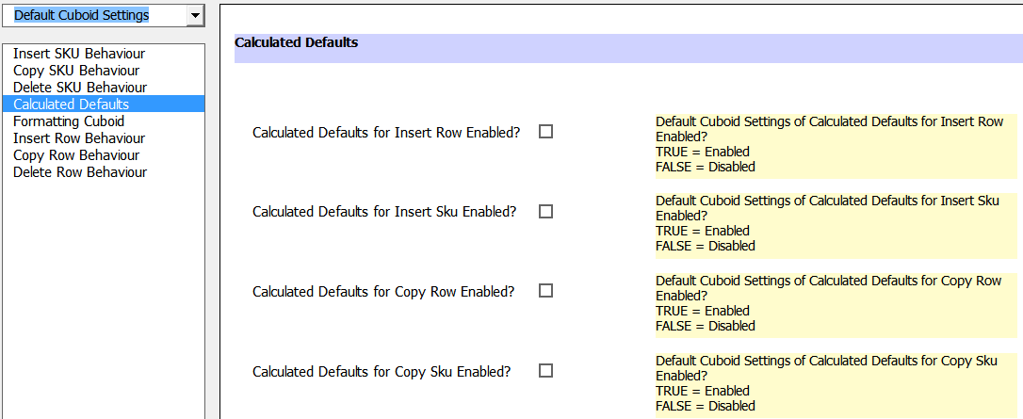

**Formatting Cuboid:**

Formatting for Inserting, Copying SKU or Row is set using this.

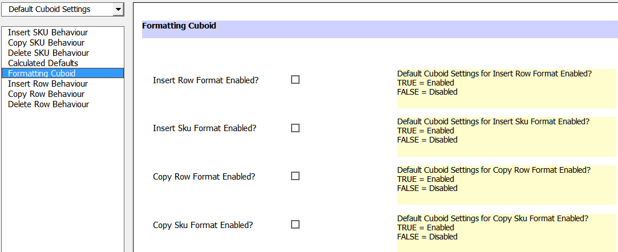

#### **Auto-Save Behaviour**

Settings related to Template Saving can be set from here using GUI.

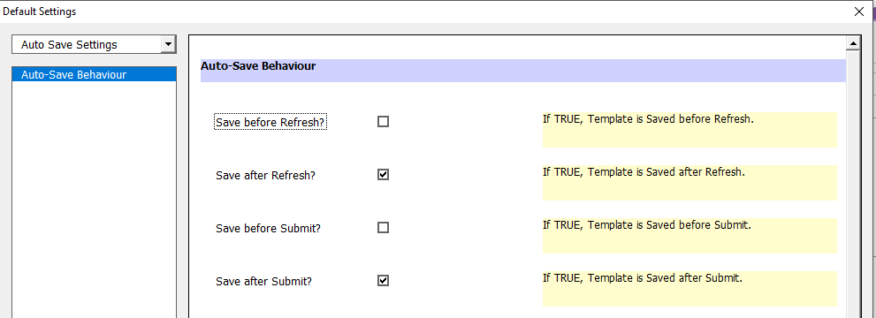

#### Import-Export Metadata Settings

Settings related to Import-Export Metadata can be set from here using GUI.

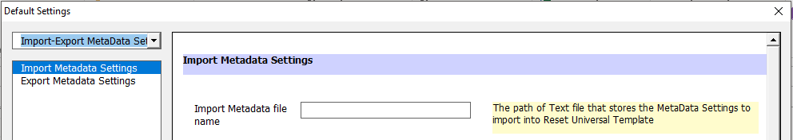

#### Template Settings

High level Template Settings can be set from here using GUI.

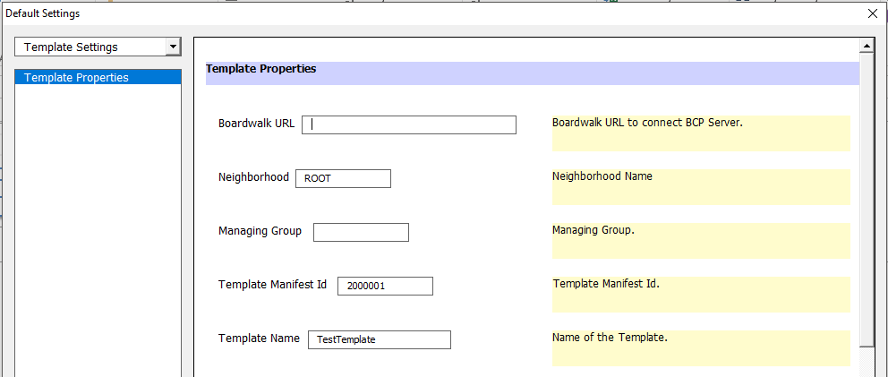

#### Macro Settings

All the Macro Settings can be set from here using GUI.

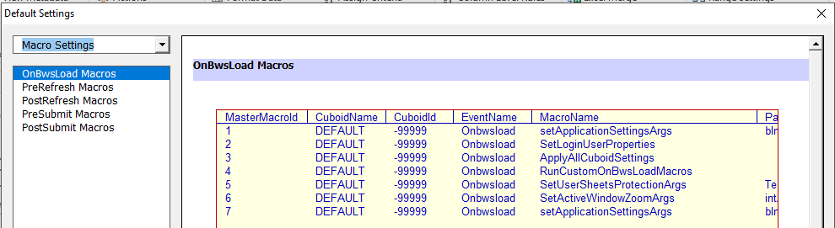

* 1. **Addition of Column**

This section explains how to add a column in the Cuboid. Column can be added at the

* Beginning
* End
* Cursor position

To add a new column, navigate to the Cuboid in which you need add a new column.

Go to Universal Template > Configure Sheet > Advanced > Add New Column > At Cursor/At Beginning/At End.

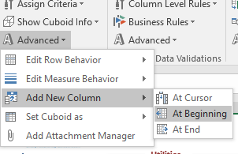

Enter new column name and then click on ‘OK’.

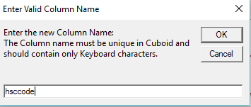

Confirm the addition of column by clicking on ‘Yes’

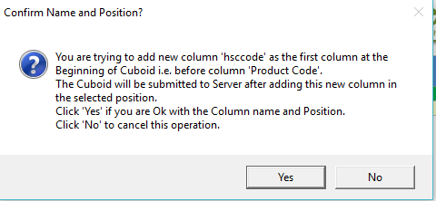

The new column will be added at the selected position.

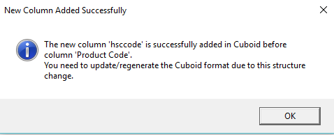

* 1. **Dependent Refresh**

This functionality allows us to configure the Refresh functionality of a Cuboid to refresh dependent Cuboids in a sequential order.

*Note: If there are no changes to any of the listed Cuboids, those Cuboids will be skipped.*

To configure, go to Universal Template > Configure Sheet > Advanced > Set Dependent Cuboids > Set for Refresh.

The below pop-up screen will be opened with all the available Cuboids to configure.

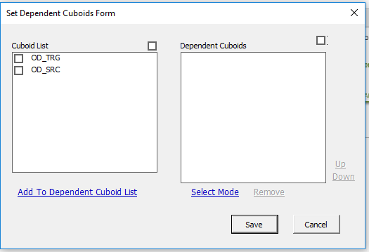

Select required Cuboids from ‘Cuboid List’ and Click on ‘Add To Dependent Cuboid List’. Once done, the selected Cuboids will be moved to ‘Dependent Cuboids’ as shown below. ‘Select Mode’ can be used to modify the order of the Cuboids.

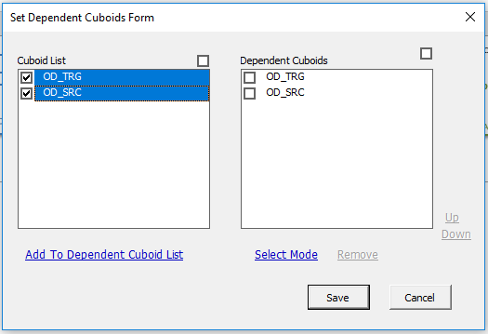

* 1. **Set Cuboid As**

This option is useful to set Cuboid as

* AdHoc
* Default/OnDemand
* Display at Startup
* Add to Submit All/Refresh All/Bulk Refresh All
* Remove from Submit All/Refresh All/Bulk Refresh All

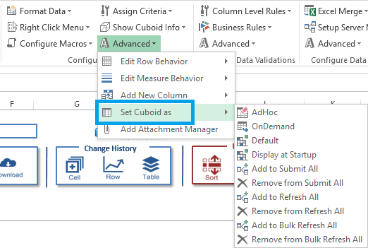

#### Submit All – Adding or Removing Cuboids

Submit All is the functionality used to Submit multiple Cuboids at a time. Once the Cuboid is set for Submit All functionality, it will be added in ‘SubmitAllCuboids’ sheet. All the Cuboids which have the entries in this sheet will be Submitted to the server when user clicks on ‘Submit All’.

To set a Cuboid to the list of Submit All functionality, go to Universal Template > Configure Sheet > Advanced > Set Cuboid As > Add to Submit All.

The Cuboid Sheet which is open will be added to the list of Submit All.

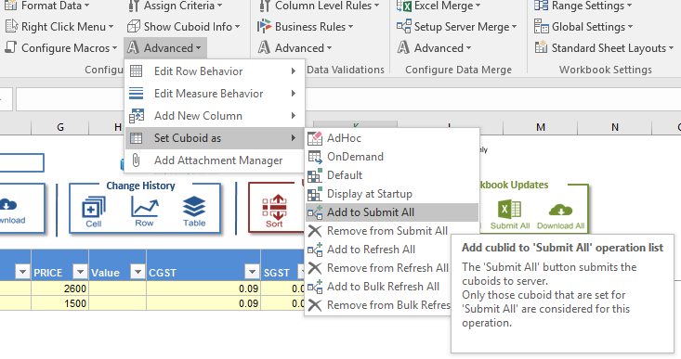

Click on this will give appropriate messages of confirmation and Cuboid settings as below.

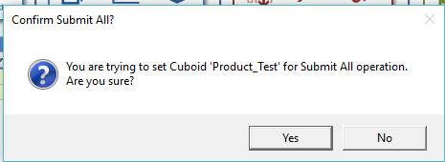

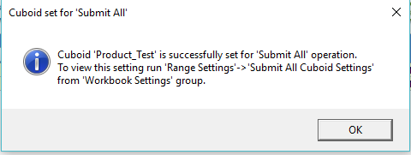

To confirm addition of cuboids in ‘SubmitAllCuboids’ sheet, go to Universal Template > Workbook Setting > Range Settings > Submit All Cuboid Settings.

On Click it will show the list of Cuboids present the ‘SubmitAllCuboids’ sheet as below.

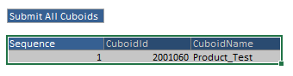

To remove Cuboid from the list of Submit All, go to Universal Template > Configure Sheet > Advanced > Set Cuboid As > Remove from Submit All.

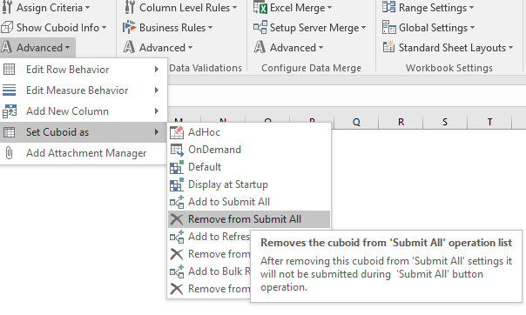

#### Refresh All – Adding or Removing Cuboids

Refresh All is the functionality used to Refresh multiple Cuboids at a time. Once the Cuboid is set for Refresh All functionality, it will be added in ‘RefreshAllCuboids’ sheet. All the Cuboids which have the entries in this sheet will be Refreshed from the server when user clicks on ‘Refresh All’.

To set a Cuboid to the list of Refresh All functionality, go to Universal Template > Configure Sheet > Advanced > Set Cuboid As > Add to Refresh All.

The Cuboid Sheet which is open will be added to the list of Refresh All.

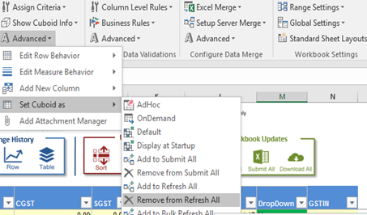

Click on this will give appropriate messages of confirmation and Cuboid settings as below.

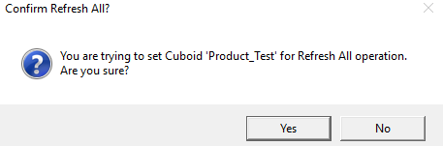

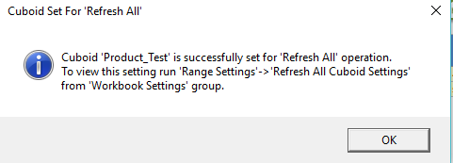

To confirm addition of Cuboids in ‘RefreshAllCuboids’ sheet, go to Universal Template > Workbook Setting > Range Settings > Refresh All Cuboid Settings.

On Click it will show the list of Cuboids present the ‘RefreshAllCuboids’ sheet as below.

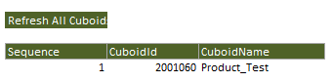

To remove Cuboid from the list of Refresh All, go to Universal Template > Configure Sheet > Advanced > Set Cuboid As > Remove from Refresh All.

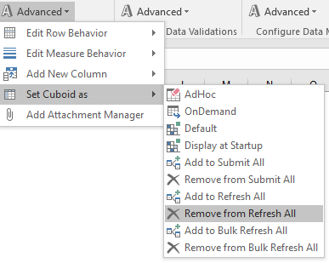

#### Bulk Refresh All – Adding or Removing Cuboids

Bulk Refresh All is the functionality used to Bulk Refresh multiple Cuboids at a time. Once the Cuboid is set for Bulk Refresh All functionality, it will be added in ‘BulkRefreshAllCuboids’ sheet. All the Cuboids which have the entries in this sheet will be Bulk Refreshed from the server when user clicks on ‘Bulk Refresh All’.

To set a Cuboid to the list of Refresh All functionality, go to Universal Template > Configure Sheet > Advanced > Set Cuboid As > Add to Bulk Refresh All.

The Cuboid Sheet which is open will be added to the list of Bulk Refresh All.

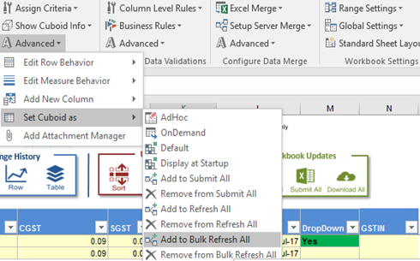

Click on this will give appropriate messages of confirmation and Cuboid settings as below.

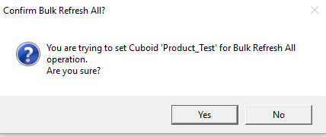

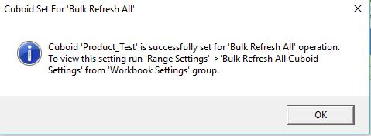

To confirm addition of Cuboids in ‘BulkRefreshAllCuboids’ sheet, go to Universal Template > Workbook Setting > Range Settings > Bulk Refresh All Cuboid Settings.

On Click it will show the list of Cuboids present the ‘BulkRefreshAllCuboids’ sheet as below.

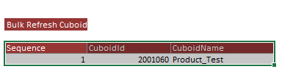

To remove Cuboid from the list of Bulk Refresh All, go to Universal Template > Configure Sheet > Advanced > Set Cuboid As > Remove from Bulk Refresh All.

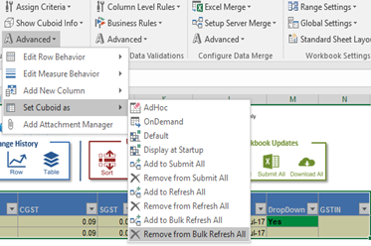

* 1. **Attachment Settings**

Attachment Manager is the useful and efficient functionality for attaching any type of document.

Type of files that can be allowed to attached are listed below

* Images (.jpg or .jpeg or .png or .bmp or .gif)
* Documents
* Portable Document Format(.pdf)
* Microsoft Word (.doc or .docx)
* Microsoft Power (ppt,.pptx,.pps,.ppsx)
* Text Document(.txt)
* Rich Text Format (.rtf)
* Microsoft Excel (.xls or .xlsx)
* Winzip (.zip)
* Video Files
* HTML Files (.htm or .html)

It is used for specific Source Cuboid i.e. each Source Cuboid is having its own Attachment Cuboid.

* **Source Cuboid**: This term is used for the Boardwalk Cuboid from which the Attachment Management Form is called for attaching the files.
* **Attachment Cuboid:** Boardwalk Cuboid which keeps the track of attachments details like name given to attachment, type of attachment, size of attachment, uploaded by and date of upload.

Primary Key columns of Source Cuboid can be added into the Attachment Cuboid for attachment references. For e.g. In Attachment cuboid for specific primary key column, it will show number of attachments linked to respective primary key.

Let us see how to start with this functionality. Attachment Manager Cuboid should be present in database.

The ‘Attachment Manager’ functionality works on two major parts as

* Creating Attachment Manager Cuboid
* Setting Attachment Rule

To Open Attachment Settings Form, go to Universal Template **>** Configure Sheet > Advanced > Add Attachment Manager.

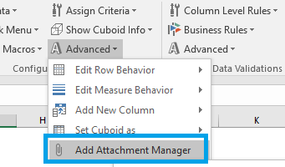

Clicking on this will add rule in worksheet ‘Attachment_Rules’ and give message as below.

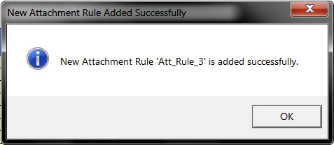

Click on ‘Ok’ will pop up with Instruction message as

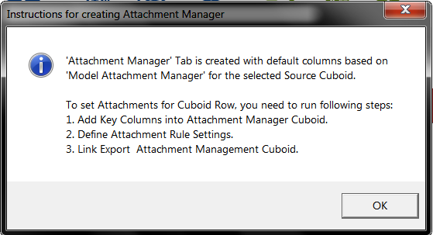

Then it opens ‘Attachment Setting Form’.

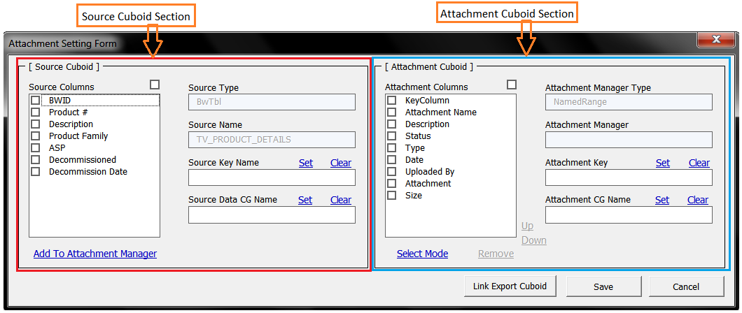

The attachment form is used to add Primary Key columns of Cuboid into Attachment Cuboid which are used as reference for attachments.

On ‘Save’ button click it generates attachment rule and populate below details related to attachment rule in worksheet ‘Attachment_Rules’ with excel range named as “Attachment_Rules”.

Once it is saved, Link Export the Attachment Cuboid on server using **‘Link Export Cuboid’** button.

*Note: Files present on ftp server cannot be attached directly from ftp server. Document from ftp server need to be downloaded on local machine then it can be attached using attachment manager.*

Below are the descriptions of the columns of the ‘Attachment_Rules’ range.

|  |  |  |
| --- | --- | --- |
| **Columns in Worksheet ‘Attachment_Rules’** | **Attachment Form Fields** | **Description** |
| AttRuleId | -- | Number assigned for attachment rule (System Generated) |
| AttRuleName | -- | Name assigned to Attachment Rule (System Generated) |
| Source_Cuboid_Name | Source Name | Name of the Source Cuboid is Auto-Populated. |
| Source_Cuboid_Id | -- | Cuboid Id of Source Cuboid is Auto-Populated. |
| Attachment Cuboid Name | -- | Name given to attachment cuboid while link exporting cuboid |
| Attachment_Cuboid_Id | -- | Cuboid Id of attachment cuboid is auto-populated |
| Source_Primary_Key_Column | Source Key Name | Primary Key columns from Source Cuboid section selected by user |
| AttMgr_Primary_Key_Column | Attachment Key | Primary key columns in Attachment Cuboid section selected by user |
| Source_Column_For_Copy | Source Data CG Name | These are required non primary key columns of source cuboid |
| AttMgr_Column_For_Copy | Attachment CG Name | These are required non primary key columns of source cuboid added into attachment cuboid |

#### Attachment Form Settings

The sections of the attachment form are

* Source Cuboid
* Attachment Cuboid
* Buttons Section



**Source Cuboid Section:**

This section refers to the Source cuboid. Source Cuboid is the cuboid for which the attachments are attached. It has

* Source Columns: It is the list box containing the list of columns of Source Cuboid. Each column is associated with check box for selection.
* Source Type: It indicates the type of Source Cuboid. It can be either ‘BwTbl’ for Boardwalk Cuboid or ‘NamedRange’ for MS-Excel Range.
* Source Name: It contains the name of the Source Cuboid.
* Source Key Name: It is text box which contains the name of the primary key columns selected from source column list.
* Label ‘Set’ is used to enter values in textbox after selecting single or multiple columns from Source Columns list.
* Label ‘Clear’ is used to remove column names from Source Key Name text box.
* Source Data CG Name: It is text box which contains required non primary key columns of Source Cuboid
* Label ‘Set’ is used for entering values into text box.
* Label ‘Clear’ is used to remove column names from text box.
* Add to Attachment Manager: It is label used for adding primary key as well as source data CG columns into Attachment columns of Attachment Cuboid section.

**Attachment Cuboid Section:**

This section refers to the Attachment Cuboid. Attachment Cuboid is the Cuboid which contains details related to the attachment made for specific source Cuboid data. It has

* Attachment Columns: It is the list box containing the list of columns present in Attachment Manager Cuboid. Each column is associated with check box for selection.
* Attachment Manger Type: It indicates the type of Attachment Manager Cuboid. It is ‘BwTbl’ for Boardwalk Cuboid.
* Attachment Manager: It contains the name given to the Attachment Manager Cuboid at the time of Link Export Cuboid.
* Attachment Key name: It is text box which contains the name of the primary key columns selected from attachment column list.
  + - Label ‘Set’ is used to enter values in text box after selecting single or multiple columns from Attachment column list.
    - Label ‘Clear’ is used to remove column names from Attachment Key Name text box.
* Attachment CG Name: It is text box which contains required non primary key columns of Source Cuboid added into Attachment Cuboid.
  + - Label ‘Set’ is used for entering values into text box.
    - Label ‘Clear’ is used to remove column names from text box.
* Select Mode: It is used to remove or altering sequence of Attachment Cuboid columns. Click on ‘Select Mode’ activates ‘Remove’ and ‘Up Down’ options.
* Remove: It is used to remove columns other than Attachment Cuboids default columns. Default columns are
* Attachment Name
* Description
* Status
* Type
* Date
* Uploaded By
* Attachment
* Size
* Up Down: It is used to alter the sequence of columns other than Attachment Cuboid columns. Sequence of default Attachment Cuboid columns cannot be altered.

**Buttons Actions:**

* Link Export Cuboid: Clicking on ‘Link Export Cuboid’ will generate Attachment Cuboid on the server. (Please follow all the steps of Link Exporting a Cuboid) after Link Exporting, click on ‘Save’ and then Cancel.
* Save: It is used to generate new Attachment Rule and populate details related to attachment rule in worksheet ‘Attachment_Rules’ with Excel range named as “Attachment_Rules”.
* Cancel: This will close the attachment form without saving any changes made in attachment rule.

#### Setting Attachment Rule using Attachment Settings Form

Check the single or multiple Source Columns from Source Cuboid section which are to be set as Source Key columns and click on ‘Set’.

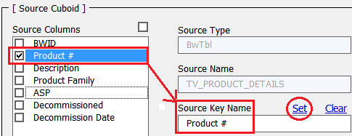

Set the Source Data CG columns also in the same way as above.

‘Add To Attachment Manager’ is used to add columns of Source Cuboid section into Attachment Cuboid section which are used for reference as shown below.

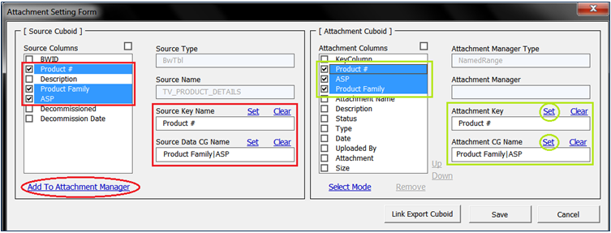

Check the single or multiple Attachment columns from Attachment Cuboid section which are to be set as Attachment Key columns and click on ‘Set’.

Set the Attachment CG Name columns also in the same way as above.

*Note: Number of key columns must be equal. And Source Key Column Names and Attachment Key Column Names should be same.*

‘Select Mode’ Functionality is used for altering sequence or removal of columns other than default Attachment Columns. Initially it is a check box selection. Click on ‘Select Mode’ will change the check box option to radio button and it enables two more options ‘Up Down’ and ‘Remove’ as shown below.

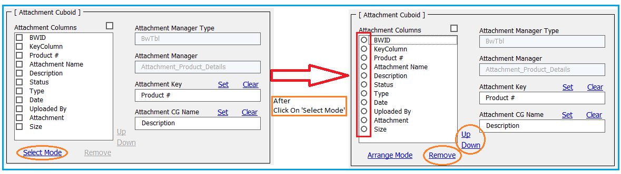

1. Up Down: It is used for re-sequencing columns other than Attachment Cuboid columns which are present in Attachment Column list. 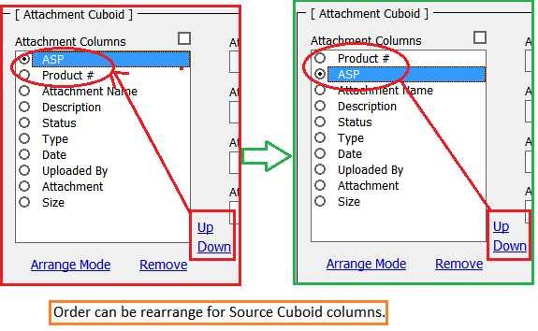
2. Remove: It is used to remove columns other than Attachment default columns present in Attachment Cuboid.

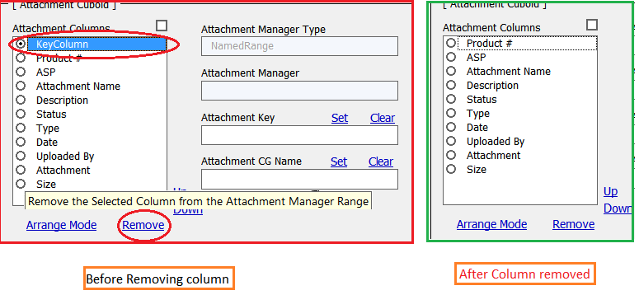

Click On ‘Save’ button on Attachment Settings Form. *(This step generates Attachment Rule)*

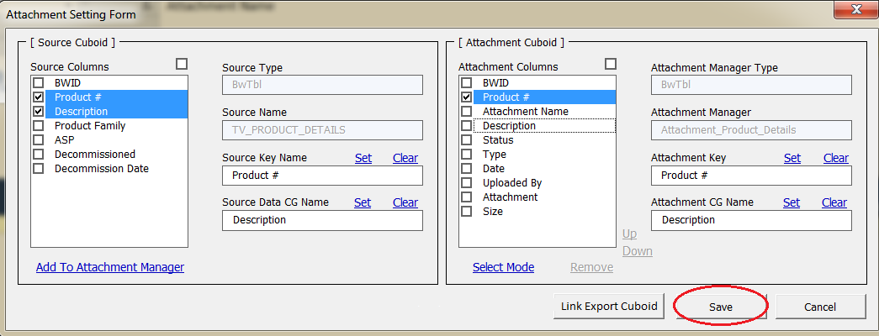

It generates new Attachment rule and populate details related to attachment rule in worksheet ‘Attachment_Rules’ with Excel range named as ‘Attachment_Rules’.

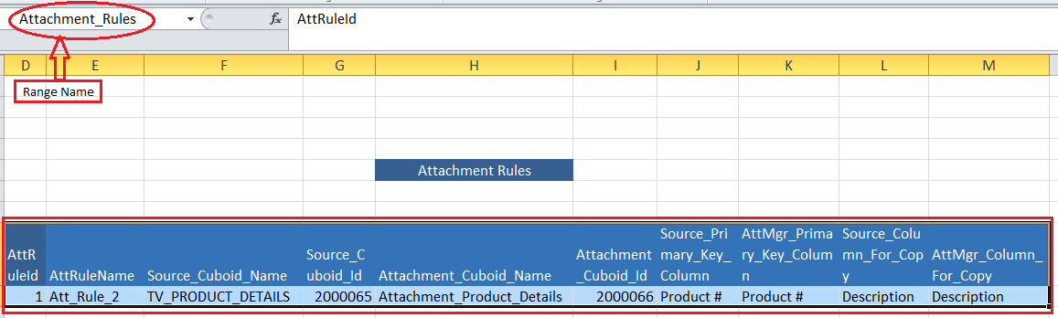

Click on ‘Link export Cuboid’ will create new Attachment Manager Cuboid and metadata for respective Cuboid is generated in the range ‘CUBOID_METADATA’ in worksheet ‘CuboidMetaData’.

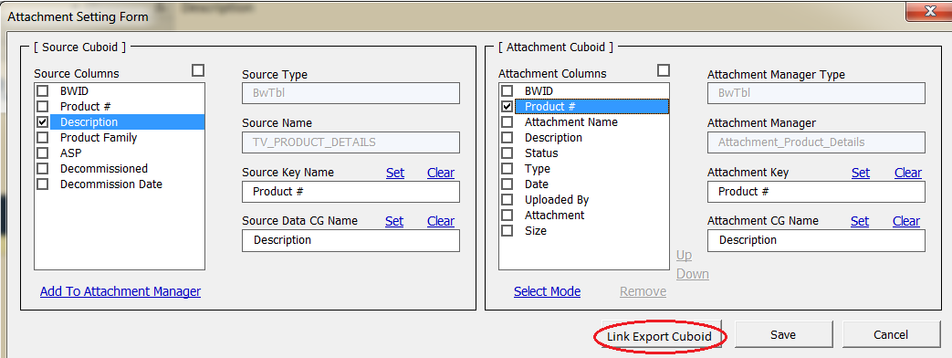

Attachment Cuboid structure without any attachment and after attachment is as below.

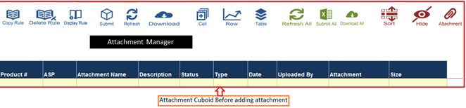

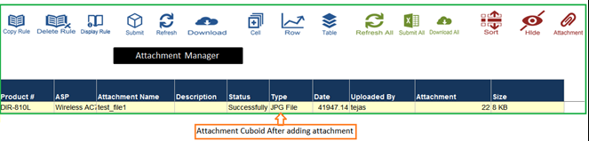

Likewise individual attachments are get added with reference primary key Source Columns and tracking is maintained for attached file in Attachment Manager Cuboid.

#### Buttons to work with Attachment Rule

There are three rule buttons present on worksheet ‘Attachment Manager’.

* Copy Rule
* Display Rule
* Delete Rule

**Copy Rule:** This facilitates to copy already existing attachment rule and creates new rule with the existing rule values and then modifications can be made in new generated rule.

The existing rule definition can be identified from the worksheet ‘Attachment_Rules’ within excel named range “Attachment_Rules” and then can be used for copying using ‘Copy Rule’.

Clicking on ‘Copy Rule’ indicates the list of existing rules related to respective Attachment Cuboid. Select the appropriate existing attachment rule from the list for copying.

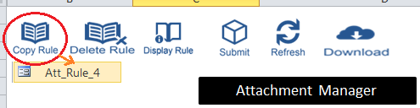

Once the selected Rule name is clicked, a copy of that rule will be created following the confirmation pop-up messages.

**Display Rule:** Display Rule button opens Attachment Management Form after selecting appropriate rule to make modification in the rule.

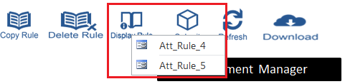

Required changes can be made in Attachment Management Form with respective rule and ‘Save’ the new attachment rule. ‘Submit Cuboid’ will send the changes made in the attachment rule to server and attachment cuboid is updated with changes.

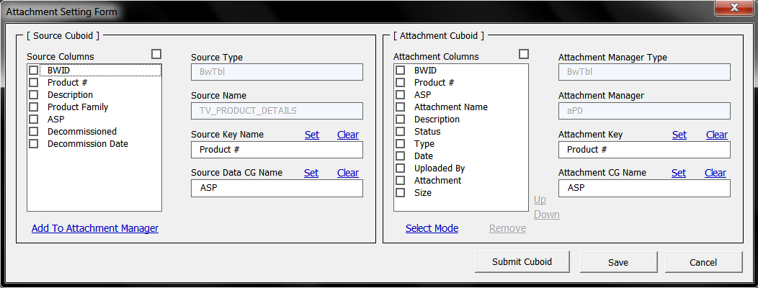

**Delete Rule:** Delete Rule button is used to delete rule from worksheet ‘Attachment_Rules’ from range ‘Attachment_Rules’.

Select appropriate rule for deletion from the rule list.

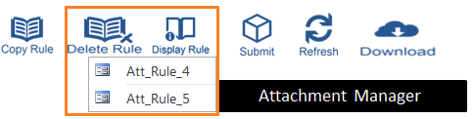

The selected rule will be deleted from the Excel range ‘Attachment_Rules’ of the worksheet ‘Attachment_Rules’. This will delete the rule from worksheet as well as from the range and range is modified accordingly. After deleting attachment rule template must be saved.

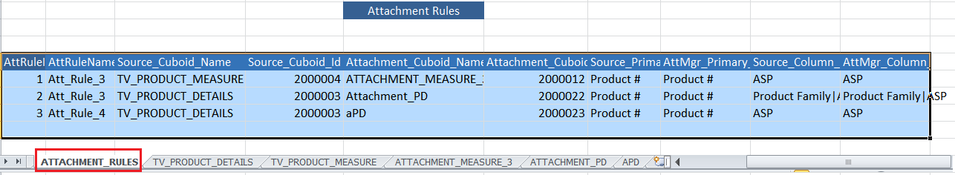

*Note: Attaching any file is explained in USER Mode Functions Section below (please refer Attachment)*

* 1. **Setting Column Level Rules**

Column Level Rules are useful to set

* Pre-Defined Text Columns
* Date Column for History
* Locale Dependent Columns
* Data Validation Rules
* Conditional Format Rules

#### Pre-Defined Text Columns

This functionality helps us to set Text Format on a selected Cuboid column.

To apply the Text Format, select a cell of the column where we need to apply and then go to Universal Template > Configure Data Validation > Column Level Rules > Pre-Defined Text Columns > Set as Pre-Defined Text Format.

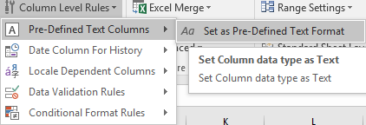

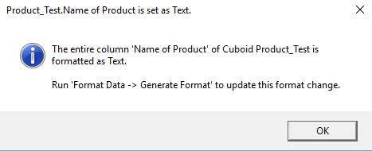

The column will be formatted as Text once OK button is clicked.

All the columns of the selected Cuboid on which the Text format is applied can be viewed by navigating to Universal Template > Configure Data Validation > Column Level Rules > Pre-Defined Text Columns.

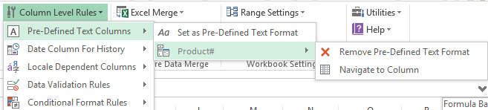

We can either remove the column from the list or navigate to that column in the Cuboid.

*Note: The Text format is not applied on any column if no columns are visible in the list.*

#### Date Column for History

Whenever we select Cell/Row/Table History on a Cuboid, the data will be visible in General Format. If a column is Date formatted in the Cuboid and user wants to check the history of that, user cannot understand the general formatted date in the history sheet. But we can set the History format as Date for selected column.

To set a Column as Date Column for History, go to Universal Template > Configure Data Validation > Column Level Rules > Date Column for History > Set as Date Column for History.

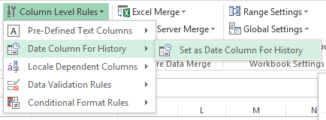

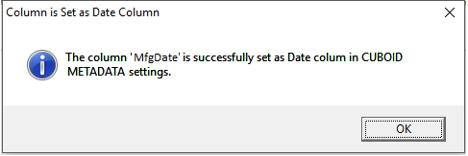

The column will be set as Date Column for History once OK button is clicked.

All the columns of the selected Cuboid on which ‘Date Column for History’ is applied can be viewed by navigating to Universal Template > Configure Data Validation > Column Level Rules > Date Column For History.

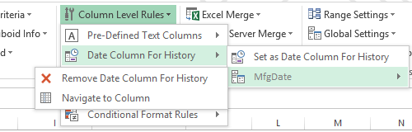

We can either remove the column from the list or navigate to that column in the Cuboid.

*Note: The ‘Date Column for History’ is not applied on any column if no columns are visible in the list.*

#### Locale Dependent Columns

Microsoft excels uses regional date and number format settings known as ‘Locale Settings’. In Boardwalk platform all such regional formats are converted into US English format. So whenever particular column needs to be ‘Locale Dependent’ then this constraint can be applied to the column.

To set a Column as Date Column for History, go to Universal Template > Configure Data Validation > Column Level Rules > Date Column for History > Set as Date Column for History.

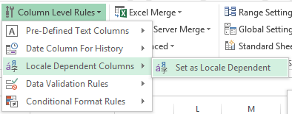

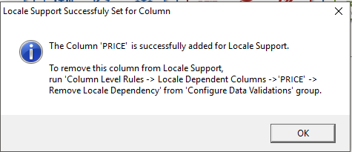

The column will be set as Locale Dependent once OK button is clicked.

All the columns of the selected Cuboid on which ‘Date Column for History’ is applied can be viewed by navigating to Universal Template > Configure Data Validation > Column Level Rules > Locale Dependent Columns.

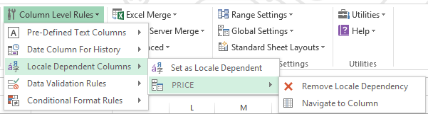

We can either remove the column from the list or navigate to that column in the Cuboid.

*Note: The ‘Locale Dependent’ format is not applied on any column if no columns are visible in the list.*

#### Data Validation Rules

Date Validation is a default feature of Microsoft Excel which will allow the validation rules on a cell. ‘Data Validation Rules’ is the UT functionality which allows us to implement Excel Data Validation on a Boardwalk Cuboid Column.

Let’s apply ‘Date Validation’ on ‘Date’ column below

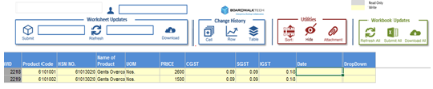

Select that particular cell of the Date column and go to the Data tab of Excel.

Go to Data > Data Tools > Data Validations > Data Validation

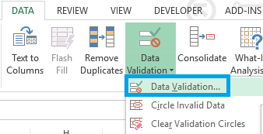

Below screen shows the default settings.

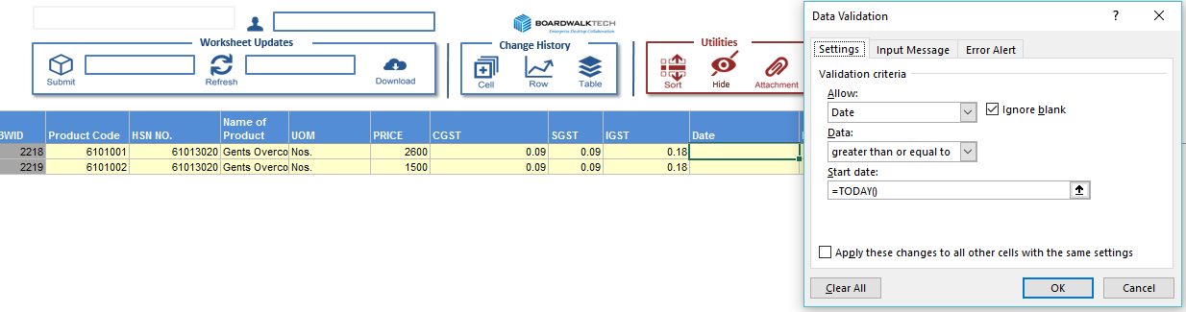

Apply the Date validation as per the requirement. The validation will be applied to the selected cell.

To save the validation rule, go to Universal Template > Configure Data Validations > Column Level Rules > Data Validation Rules > Save Settings.

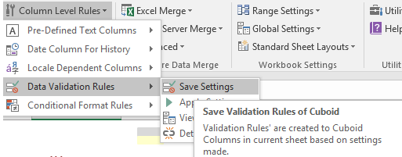

Confirm this action by clicking on ‘Yes’.

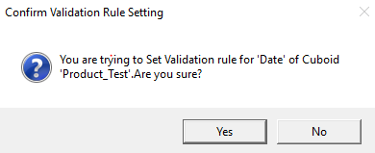

The customized rule is created for the entire ‘Date’ column, however the rule is not applied yet.

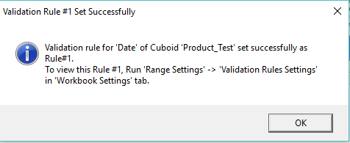

To Apply to the rule, navigate to Universal Template > Configure Data Validations > Column Level Rules > Data Validation Rules > Apply Settings.

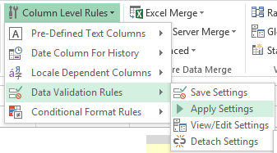

All Data validation Rules are saved in the template and can be viewed by navigating to Universal Template > Configure Data Validations > Column Level Rules > Data Validation Rules > View/Edit Settings.

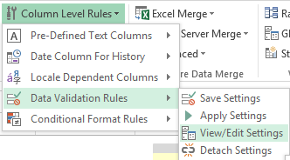

To detach the applied Data Validations, navigate to Universal Template > Configure Data Validations > Column Level Rules > Data Validation Rules > Detach Settings.

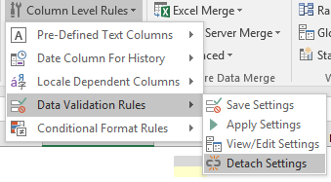

*Note: List Validations can also be applied the same way mentioned above.*

#### Conditional Format Rules

Conditional formatting is the Microsoft Excel functionality which is used to format the required cell for specific condition.

‘Conditional Format Rules’ is the UT functionality which allows us to implement Excel Conditional formatting on a Boardwalk Cuboid Column.

Select a required cell of column where conditional formatting is needed to apply.

Go to Home > Conditional Formatting > New Rule to create new conditional formatting. (If rule exist already use ‘Manage Rules’.)

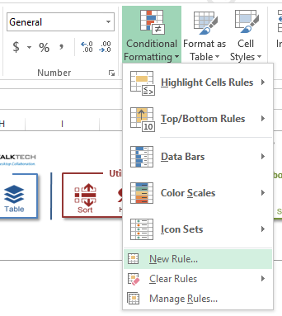

This opens the following window

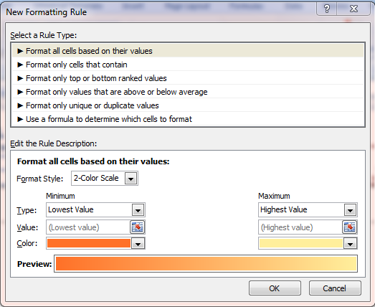

Select appropriate rule type and then set its values proper values for the rule.

Click on ‘OK’ will set the conditional formatting to the selected cell.

Rule definition can be checked by selecting cell on which conditional formatting is applied and clicking on Home > Conditional Formatting > Manage Rules.

This will open rule defined for cell as

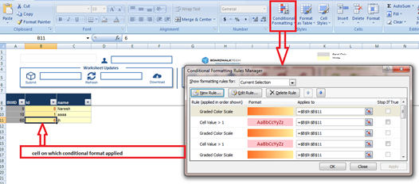

To set this conditional formatting to the entire column, go to Universal template > Configure Data Validation > Conditional Format Rules > Save Settings.

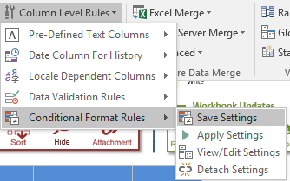

It will confirm the ‘Conditional Formatting Settings’ by displaying message as

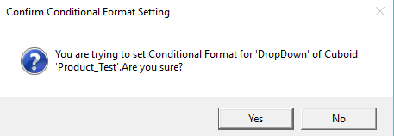

Click on ‘Yes’ to create the new rule.

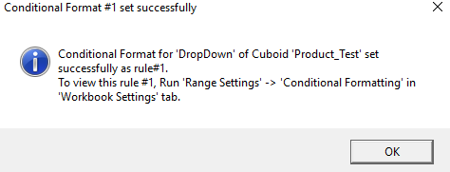

The Rule is created but not yet applied to the Cuboid column. It can be applied using Universal Template > Configure Data Validation > Column Level Rules > Conditional Format Rules > Apply Settings.

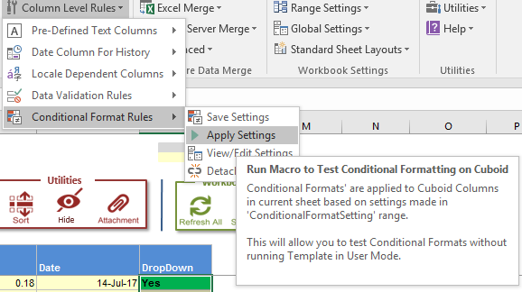

All Conditional Formatting Settings Rules are saved in the template and can be viewed by navigating to Universal Template > Configure Data Validations > Column Level Rules > Conditional Format Rules > View/Edit Settings.

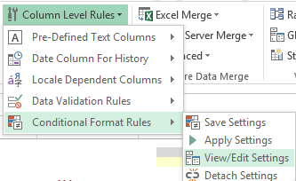

It will navigate to Conditional Formatting Settings Rule in ‘ConditionalFormat’ sheet with excel named range ‘ConditionalFormatSetting’ as shown below.

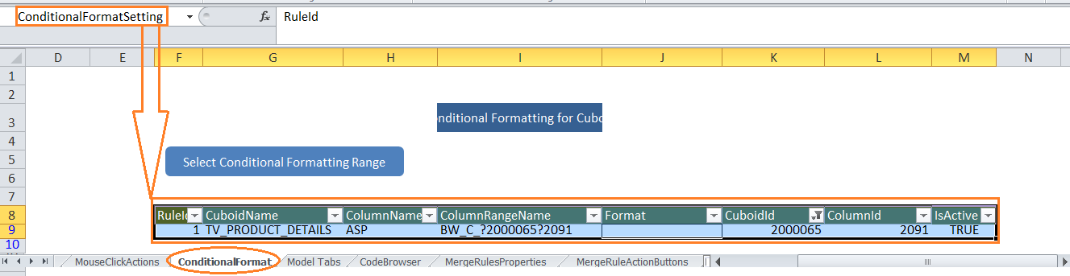

To detach the applied Conditional Formatting, navigate to Universal Template > Configure Data Validations > Column Level Rules > Conditional Format Rules > Detach Settings.

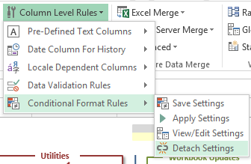

* 1. **Business Rules**

Business Rule are useful to validate data as per business requirements. These rules help user/developer to validate data and then proceed for further process.

This validation process starts before submitting the data to the Boardwalk server. Rule created will examine the data and if everything passes then start with the Submit process otherwise it will highlight the cells not fulfilling the validations. There are different rules we can set to validate data which are applied on the specific columns defined in the rule.

The color for the respective rule is specific to identify the validation failed cells. This color code can be modified in rule settings.

All the Business Rule Types can be viewed under Universal Template > Configure Data Validations > Business Rules as shown below.

There is a range named as “business_validation_rule_master” which contains these rule types. New rule type can be created by adding that details in this range so that it will be available in Business Rules list.

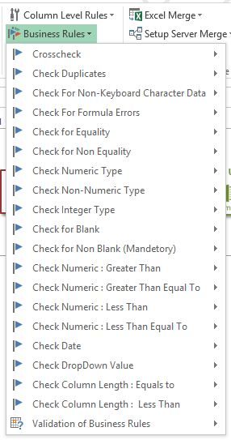

The following table gives details about the rule types.

|  |  |  |
| --- | --- | --- |
| **No** | **Rule Type** | **Rule Description** |
| 1 | Crosscheck | Validate data between columns of two Cuboids. If matched it is valid else it will be invalid |
| 2 | Check Duplicates | Highlights duplicate values present in column |
| 3 | Check For Non-Keyboard Character Data | Validate for Non keyboard characters like ‘- -‘ which is invalid |
| 4 | Check For Formula Errors | Excel Formula Error cells are highlighted |
| 5 | Check For Equality | Validate data with value specified in ‘To_validate_value’ column of rule definition. If equals it is valid or else it is invalid |
| 6 | Check For Non Equality | Data with values not equal to value specified in ‘To_validate_value’ will be valid else it will be invalid |
| 7 | Check For Numeric Type | Validate for Numeric data i.e. Numeric values present in columns are valid and non-numeric data is invalid |
| 8 | Check For Non-Numeric Type | This rule is to check the non-numeric data in the particular column within the Cuboid. If the column having the non-numeric data is valid otherwise the data is invalid |
| 9 | Check Integer Type | Validate for the integer data i.e. integers are valid and remaining are invalid |
| 10 | Check for Blank | Validate for the blank cells data i.e. blank cells are valid data and non-blank cells are invalid |
| 11 | Check for Non Blank (Mandatory) | Validate for the non-blank cells data i.e. non-blank cells are valid data and blank cells are invalid |
| 12 | Check Numeric : Greater Than | Data with values greater than value specified in ‘To_validate_value’ will be valid else it will be invalid |
| 13 | Check Numeric : Greater Than Equal To | Data with values greater than or equal to value specified in ‘To_validate_value’ will be valid else it will be invalid |
| 14 | Check Numeric : Less Than | Validate Data with values less than value specified in ‘To_validate_value’ will be valid else it will be invalid |
| 15 | Check Numeric : Less Than Equal To | Data with values less than or equal to value specified in ‘To_validate_value’ will be valid else it will be invalid |
| 16 | Check Date | Validate for ‘Date type’ data i.e. date values present in columns are valid and remaining are invalid |
| 17 | Check DropDown Value | Validate data with the values defined in certain name ranges. Values not present in the defined named range will be invalid data |
| 18 | Check Column Length : Equals to | After applying this rule to any column in the particular cuboid it will check the length of the column whether it is within the limits or beyond the limits which we mentioned in the rule form |
| 19 | Check Column Length : Less Than | This rule is for checking the length with in the column after applying this rule if column having greater length what we mentioned in the rule form then it will show you the pop up menu |

All these rules types are stored in ‘business_validation_rule_master’ name range in ‘BusinessValidationRules’ sheet. It can be viewed by navigating to Universal Template > Configure Data Validations > Advanced > Goto Column Rule Definitions.

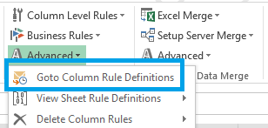

#### Defining a Business Rule

Now we will see how to define the rule. The steps given below will give detail idea about the same.

To add new rule, go to Universal Template > Configure Data Validation > Business Rules > Select the rule type under which the rule need to be created > Add New Validation Rule.

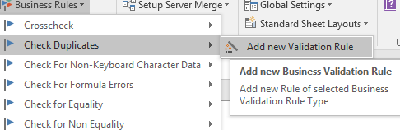

This will display message contains the name of new validation rule as shown below.

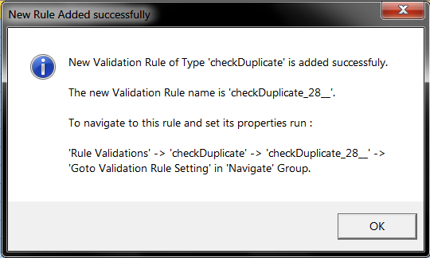

A Business Rule Form will be opened based on the rule type selected and we need to define the settings based on the business requirement.

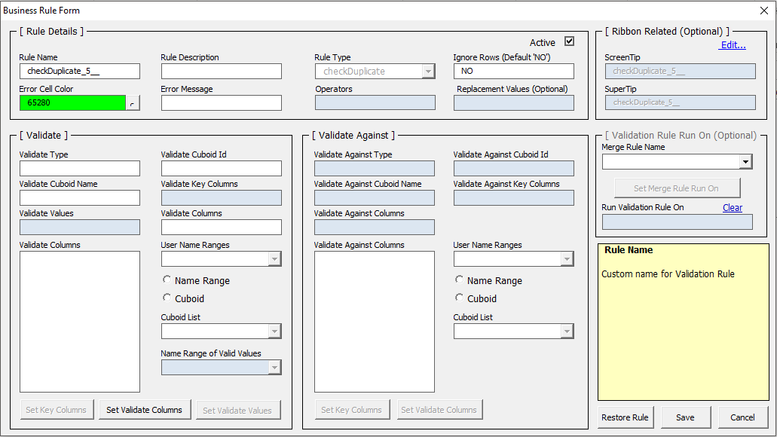

Once the settings are done as per the business requirement, click on ‘Save’ button to save the configured rule and then click on ‘Cancel’ to close the form.

The rule configured will be saved in ‘business_validation_rules’ named range of ‘BusinessValidationRules’. The table given below will give the detailed information about columns used for setting validation rule.

|  |  |  |
| --- | --- | --- |
| **No** | **Validation Rule columns** | **Description** |
| 1 | RULE_NAME | Name assigned to the validation rule to identify rule. Mandatory. |
| 2 | RULE_TYPE | Rule type required as per business requirement. Mandatory. |
| 3 | TO_VALIDATE_TYPE | It can be BWTBL: Boardwalk table. Mandatory. |
| 4 | TO_VALIDATE_TABLE | Name of the Boardwalk table. Mandatory. |
| 5 | TO_VALIDATE_CUBOID_ID | Cuboid id of the table mentioned in ‘TO_VALIDATE_TABLE’. Mandatory. |
| 6 | TO_IGNORE_ROWS | This is optional and default value is ‘NO’. If certain rows need to be ignored then ‘YES’ and mention column name with values and column name pipe separated as [IF(|Col1|not equal ‘0’,’0’,’1’)]. |
| 7 | TO_VALIDATE_KEYS | Name of the key columns acting as primary key columns. Mandatory. |
| 8 | TO_VALIDATE_COLS | Name of the column need to validate. Mandatory. |
| 9 | TO_VALIDATE_VALUE | This property is more useful in equality or non-equality types. Mandatory or Optional depends on rule type. For Rule type ‘CheckDropDownValue’ this will contain the name of the range with which comparison of data performed. |
| 10 | REPLACEMENT_VALUE | Enter the value to be replaced with. Mandatory or optional depends on rule type. |
| 11 | OPERATORS | This is useful in equality operations or to check numeric or date type data. Values for this are EQUAL, NOT EQUAL, LESS THAN, GREATER THAN, LESS THAN EQUAL TO, GREATER THAN EQUAL TO, BLANK, NOT BLANK, NUMERIC, DATE. |
| 12 | VALIDATE_AGAINST_TYPE | This is useful for Crosscheck rule type. It can be BWTBL: Boardwalk table. Mandatory for crosscheck. |
| 13 | VALIDATE_AGAINST_TABLE | Name of the boardwalk table against which crosschecking needs to be done. |
| 14 | VALIDATE_AGAINST_CUBOID_ID | Cuboid id of the Boardwalk table. |
| 15 | VALIDATE_AGAINST_KEYS | The primary key columns of the table. |
| 16 | VALIDATE_AGAINST_COLS | Name of the column against which validation need to be perform. |
| 17 | INTERMEDIATE_TABLE_ID | This is temporary table acting as staging table. |
| 18 | INTERMEDIATE_TABLE_NAME | Name of staging table. |
| 19 | INTERMEDIATE_COLS | Column names of staging table. |
| 20 | ERROR_CELL_COLOR | The name of color to highlight error cells. |
| 21 | ERROR_MSG | Error message to be displayed to user. |
| 22 | IS_ACTIVE | True(To activate Validation Rule)/False(To De-activate validation rule) |
| 23 | RULE_DESC | Description about rule in short. To understand the operation of rule. |
| 24 | ScreenTip | Message appearing on the screen. |
| 25 | SuperTip | Message giving information about rule. |

Once the rule is defined then activate the rule.

To activate rule Universal Template > Configuration Data Validation >Business Rule > Rule Type> Rule Created > Activate Validation Rule.

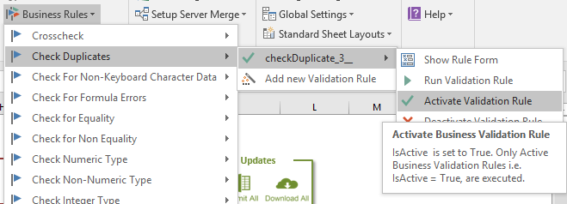

On successful activation it gives message as

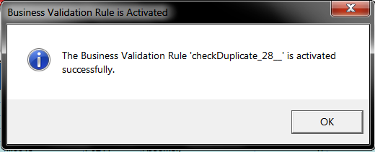

*Note: Using Deactivate Validation Rule we can deactivate the current active rules.*

After defining validation rule we can test the rule by executing the rule.

To execute validation rule, go to Universal Template > Configuration Data Validation > Business Rules > <<*Rule Type>>* > <<*Rule Name>>* > Run Validation Rule.

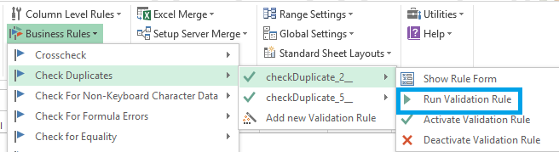

After executing rule it performs validations check on the columns mentioned in the rule and highlights the validation failed cells with the color mentioned in validation rule.

Invalid Data cell window gives the list of cell references where validation failed.

The following image shows the Invalid Data cell format.

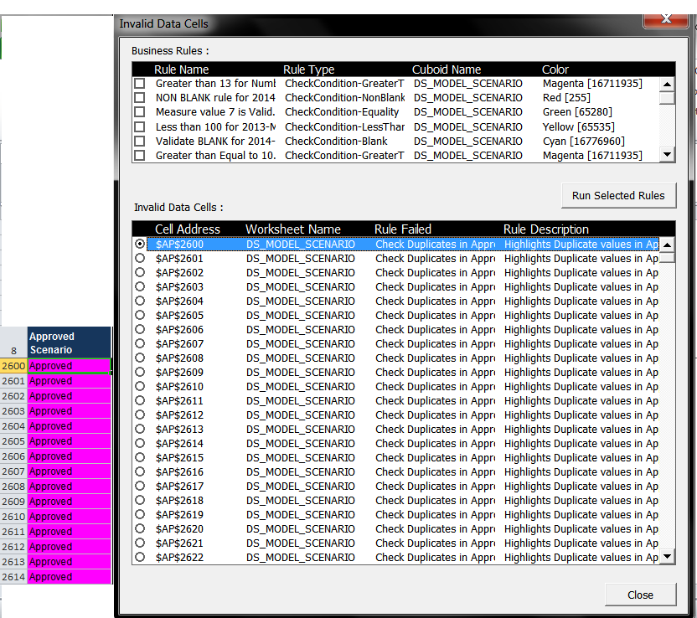

*Note: The procedure of defining validation rule for any rule type remains same. New rule type also can be added in the validation rule type setting.*

#### Run Business Rules While Submitting

A new rule is created by following the above process, however the same rule should be executed before Submitting to take care of the validations.

To do this, go to Universal Template > Configuration Data Validations > Business Rules > Validation of Business Rules > Set Validate Cuboid ON.

*Note: To disable the rule execution, use Set Validate Cuboid OFF.*

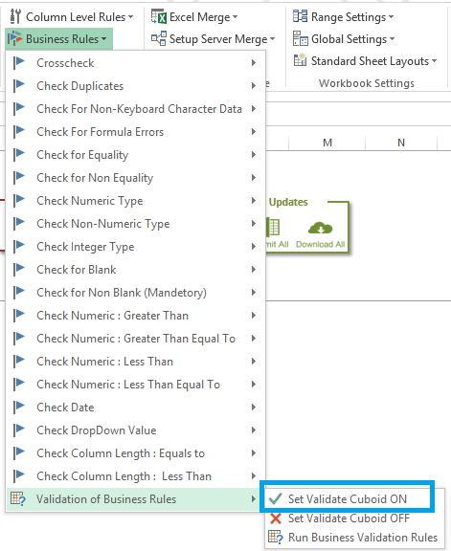

Click on OK button and all the Business Rules configured on the selected Cuboid sheet will be executed before each Submit.

#### View/Edit or Delete Business Rules

All the Business Rules configured on the selected Cuboid will be listed to View/Edit or Delete.

Click on any rule from Universal Template > Configuration Data Validations > Advanced > View Sheet Rule Definitions, to go to ‘BusinessValidationRules’ sheet.

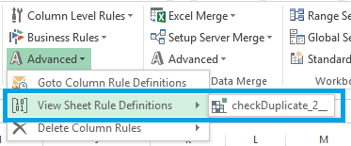

Click on any rule from Universal Template > Configuration Data Validations > Advanced > Delete Column Rules, to delete.

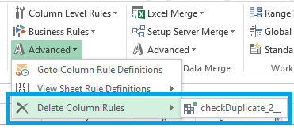

* 1. **Setting Cuboid Links (Dynamic Download)**

This is the functionality where we can set relationship between Cuboids (1 to many or 1 to 1).

By virtue of this feature, once the links are established between the Cuboids – then we can populate data in Target Cuboid based on the selection made in Source Cuboid.

The Target Cuboid can have Download Type in the Template Manifest as ‘Default’ or ‘OnDemand’, but Source Cuboid should have ‘Default’.

The Cuboids with ‘Default’ Download Type will get downloaded when template is downloaded but the Cuboid with type as ‘OnDemand’ will not be downloaded first, however will be available only when link is established and that link is executed.

Let’s us go through the steps to establish link between the cuboids.

Let’s consider two Cuboids named as ‘PRODUCT_MASTER’ acting as Source Cuboid through which we are going to execute the link and the other two cuboids as ‘SALES_MASTER’ and ‘FORECAST’ are On Demand Cuboids.

#### Configuration

Select ANY CELL OF THE Source Cuboid ‘PRODUCT_MASTER’with which we want to create relationship and go to Universal Template > Boardwalk Workbook Actions > Advanced > Set Cuboid Links >*<<Target Cuboid (SALES_MASTER)>>* > Add/Edit Link.

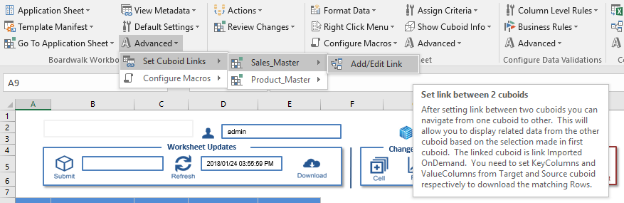

On click, a pop-up screen with name ‘Cuboid Link Relation Settings’ will open as shown below.

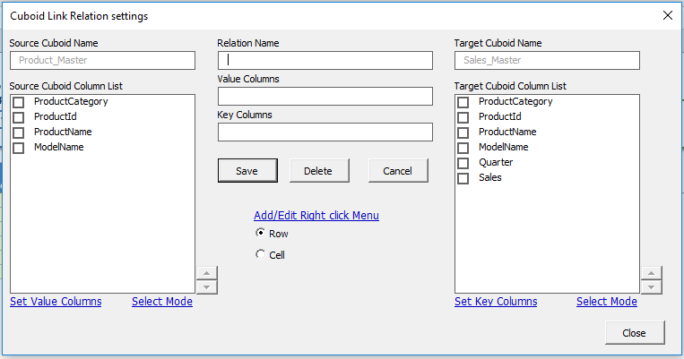

The left pane belongs to the Source Cuboid settings where as the right pane belongs to the Target Cuboid settings.

Source and Target Cuboid Name fields are read-only and cannot be modified.

First enter any suitable name for the field ‘Relation Name’.

Once done, select the required ‘Value Columns’ of the Source Cuboid from ‘Source Cuboid Column List’ and click on ‘Set Value Columns’. The selected columns will be set as ‘Value Columns’.

Once done, select the required ‘Key Columns’ of the Target Cuboid from ‘Target Cuboid Column List’ and click on ‘Set Key Columns’. The selected columns will be set as ‘Key Columns’.

Clicking on ‘Save’ button will save the Cuboid Link in the sheet named as ‘CuboidRelations’.

*Note: ‘Select Mode’ option can be used to change the order of either Key Columns or Value Columns.*

#### Right Click Menu Option for “Download ONDemand”

Once the Cuboid Link is created between Source and Target Cuboids, an option to download the Target Cuboid can be provided by following the below steps.

Select Row or Cell and click on ‘Add/Edit Right Click Menu’ in the ‘Cuboid Link Relation Settings’ as shown below.

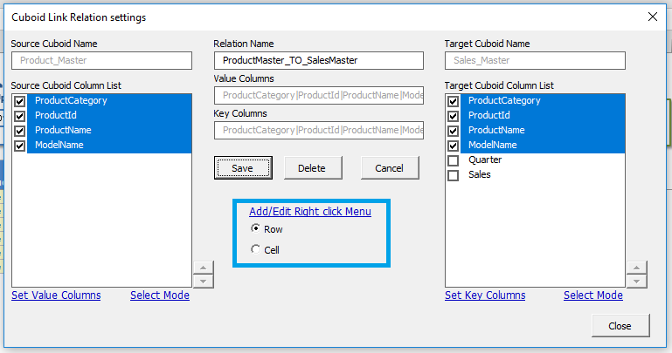

A pop-up screen with name ‘Menu Hierarchy’ will be appeared to set the ‘Boardwalk Right Click Menu-Hierarchy option’ to download the Target Cuboid. Separate the items with PIPE(|) symbol as shown below, if multi-level hierarchy is needed.

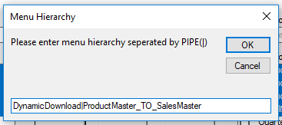

Once clicked on OK, a new pop-up will be appeared to configure the final selection option to download the Target Cuboid. Clicking ‘OK’ after entering the appropriate value will create an option in Boardwalk Right Click Menu.

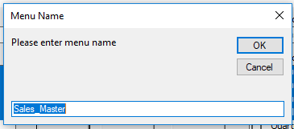

Once the Right Click Menu is created, to verify go to Universal Template > Configure Sheet > Right Click Menu > Test Menus. (Right Click Menu should be created if not already by clicking on ‘Create Default’).

The Right Click Menu option will be created for Source Cuboid for Cell or Row (based on the option created earlier) as shown below.

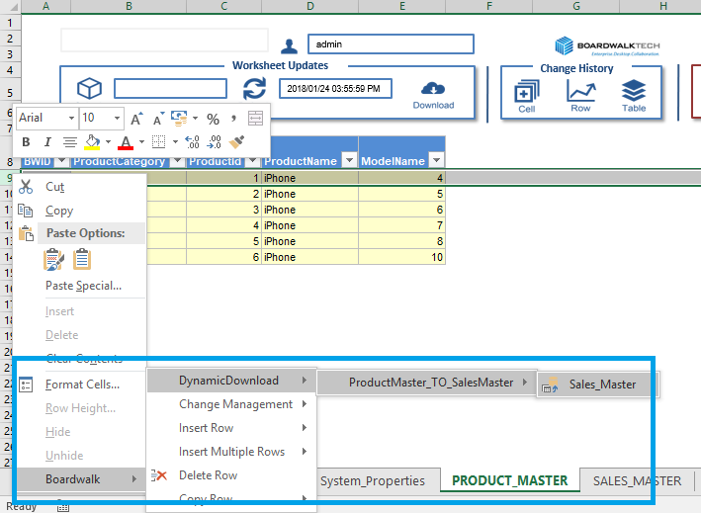

#### Setting Target Cuboid as “ONDemand”

Set the Target Cuboid as ONDemand so that it is not present at the time of download but it will display on demand by user. This is Optional.

To make the Target Cuboid as ‘ONDemand’, go to Universal Template> Configure Sheet > Advanced > Set Cubiod As > ON Deamand.

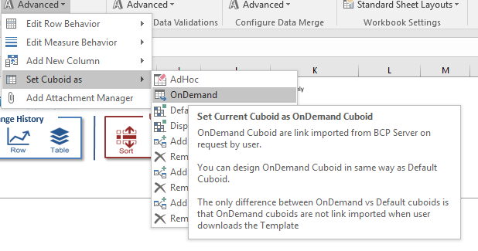

Clicking on the last option in the hierarchy (*Sales_Master*) will download the Target Cuboid (SALES_MASTER) for the given criteria.

#### Remove LINK Relationships

To remove the link relationships, go to Universal Template > Boardwalk Workbook Actions > View Metadata > *<<Source Cuboid>>* > Cuboid Links > *Select the link to be removed* > Delete Link.

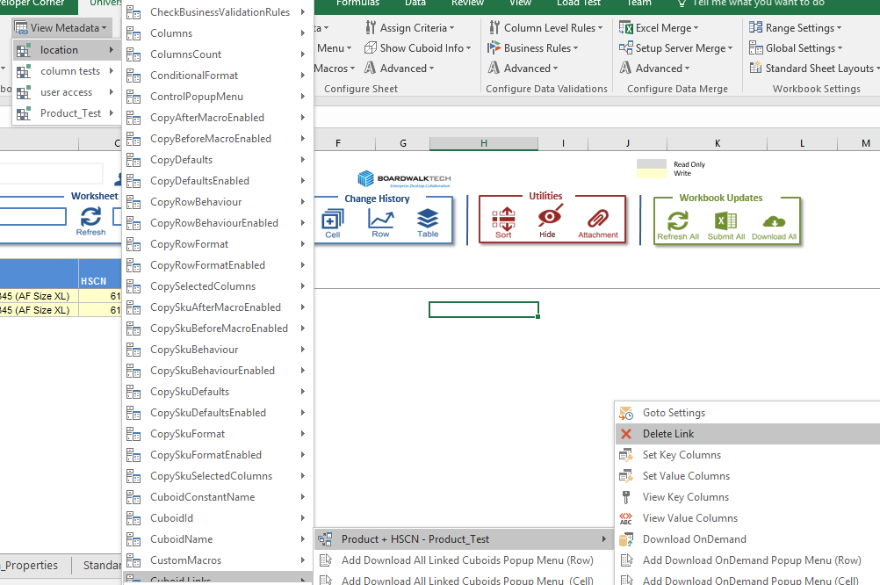

*Note: Above steps are useful to set 1:1 relationship i.e. one Source Cuboid and one Target Cuboid. In the similar way we can set 1:N i.e. one Source Cuboid and many Target Cuboids. Same steps in above topic can be repeated for other Target Cuboid by selecting the other desired Target Cuboids.*

* 1. **Unlink Cuboid**

This option helps us to cleanse the template in case if we want to remove any Cuboid from the template. It consists of two sub-options as

* Keep Dependents
* With Clear All Traces

#### Unlink with Keep Dependencies

This needs to execute at the time of publishing template to the user.

Below activities are executed on click of this option:

* Unlinks the Cuboid
* Cuboid Data is deleted
* All cell comments, cell contents, validation, hyperlinks, notes, cell outlines are removed

Note: Even though the Cuboid is unlinked, but the related information and ranges i.e. the metadata of Cuboid is not removed.

*Related ranges include format ranges like ROWFORMAT, COLUMNFORMAT, SKUFORMAT.*

*Related information includes entries for validation rules, conditional formatting, popup menu, custom macro settings, cuboids’ metadata & SysColumns.*

To Unlink a Cuboid, go to Universal Template > Boardwalk Workbook Action > Application Sheet > Unlink > Keep Dependencies.

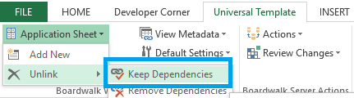

Cuboid will be unlinked and all the Cuboid data in the sheet will be removed.

We can see the metadata of the Cuboid which is unlinked using ‘Keep Dependents’ option by navigating to Universal Template > Workbook Settings > Range Settings > Show Metadata.



#### Unlink with Remove Dependencies

Below activities are executed on performing this option.

* Unlinks cuboid
* Cuboid Data is deleted
* All cell comments, cell contents, validation, hyperlinks, notes, cell outlines are removed
* All related ranges and information are deleted
* Related ranges include format ranges like ROWFORMAT, COLUMNFORMAT, SKUFORMAT.
* Related information includes entries for validation rules, conditional formatting, popup menu, custom macro settings, cuboids’ metadata & SysColumns.

To Unlink a Cuboid, go to Universal Template > Boardwalk Workbook Action > Application Sheet > Unlink > Remove Dependencies.

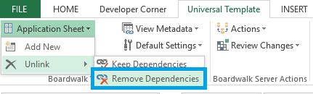

Cuboid will be unlinked and all the Cuboid data in the sheet will be removed.

Cuboid metadata will also be removed and the same can be verified by navigating to Universal Template > Workbook Settings > Range Settings > Show Metadata.

* 1. **Setting Template Manifest**

Security is the important factor of any system. ‘Template Manifest’ is the addition in UT for enhancement of security so that the users can access Cuboids present in specific Neighborhood only.

There will be one ‘Template Manifest’ per template. This will decide the template access to Neighborhood members that means for example one user of specific Neighborhood can access 3 Cuboids then those entries will be present in the ‘Template Manifest’.

Template Manifest Cuboid should be Link Exported before publishing template to the user.

Below are the columns of the Template Manifest Cuboid.

|  |  |
| --- | --- |
| **Column Name** | **Description** |
| Process | This the name of process name specified in System Properties. |
| Workbook | Name of the workbook must be same as specified in System Properties. |
| Worksheet | Name of the sheet contains cuboid after link exporting new cuboid. |
| Visible | Cuboid should be visible to user on download or not. |
| XPOS | X-axis position of cuboid after download. |
| YPOS | Y-Axis position of cuboid after download. |
| Table | Cuboid ids of respective cuboid present in the template. |
| NH0 | Name of the Level 0 Neighborhood. |
| NH1 | Name of the Level 1 Neighborhood. |
| NH2 | Name of the Level 2 Neighborhood. |
| NH3 | Name of the Level 3 Neighborhood. |
| View | Value is ‘Latest’ to fetch all rows. |
| Mode | Value = ‘0’ means user can read/write  Value = ‘1’ means data read only. |
| DownloadType | ‘DEFAULT’ means cuboid should be available on download or ‘ONDEMAND’ means it is not displayed on download. However after download, if user wishes to go to this Cuboid, can do it. |
| DownloadForManagerGroup | All the rows of a particular template should be YES or NO.YES to give access to the Manager Group to download the data. |

Note: Designer or a developer of a template needs to set this access as per the business requirement. This is an important step in the template as on the basis of these settings downloading of template will take place.

Let us see how to add the ‘Template Manifest’ Cuboid.

To add the Template Manifest sheet, go to Universal Template > Boardwalk Workbook Actions > Template Manifest > Add New.

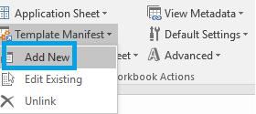

This will add one sheet named as ‘Template Manifest’. Message with instruction for creating Template Manifest Cuboid will appear as shown below.

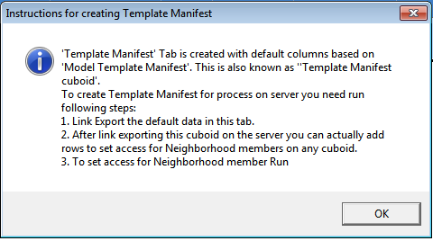

By default

* 1. Rows will be populated automatically with the Cuboids present in the template and
  2. All the parameters of Template Manifest will be taken from System_Properties automatically.

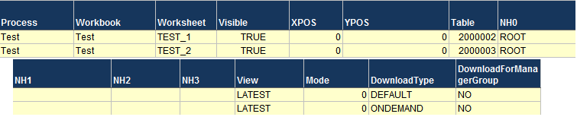

*Note: Re-Confirm the values as it is going to affect download process. The information can be changed as per the business requirement.*

Set NH0, NH1, NH2, NH3 columns with Neighborhood Hierarchy information.

*Note: Once these values are set, no other users except the given Neighborhood Hierarchy can download the data using this Template Manifest.*

Link export the Template Manifest Cuboid by navigating to Universal Template > Boardwalk Server Actions > Actions > Link Export.

Successful Link Export will give message for metadata generation followed by successful Cuboid creation as shown below.

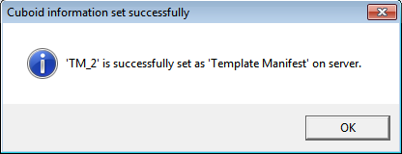

Once Link Export is completed, the Cuboid Id generated will automatically set to the property ‘TEMPLATE_MANIFEST_ID’ of ‘System_Properties’ sheet.

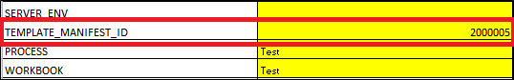

There is one more property in the ‘System_Properties’ which needs to be set to complete the process of Template Manifest which is ‘NEIGHBORHOOD_HIERARCHY’

Let us say is we need to give the download access to the users belongs to NH0 as ROOT, NH1 as SALES and NH2 as NorthAmerica, then the ‘NEIGHBORHOOD_HIERARCHY’ should be ‘ROOT|SALES|NorthAmerica’.

*Note: This Neighborhood Hierarchy should be the same hierarchy we have provided in the Template Manifest Cuboid columns NH0, NH1, NH2 and NH3. If not the template cannot be downloaded.*

The Template Manifest Cuboid should be unlinked from the template once the above steps are completed. This is important step as per as security point of view.

Go to Universal Template > Boardwalk Workbook Actions > Template Manifest > Unlink.

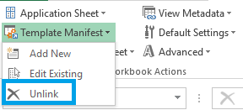

In future if any requirement occurs for addition of new Cuboid in the template then get the Template Manifest Cuboid in the template and add respective data for new Cuboid by navigating to Universal Template > Boardwalk Workbook Actions > Template Manifest > Edit Existing.

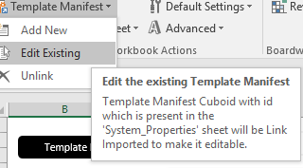

**Template Manifest Download Type**

There are two values can be assigned or set in ‘Download Type’ column of manifest table.

* Default
* ONDemand

DEFAULT is set when that specific Cuboid must be available at the time of Download Data.

ONDEMAND is set when that Cuboid is not present at the time of Download Data but will be available on user demand.

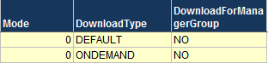

Note: For detailed information on ‘ON Demand’ please refer to 5.15. Setting Cuboid Links.

**Download For Manager Group**

If all the rows of Download For Manager Group is “Yes” in Template Manifest, then the users who are member of the parent Neighborhood Hierarchy will also have access to download the data.

*Note: All the rows of which belongs to a template should have the value as YES to avail this feature.*

* 1. **Adding Worksheet as Default Tab**

It helps to assign any worksheet from template as default tab i.e. that worksheet will be visible first to user on Download Data. It can be set using ‘Boardwalk’ right click menu option. Put the cursor over the worksheet name and with right click option ‘Boardwalk’ menu for setting worksheet as default tab is available.

*Note: Please note that this option is not present within the worksheet area, cursor must be present on the worksheet name to get this menu.*

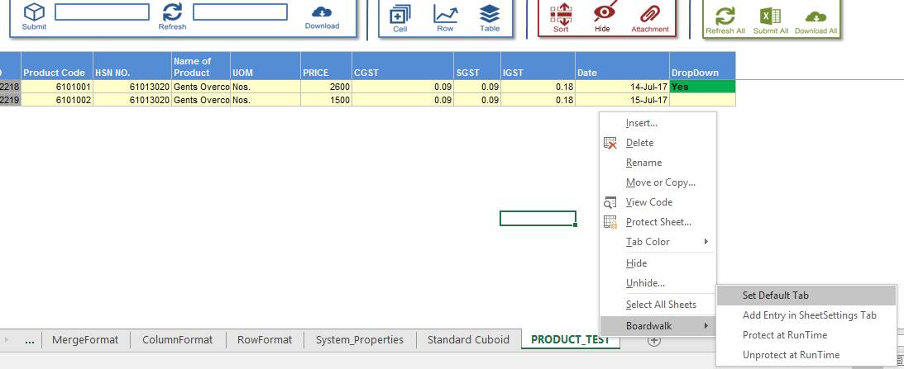

There are four options available within this as

**Set Default Tab:** This will allow setting worksheet as Startup worksheet after confirming with below messages.

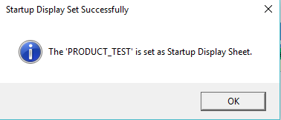

**Add Entry in SheetSettings Tab:** There is worksheet named as ‘Sheet Settings’ which contains the list of all worksheets present in template with name range as ‘SheetSettings’.

This option helps to add new worksheets entry in the sheet settings if it not exists.

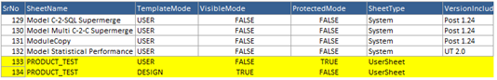

**Protect at Run Time:** This allows protecting the worksheet so that it cannot be editable. ‘ProtectMode’ is set as ‘True’ for template mode as ‘USER’.

**Unprotect at Run Time:** This allows unprotecting the worksheet and can be editable. ‘ProtectMode’ is set as ‘False’ for template mode as ‘USER’.

The above properties will set the ‘ProtectMode’ column of range of ‘SheetSettings’ as ‘True’ or ‘False’.

* 1. **Utilities**

This section provides the list of the features under ‘Utilities’.

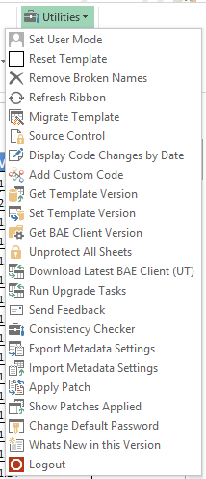

Explanation of each of these utilities are mentioned below

**Set User Mode**

Once all the Design activities are complete and the template needs to be published to the users, we need to change the Template Mode to User.

Universal Template displays 'Welcome' Tab in User Mode.

All Cuboids created during Design mode are unlinked and all metadata related tabs are hidden.

**Reset Template**

To start working on new Process/Template, we need a clean Universal Template.

Reset Template will

* Unlink All Cuboids.
* Clear All Traces.
* Clear all Settings and makes template ready for new Processes.
* Deletes Custom Modules
* Reset System Properties

**Remove Broken Names**

Broken Name Ranges contains #REF because the reference cells or range is not present in the Template. We need to delete such Name Ranges by using Remove Broken Names.

**Refresh Ribbon**

The custom settings of the Galleries used in Ribbon are made in 'GallaryMenuActionSettings' name range.

We need to run Invalidate Ribbon to find the effect of any changes made in these settings.

Refresh Ribbon runs Invalidate Ribbon to update the Ribbon.

**Migrate Template**

This functionality is used to migrate the changes from a cuboid in one database to the same cuboid in other database.

**Source Control**

Visual SourceSafe is used to store the VBA code. This will launch the Source Control window for version management of VBA Macros.

**Display Code Changes by Date**

It lists all modified and newly created list of macros from specific date.

**Add Custom Code**

This will open Excel VBA editor to write or edit custom macro.

You must write all custom macros in custom module.

All other modules are related to Universal Template and should not be modified for Custom changes.

The custom module name is defined in CUSTOM_MODULE system property.

**Get Template Version**

The Template version is stored in Boardwalk database on Server.

BW_TEMPLATE_VERSION is a SQL table that stores Name, Major Version and Minor Version of the template.

This command will display the current version settings in BW_TEMPLATE_VERSION for the Template.

**Set Template Version**

Before a new Template is released to Users you need to update the Template Version on the Server.

This will update Database table with the template version information of System_Properties.

**Get BAE Client Version**

BAE Client is an Excel based user interface that allows Boardwalk users to work in collaboration.

BW_EXCEL_VERSION is a SQL table that stores Major Version and Minor Version information of BCP Client.

This command will display the current version settings in BW_EXCEL_VERSION.

**Unprotect All Sheets**

Unprotects all the Cuboid sheets present in the template.

**Download Latest BAE Client (UT)**

This will download latest Universal Template from the Server.

Before downloading the latest version, save your current Template and close all Excel files.

Download the latest Universal Template into local folder on your machine.

After downloading the latest Universal Template version from the server, you need to run following steps,

1. Close all Excel files.

2. Open latest Universal Template downloaded from the server.

3. Run 'Upgrade Tasks' from 'Utilities' gallery. During this step all settings from the old Template will be copied over into latest version. For this you need to browse provide the old template location.

**Run Upgrade Tasks**

After downloading Universal Template from the server you need to run Upgrade Task.

The latest Universal Template downloaded from server needs to be updated with Metadata settings so that Developers can continue the template development using latest version.

Upgrade Task copies CUBOIDMETADATA, FORMATS etc. from the old template.

**Send Feedback**

Your views, ideas and feedback are important to us.

We welcome your ideas and feedback to add new features into our Product.

This button will allow you to share your ideas with us and send email to Boardwalk Development Team.

**Consistency Checker**

UT has certain system tabs used for saving cuboid and process metadata.

Metadata is used for processing of template in USER mode and any inconsistent changes will make template unstable.

Consistency check will identify these issues and display warnings and suggestion actions to fix those issues.

**Export Metadata Settings**

It exports the metadata from current template and saves on the defined path.

This will be useful to import this file in to another template with lower version.

Exporting new metadata will help in reducing inconsistency between the version differing templates.

**Import Metadata Settings**

Exported file of metadata can be imported using this so that template will have latest updates and inconsistency between templates due to versioning will get reduced.

**Apply Patch**

The code changes during bug fixes or enhancements are added using Apply patch.

**Show Patches Applied**

It shows list of patches added in current template.

**Change Default Password**

The worksheet containing cuboid is protected by default password. This utility allows to set new protect/unprotect password.

**Whats New in this Version**

Under Development

**Logout**

To Logout from the Boardwalk Server.

**Help**

This section provides detail information on the selection topic.

* 1. **Navigation Section**

In Universal Template, there is one group named as ‘Navigate’. This helps to navigate to various settings as below.

* Go to Application Sheet
* View Metadata
* Range Settings
* Global Settings
* Standard Sheet Layouts

#### Go to Application Sheet

This option lists the Cuboids present in the Template.

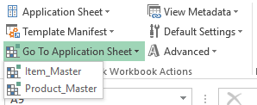

Click on the Cuboid name will navigate to the respective sheet containing that Cuboid as shown below.

Click on Cuboid name ‘Product_Master’ will navigate to respective cuboid sheet as



This option will be helpful in navigating between Cuboid sheets.

#### View Metadata

This option gives all information related to the selected Cuboid, in detail i.e. format assigned to Cuboid, number of columns present, names of columns and the list as shown below

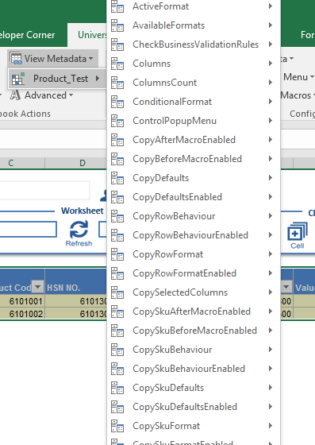

#### Range Settings

It shows list of ranges used in the template as

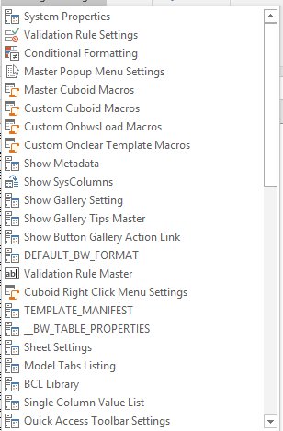

For e.g. If we want to see System Properties so click on ‘System Properties’ and we be will navigate to respective sheet containing the details.

#### Global Settings

This part list of settings present in ‘System Properties’ option are listed.There are read only settings (R) and editable settings which (RW).

For e.g. If we want to check /update Boardwalk server URL, Select that property from global setting will give respective details.

#### Standard Sheet Layouts

The default structure of all the Cuboids will be maintained in respective model sheets.

The structure can be viewed by opening these sheets.

To access, go to Universal Template > Workbook Settings > Standard Sheet Layouts > *<<Sheet Name>>.*

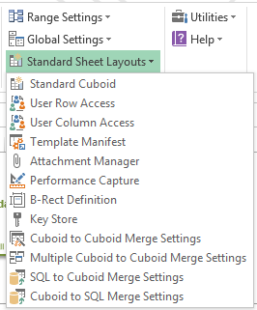

1. **User Mode Functions**

This mode is for the end users after the template designing is complete.

Go to Universal Template > Utilities > Set User Mode.

On selection of this mode,

1. A new tab with name ‘Boardwalk’ will appear.
2. ‘Universal Template’ tab will be hidden.
3. Welcome sheet appear on the screen as shown below.

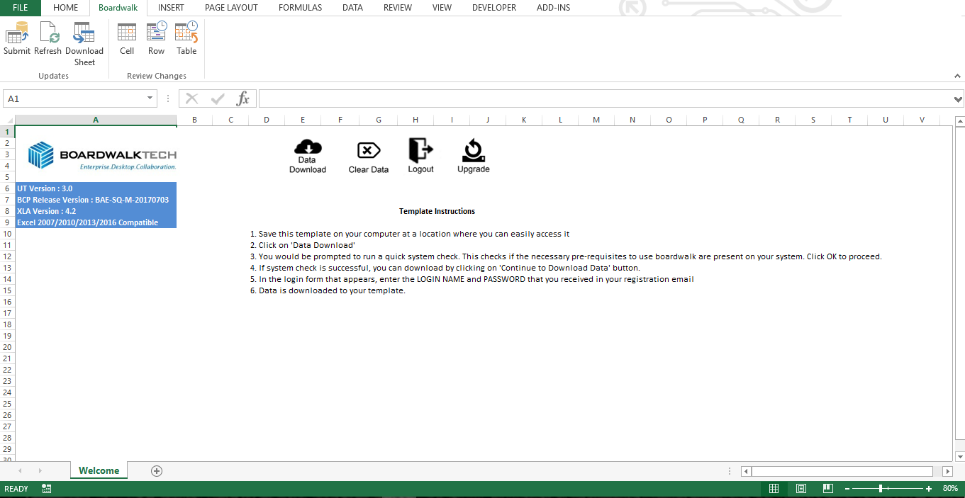

There are basically 4 buttons placed on the Welcome sheet with names ‘Data Download’, ‘Clear Data’, ‘Logout’ and ‘Upgrade’.

* 1. **Data Download**

This button is present on worksheet ‘Welcome’. It is used to download data of all Cuboids present in template. Cuboid metadata is used for downloading the Cuboids from the Boardwalk Database Server.

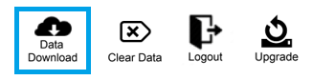

Clicking this button will start a Quick Check of the system to test its compatibility with Boardwalk.

If all the tests pass, the user can go ahead and download the template. If the tests fail, then it is recommended resolve all the issues before downloading the template.

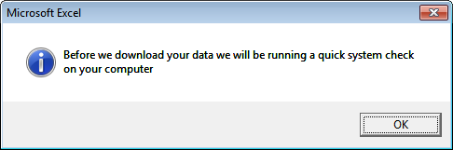

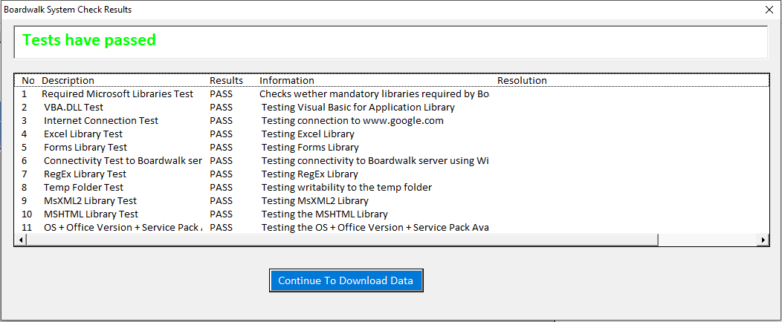

Click on ‘Continue To Download Data’ and a login form as shown below will be prompted.

Enter your valid credentials for successful authentication.

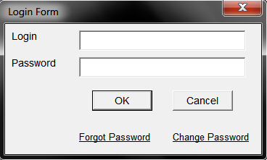

On successful authentication, it will download data into the template. Each worksheet basically contains functionalities such as

* Submit, Refresh and Download Buttons
* Cell History, Row History and Table History Buttons
* Sort, Hide/Unhide and Attachment Buttons
* Submit All, Refresh All and Download All Buttons
* Information box to show the current User Name
* Information box to show the Last Submitted Time and Last Refreshed Time

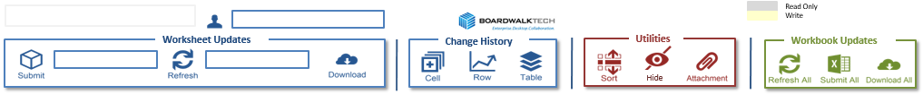

* 1. **Submit**

This function helps to Submit the changes/updates made in the Cuboid. User can work offline on the downloaded data and then the changes can be Submitted to the server whenever the user is online, so that these changes can be visible for other users on refreshing the template.

There are 2 ways you can Submit the data as shown below

1. From the ‘Boardwalk’ tab

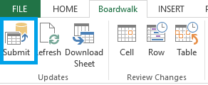

1. From the selected Cuboid worksheet

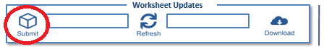

Clicking on any on these 2 buttons will ask for transaction comment which is optional but helpful to get an idea about the transaction performed in case of any issues in future.

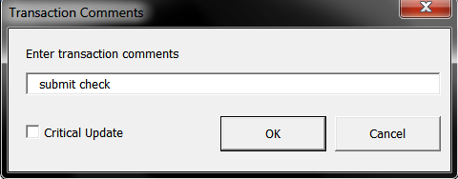

Click on ‘OK’ will submit the data and give message for successful submission.

It will update the ‘Last Submitted Time’ block with the date and time of last submit action performed.

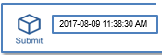

* 1. **Refresh**

This helps to fetch the latest data into the template from Boardwalk Database Server.

If there are multiple users working on the template then the changes made by the other users will get reflected in your template by this functionality.

There are 2 ways you can Refresh the data as shown below

1. From the ‘Boardwalk’ tab

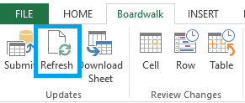

1. From the selected Cuboid worksheet

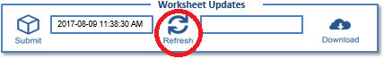

Clicking on any on these 2 buttons will fetch the latest data from the server and give message for successful refresh.

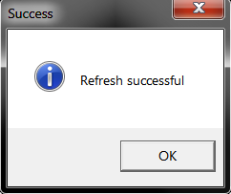

After successful Refresh, it will update ‘Last Refreshed Time’ block with date and time as shown below.

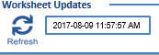

* 1. **Download Sheet**

Download Sheet is the process applicable for the active sheet Cuboid.

This will unlink the Cuboid present in active sheet and Link Import the Cuboid into the sheet.

There are 2 ways you can Download the sheet as shown below

1. From the ‘Boardwalk’ tab

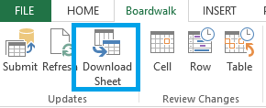

1. From the selected Cuboid worksheet

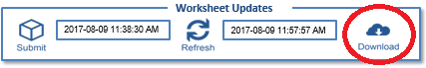

Clicking on any of these 2 buttons will pop up the message given below.

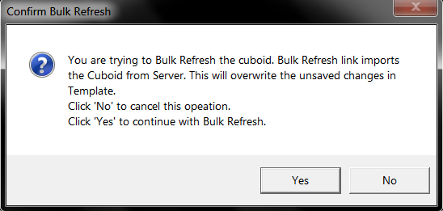

Once you click on ‘Yes’, the process will complete and prompt the successful message.

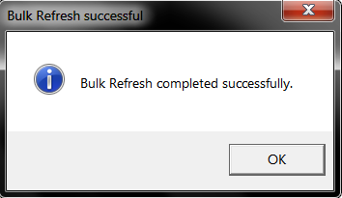

* 1. **Submit All**

This functionality helps to Submit the data of all Cuboids present in the Template simultaneously.

There is a ‘Submit All’ button available in all the Cuboid sheets as shown below.

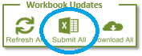

‘Submit All’ will Submit the changes of all Cuboids present in the template as per the sequence of Cuboids present in ‘SubmitAllCuboids’ sheet.

* 1. **Refresh All**

This functionality allows user to fetch latest data of all Cuboids on button click.

There is a button ‘Refresh All’ available in all the Cuboid sheets as shown below.

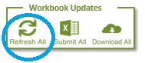

Refresh all will fetch data of all Cuboids present in the template as per the sequence of Cuboids present in ‘RefreshAllCuboids’ sheet.

* 1. **Download All**

‘Download All’ button will fetches latest changes in bulk, of all Cuboids as per the Cuboid sequence defined in ‘BulkRefreshAllCuboids’ sheet.

It unlinks the Cuboids and performs Link Import process which increases the performance in case of large Cuboid size.

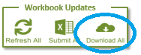

* 1. **Cell History**

This feature launches the audit trail for the selected Cell across the selected time.

There are 2 ways you can check the Cell History as shown below

1. From the ‘Boardwalk’ tab

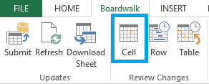

1. From the selected Cuboid worksheet



Select the desired Cell and click on any of the above 2 options.

Select the time period for which you wish to see the audit trail for the selected cell from the dropdown list.

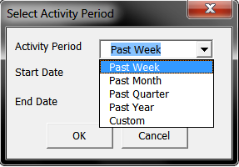

A new sheet will be launched with Cell History of the selected cell and time period.

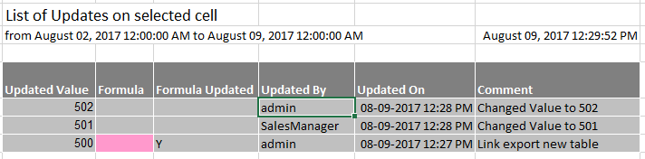

* 1. **Row History**

This feature launches the audit trail for the selected Row across the selected time.

There are 2 ways you can check the Cell History as shown below

1. From the ‘Boardwalk’ tab

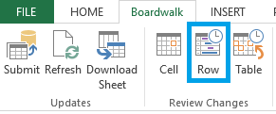

1. From the selected Cuboid worksheet



Select the desired Row or any Cell belonging to that row and click on any of the above 2 options.

Select the time period from the below dropdown list for which you wish to see the audit trail for the selected Cell and select all of the columns or required columns from the below Column list.

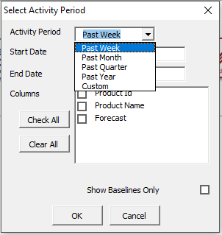

A new sheet with name ‘Row History’ will be launched with the audit trial of that row as below.

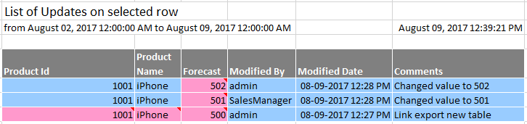

* 1. **Table History**

This feature launches the audit trail for the selected Cuboid across the selected time period.

There are 2 ways you can check the Table History as shown below

1. From the ‘Boardwalk’ tab

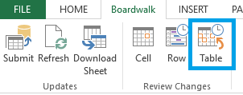

1. From the selected Cuboid worksheet



Select the any Cell belonging to the Cuboid and click on any of the above 2 options.

Select the time period for which you wish to see the audit trail for the selected Cuboid.

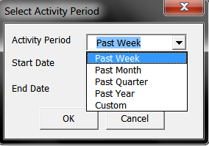

A sheet with name ‘Table History’ is launched with all the Transactions happened on that Cuboid as shown below.

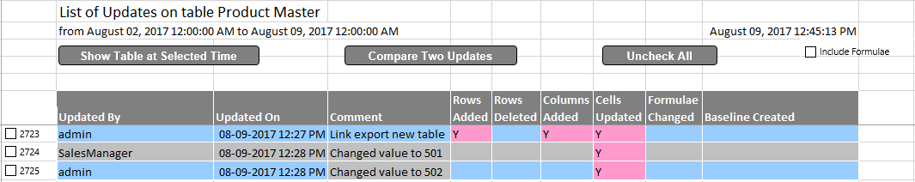

* To view the Cuboid at a particular transaction, check mark based on Updated By/Updated On information and click on ‘Show Table at Selected Time’.
* If there are more than 1 views available than you can also compare the Cuboid at 2 different transactions by checking the marks and then clicking on ‘Compare Two Updates’.
  1. **Sort**

This functionality will allow user to sort the Cuboid data based on Microsoft Excel’s Sorting functionality.



A pop-up will be prompted to sort based on the Cuboid columns like below.

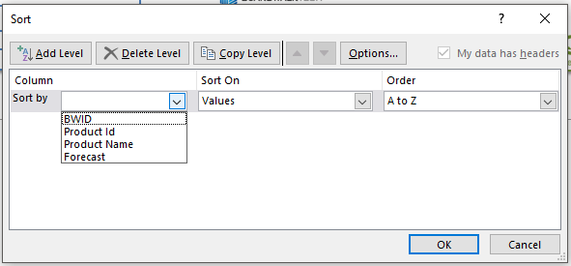

* 1. **Hide/Unhide**

This functionality allows user to hide or unhide certain columns in case there are many columns in the Cuboid and user wants a better view of the Cuboid data.

Select the cell just above the Column Name which you want to hide and change that cell value to ‘X’ or ‘x’ as shown below.

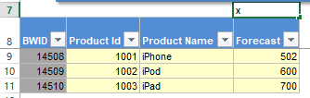

Click on the ‘Hide’ button as shown below so that the column will be hidden and the name of the ‘Hide’ button will change to ‘Unhide’ allowing you to Unhide the hidden columns.

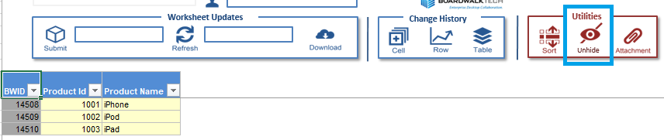

* 1. **Attachment**

This functionality facilitates user to attach the files to the Cuboid rows.

This feature will be available only after the Attachment Manager functionality is configured at the time of designing the template and the maximum size of the file you can attach is 20MB.

*Note: Files present on FTP server cannot be attached directly.*

Select any row or cell from Cuboid range for which attachment needs to be added and click on ‘Attachment’ button as shown below.

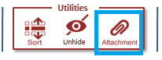

This will open Attachment Management as shown below

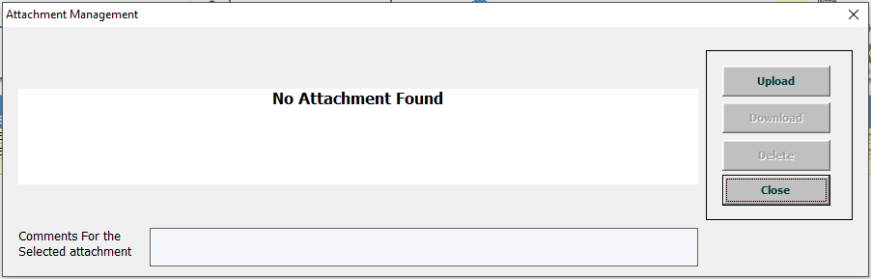

Attachment Management Screen has the below functionalities

* Upload
* Download
* Delete
* Close

**Upload Attachment:** It is used to add attachments. Click on ‘Upload’ opens form for browsing attachment file.

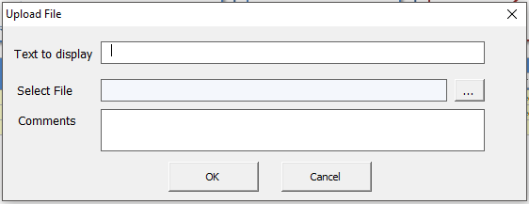

Text to Display: Assign name for the attachment.

Select File: Displays path of the selected attachment file. Using Browse, select the file required to attach.

Comments: Insert text for the attachment. Comments made for individual attachments are displayed in ‘Comments For the selected Attachment’ in ‘Attachment management’ form on selecting that attachment.

Click on ‘Ok’ will upload the attachment to server and add record in Attachment Cuboid and gives successful attachment message.

On successful upload it will show attachment in attachment management as

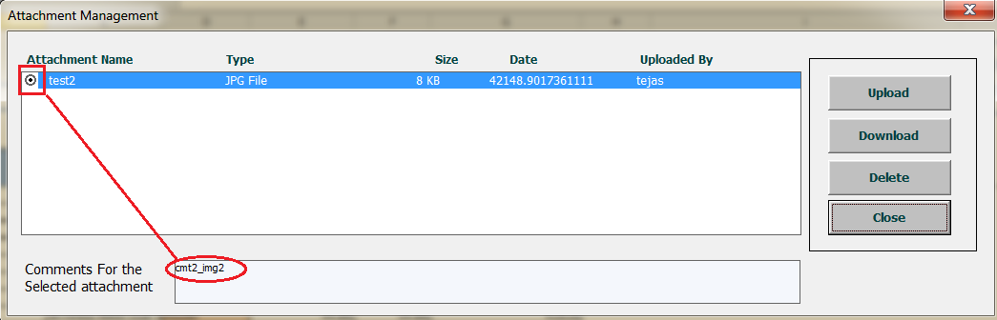

On selecting specific attachment comment for respective attachment is displayed in ‘Comments For the Selected attachment’ box.

**Download Attachment:** It is used to download the already attached document. Select the document attached from the list present in ‘Attachment Management’.

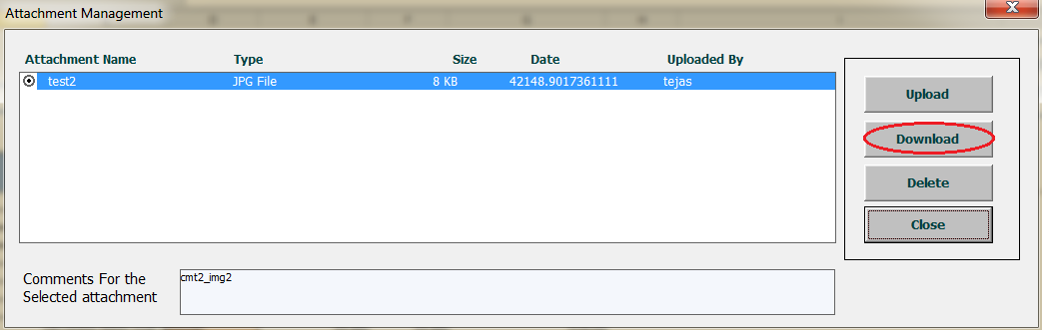

Click on ‘Download’ will open respective attachment in the browser (IE) as ‘View Downloads’ as shown below.

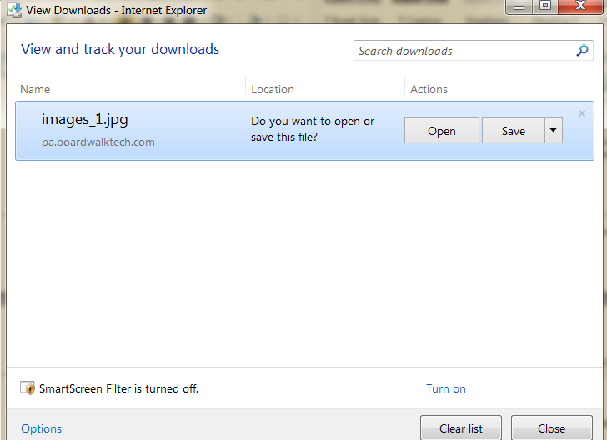

Click on ‘Open’ to view the attachment. ‘Save’ stores it to browser defaults downloads folder.

**Delete Attachment:** Delete is used to delete the unwanted attachment from Attachment Cuboid. Select the attachment you want to delete and click on ‘Delete’ will remove that file from Attachment Management.

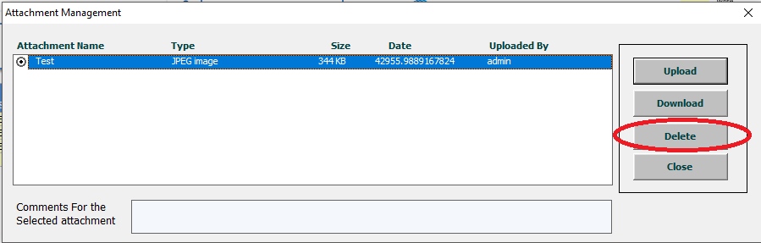**Close:** It will close Attachment Management.

* 1. **Clear Template**

This button is present on worksheet ‘Welcome’ and used to clear existing template i.e. unlinking all Cuboids from server and removing all Cuboid data from the template.

It removes only Cuboid data from the template but metadata of Cuboid is maintained so that it can be used while downloading template.

This feature can be used before sending the base template to other users for clearing Cuboid data.

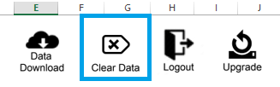

It will open the window asking to clear (purge) data in the template as shown below.

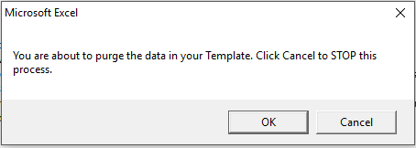

Click on ‘OK’ will unlink all Cuboids from the template.

Note: If user wants to create new data he can click on ‘Download Template’ and on successful login authentication template will get generated.

* 1. **Logout**

This button is available on worksheet ‘Welcome’. User can logout from template using this button.



* 1. **Upgrade Template**

This button is available on worksheet ‘Welcome’.

It is used for upgrading the template to latest version present on the Boardwalk server.

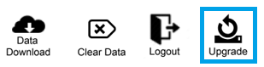

If the Template Version present in the ‘System_Properties’ is same as that of the Boardwalk Server, then the below pop-up will be prompted.

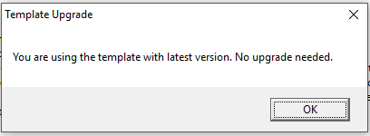

If the Template Version present in the ‘System_Properties’ is not same as that of the Boardwalk Server, it means that the template you are using is old. The below pop-up will be prompted.

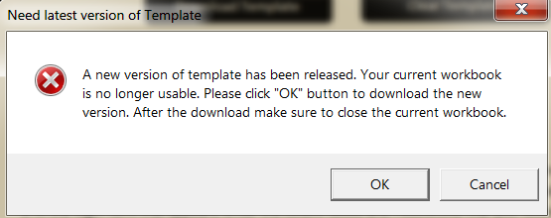

If the new template with the latest version is available on Boardwalk Server, then ‘Upgrade’ updates template with latest version provided.

Click on ‘Cancel’ closes the message box without updating template version.

Click on ‘Ok’ will open the below form with options to Open, Save and Save As.

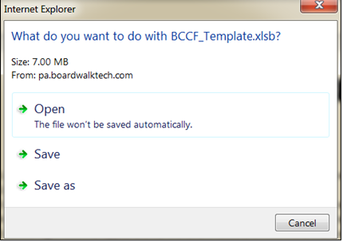

Select appropriate option and it starts downloading template to mentioned path as shown below.

